Amazon Redshift

Homework #1

Feb 2022

Data 228 - Big Data Technologies and Applications

Department of Applied Data Science

San Jose State University

Table of Contents

Getting Started with Amazon Redshift Console 4

Creating Clusters 4

Cluster Configuration 4

Database configurations 4

Connection Credentials 6

Query Editor 7

Amazon Redshift dashboard 7

Clusters 7

Cluster General Information 8

Cluster Performance 8

Query Monitoring 9

Maintenance 10

Properties 10

Connecting to Amazon Redshift 11

Getting started with Amazon Redshift clusters and data loading 11

Step 1: Create a sample Amazon Redshift Cluster 11

Creating an IAM Role 11

Step 2: Configure inbound rules for SQL clients 18

Step 3: Grant access to one of the query editors and run queries 18

Step 4: Load data from Amazon S3 to Amazon Redshift 18

Step 5: Trying example queries using the query editor 19

Step 6: Reset your environment 19

Getting started with common database tasks 21

Task 1: Create a database 21

Task 3: Create a schema 22

Task 4: Create a table 24

Task 5: Load sample data 25

Creating Bucket 25

Upload your data to your Bucket 26

Uploading in Progress 26

Associate IAM Role to cluster 27

Create a table by clicking on 28

Click Load Data 29

Browse S3 29

Select your data file 30

Choose IAM Role 31

Successfully loaded from S3 Bucket to Database 33

After Loading Data to Table 33

Task 6: Query the system tables 34

Task 7: Cancel a query 36

Task 8: Clean up your resources 37

Before dropping salesdb Database 37

After Dropping Salesdb Database 37

Getting started querying your data lake 38

Query Data Formats 38

Getting started with Amazon Redshift Spectrum 38

Step 1. Create an IAM role for Amazon Redshift 38

Creating Role 38

Creating Policy 39

Creating role using myspectrum_policy 40

Step 2: Associate the IAM role with your cluster 41

Step 3: Create an external schema and an external table 42

Creating an external schema 42

Creating an external table 42

**Getting started querying data on remote data sources** 43

Getting started accessing data in other Amazon Redshift clusters 49

Getting Started data sharing 49

Limitations of Data Sharing: 50

Getting started training machine learning models with Amazon Redshift data 51

Cluster and configure the setup for Amazon Redshift ML administration 51

Cluster setup for using Amazon Redshift ML 51

Using model with Amazon Redshift ML 54

Tutorial: Creating a customer churn model 54

SQL Reference 59

SQL Commands 59

1. Abort Command 59

2. Alter Commands 61

3. Create Commands 63

References 67

# Getting Started with Amazon Redshift Console

Amazon Redshift is a petabyte-scale data warehouse service offered by the Amazon Web Services Cloud. An Amazon Redshift data warehouse is a collection of computing resources known as nodes that are grouped together to form a cluster. Each cluster includes one or more databases that are powered by an Amazon Redshift engine.

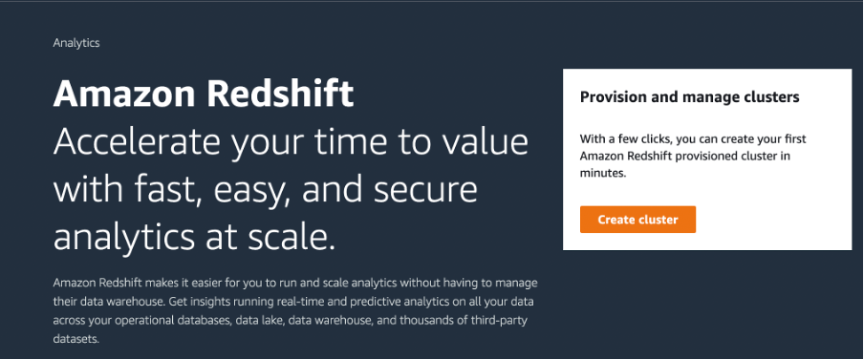

## Creating Clusters

To create a cluster, the free trial configuration is given where the sample data is loaded with the Redshift cluster and the Auto Generate password setting is given.

### Cluster Configuration

Cluster Identifier: redshift-cluster-1

(Free Trial)

### Database configurations

Admin username: awsuser

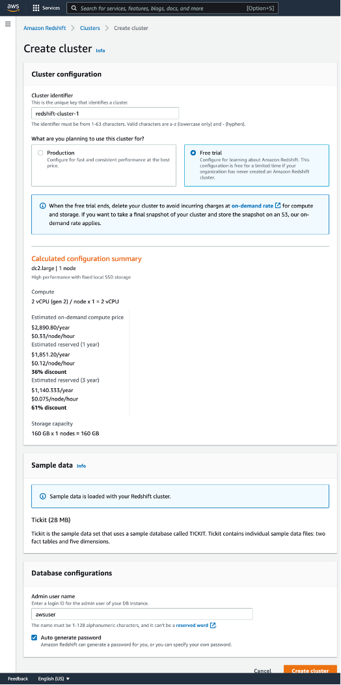

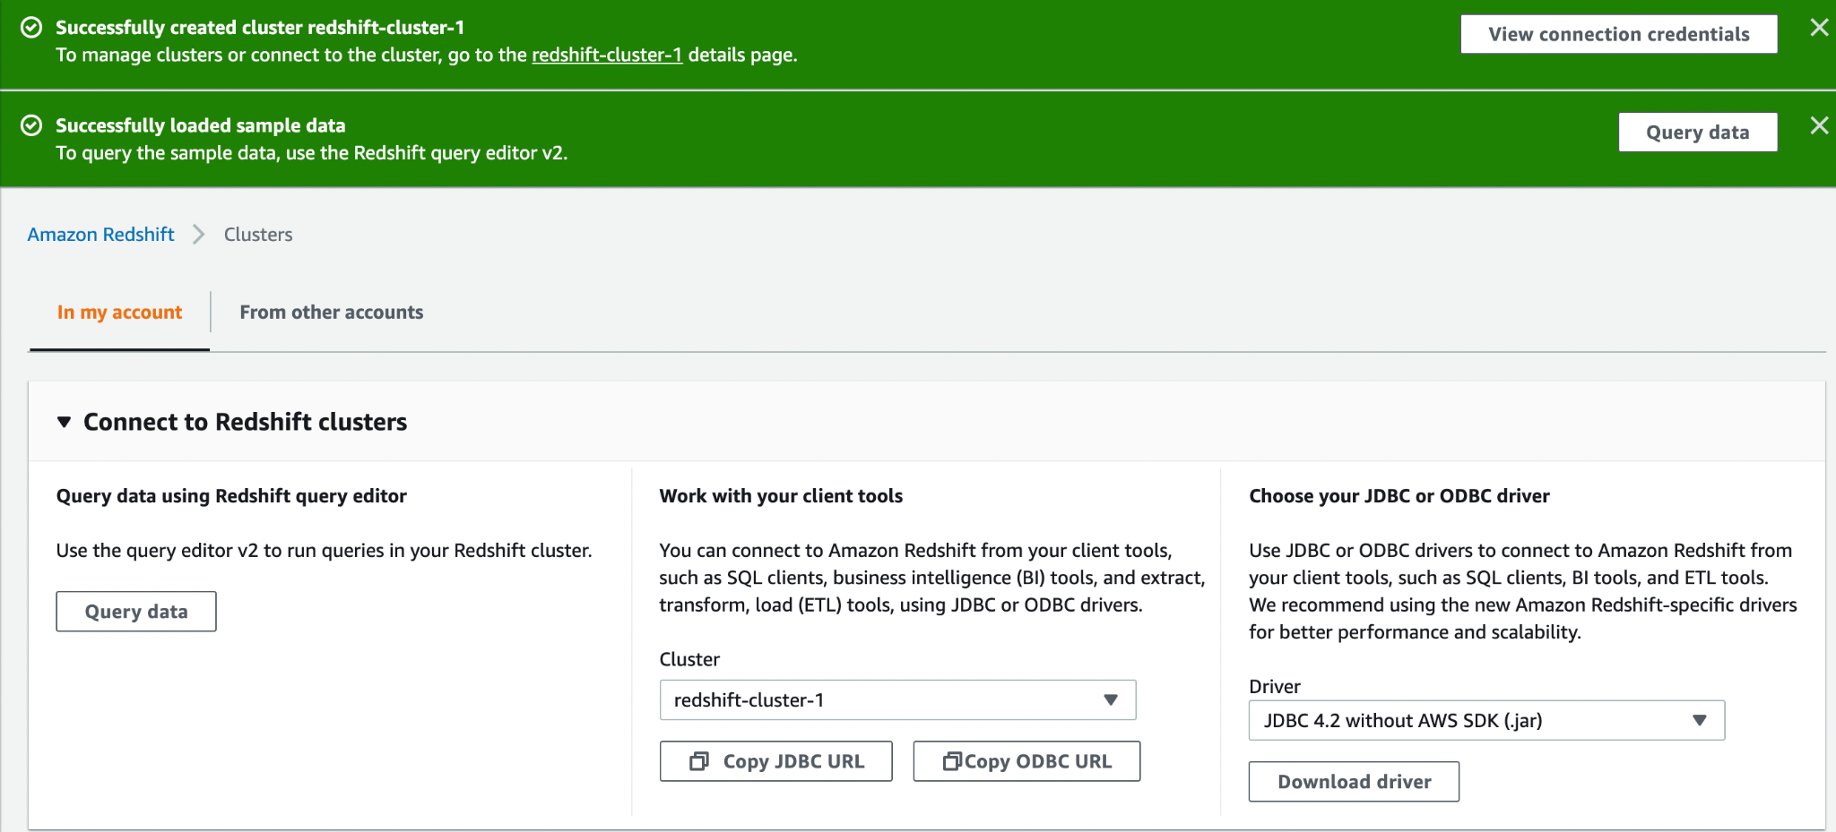

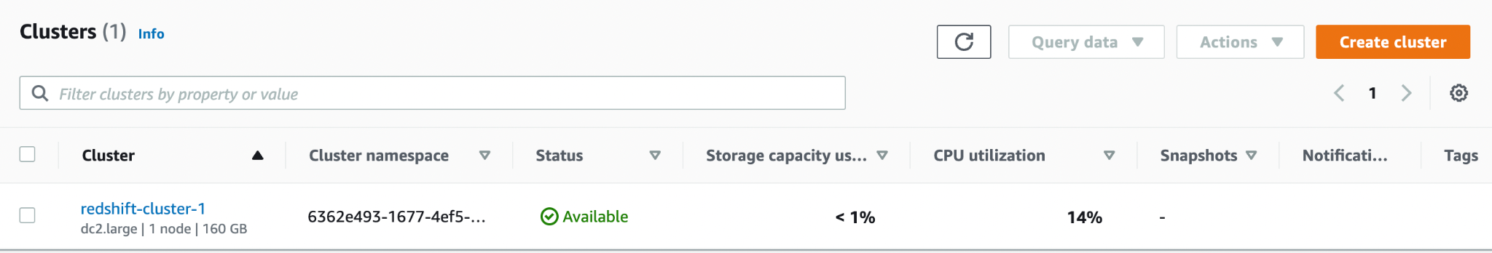

### Connection Credentials

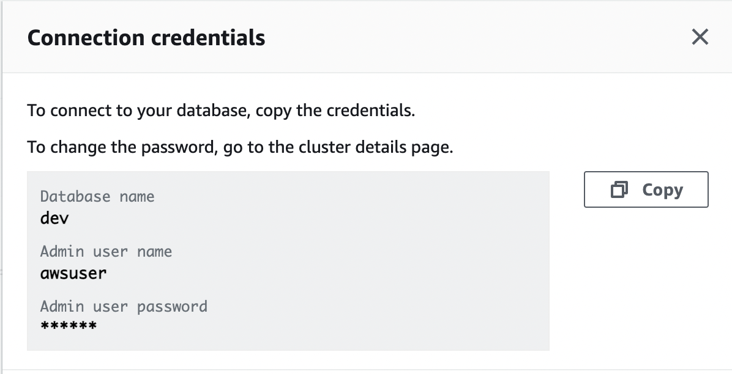

## Query Editor

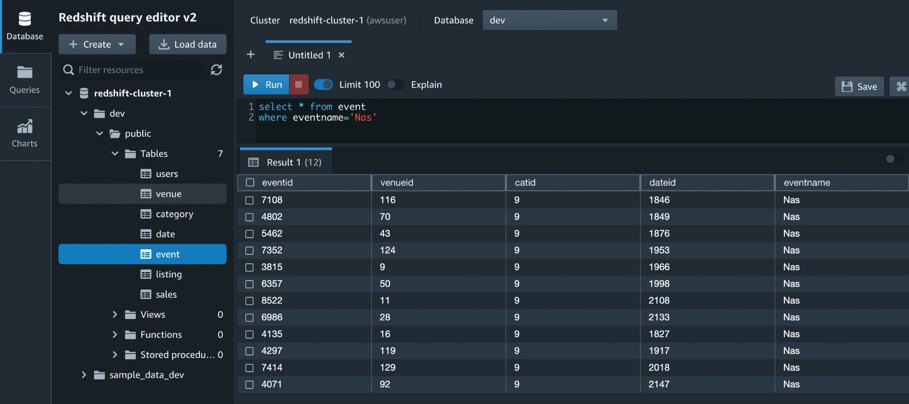

## Amazon Redshift dashboard

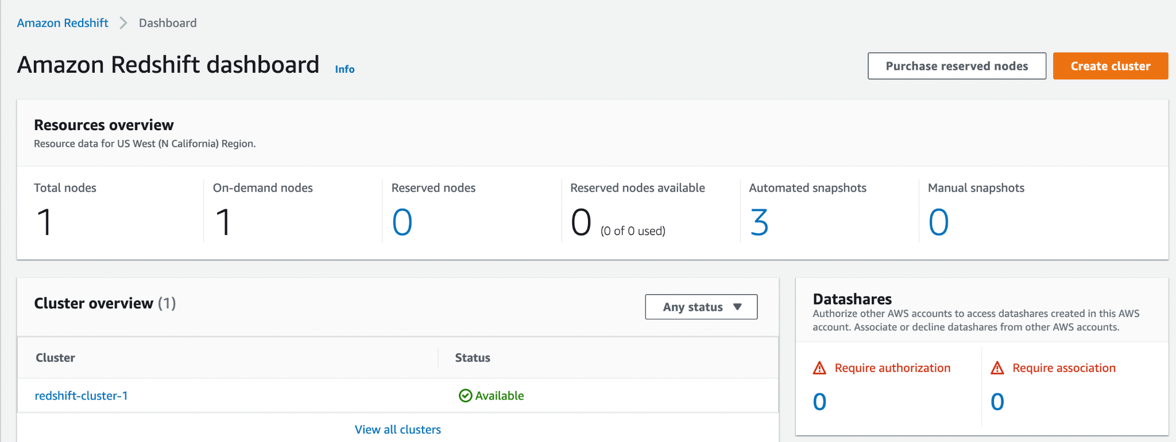

## Clusters

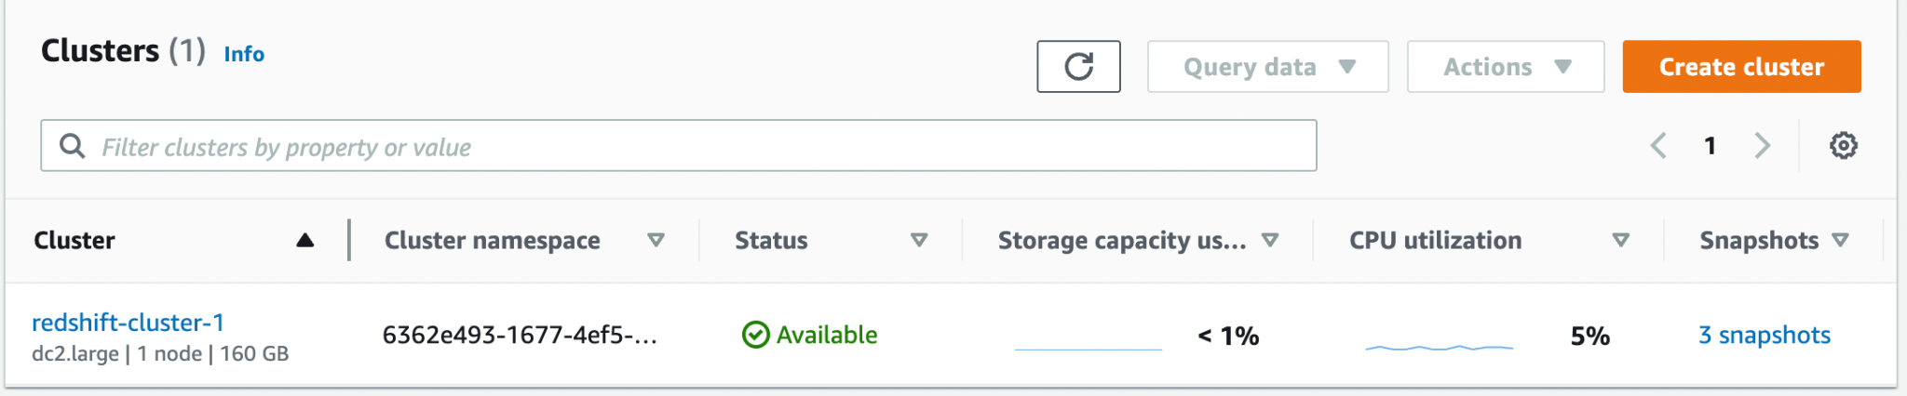

### Cluster General Information

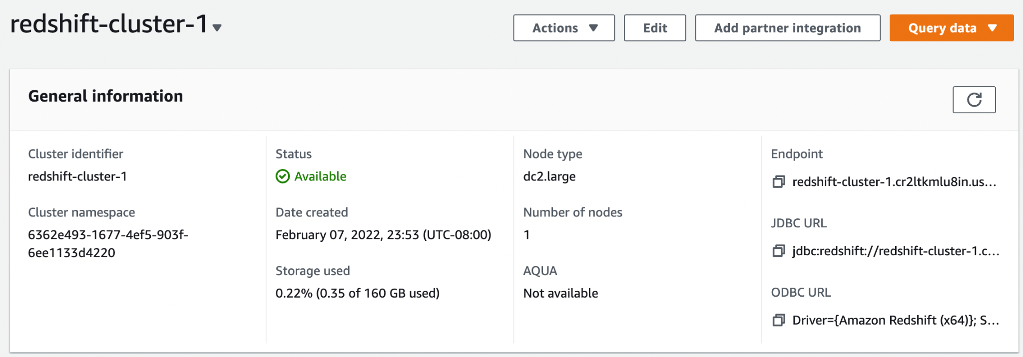

### Cluster Performance

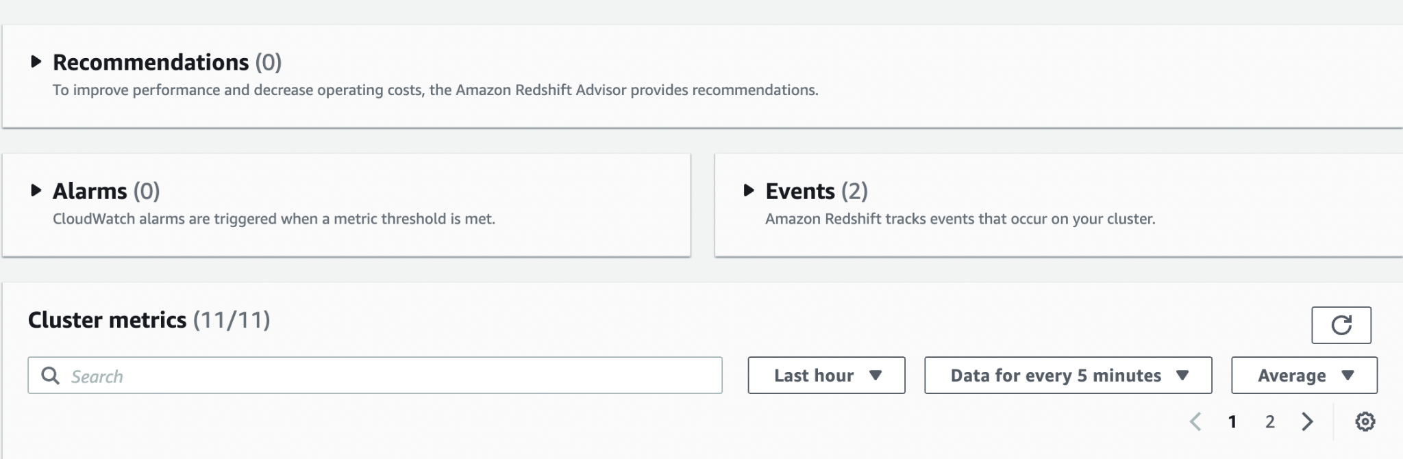

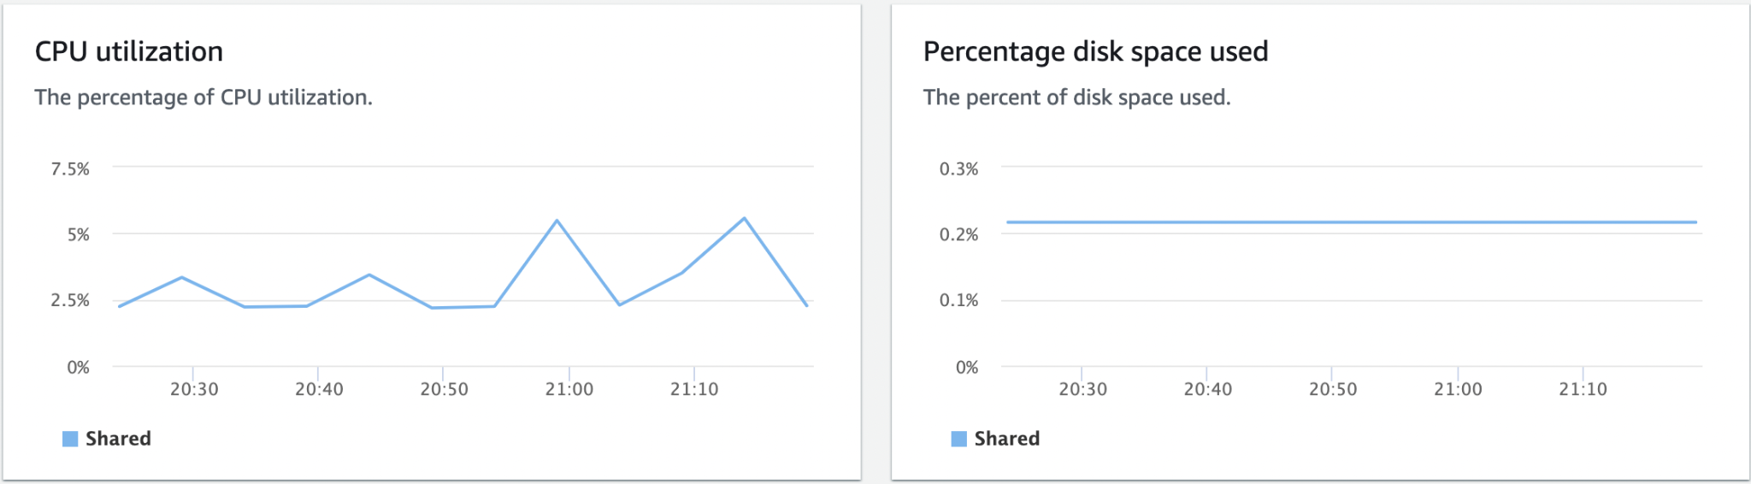

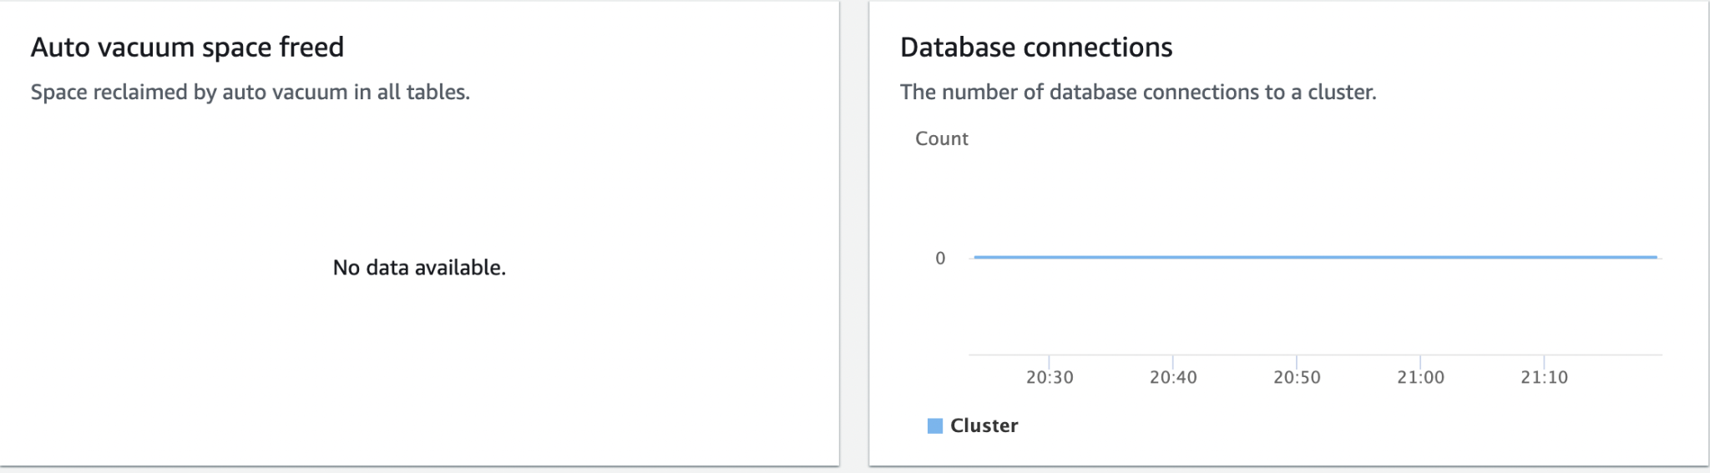

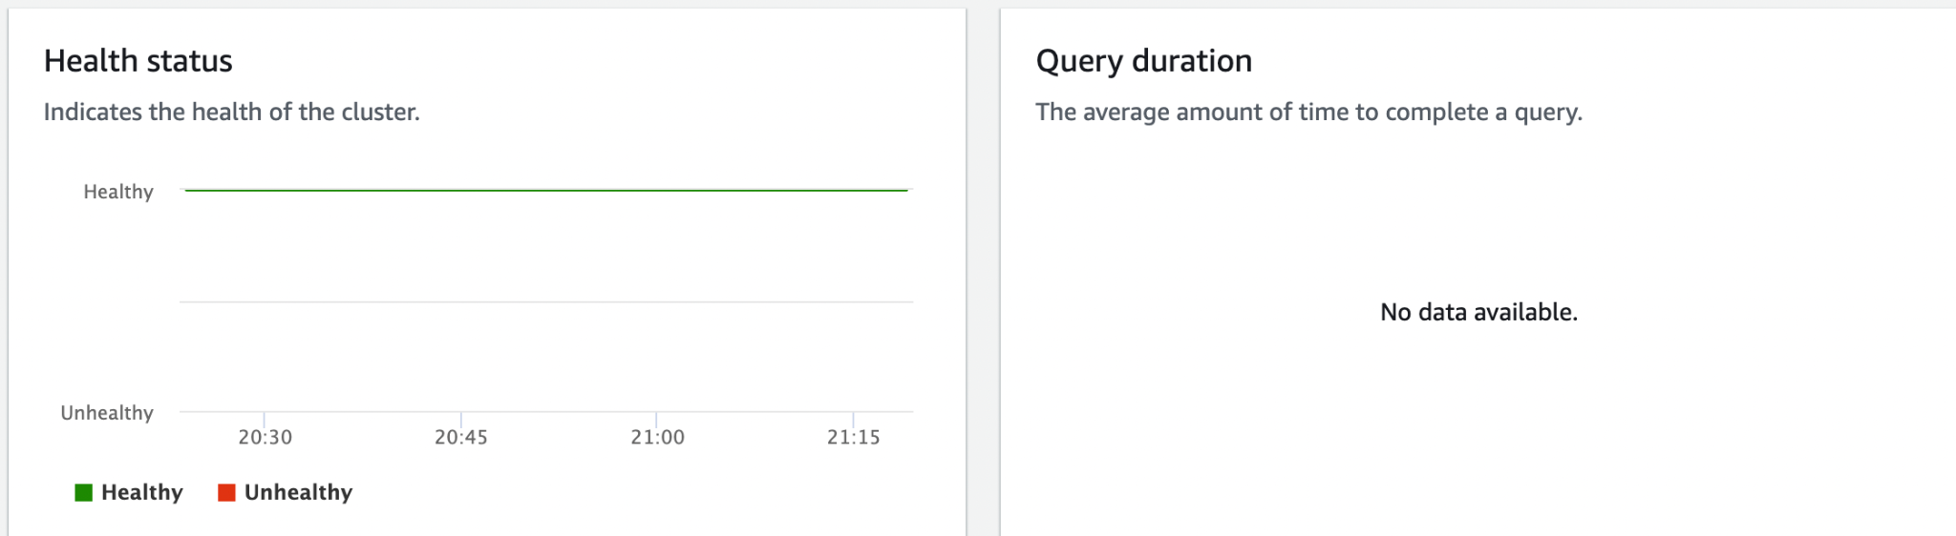

### Query Monitoring

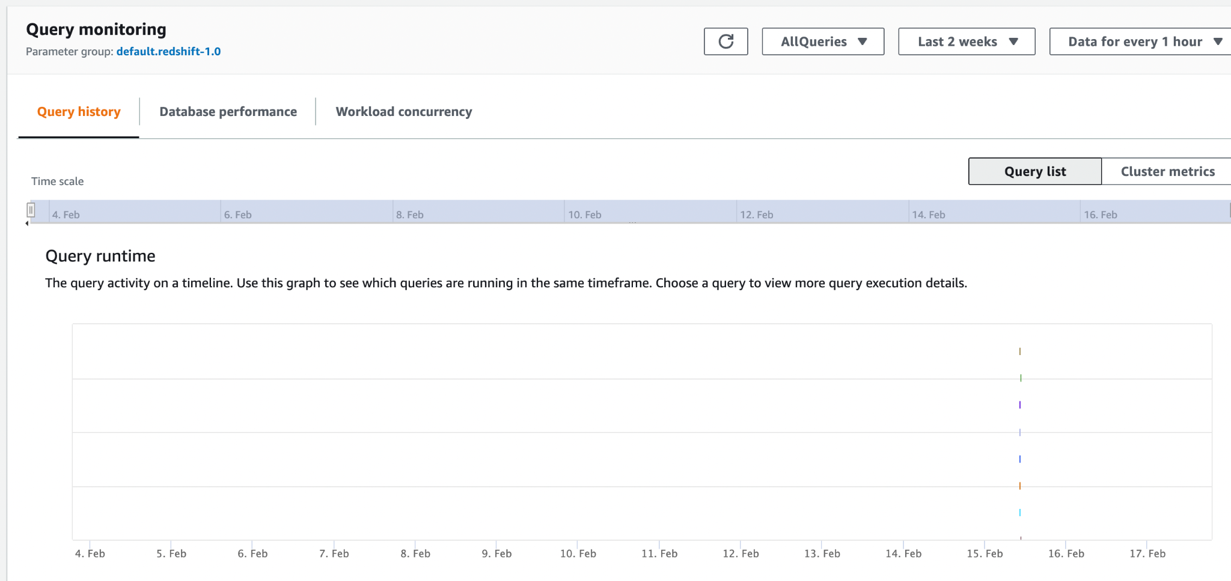

### Maintenance

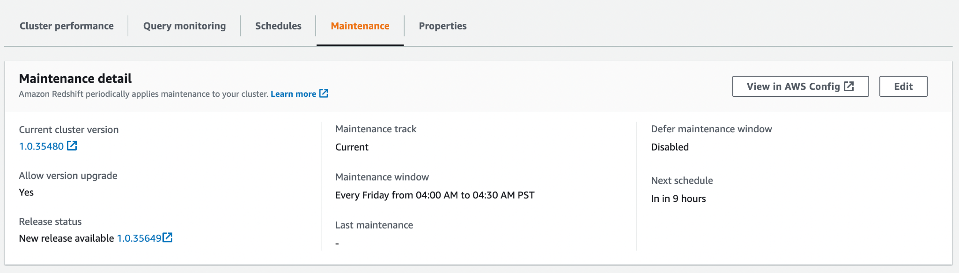

### Properties

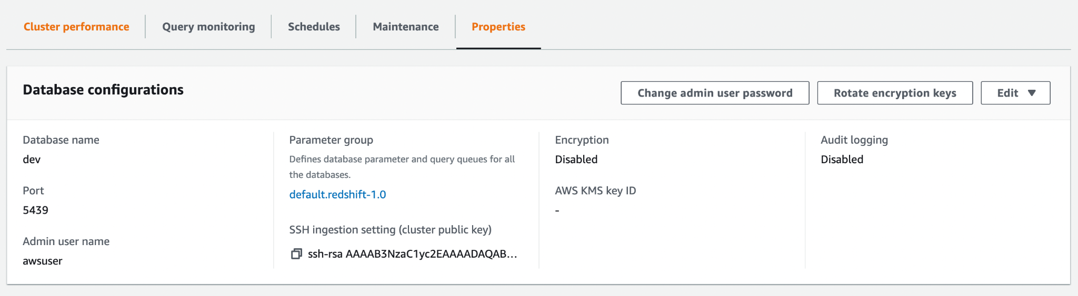

# Connecting to Amazon Redshift

## [Getting started with Amazon Redshift clusters and data loading](https://docs.aws.amazon.com/redshift/latest/gsg/data-loading.html)

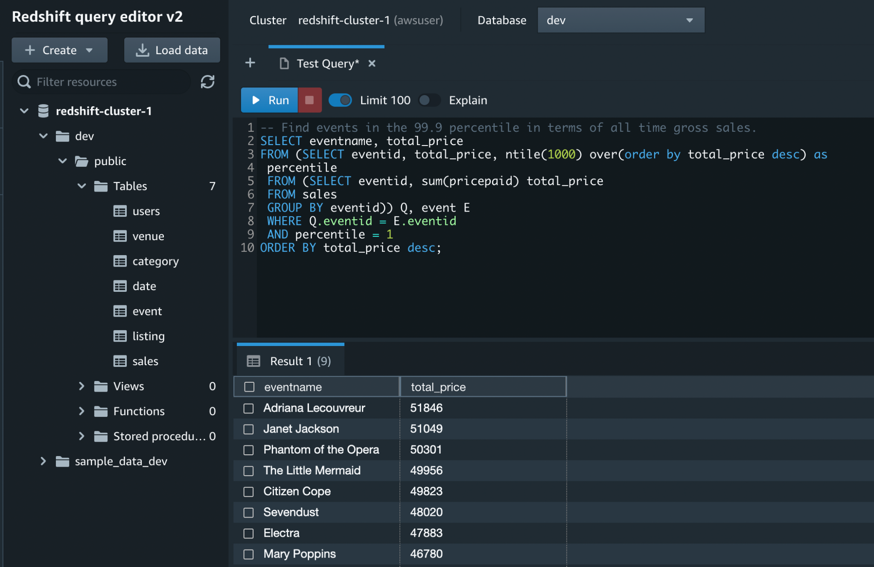

### Step 1: Create a sample Amazon Redshift Cluster

#### Creating an IAM Role

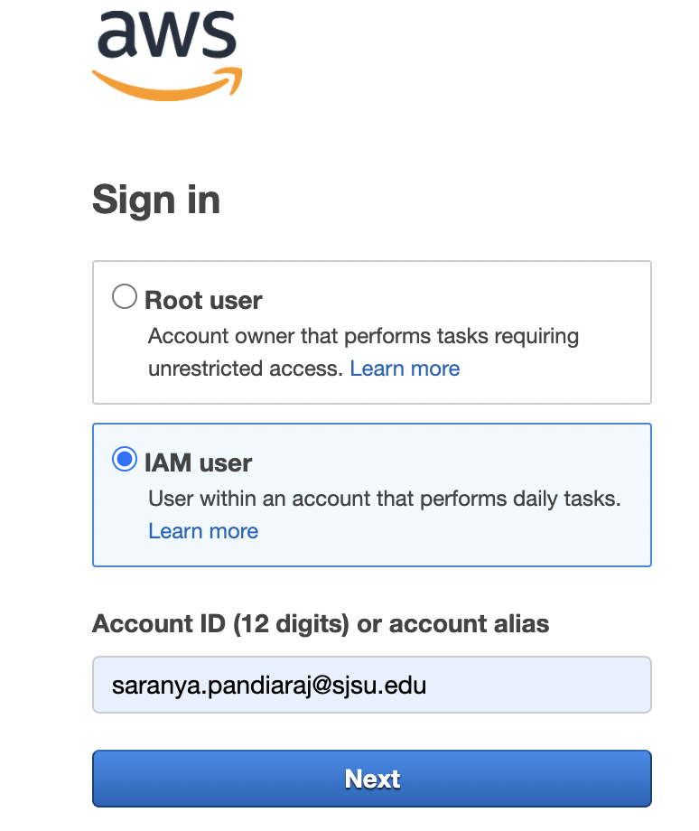

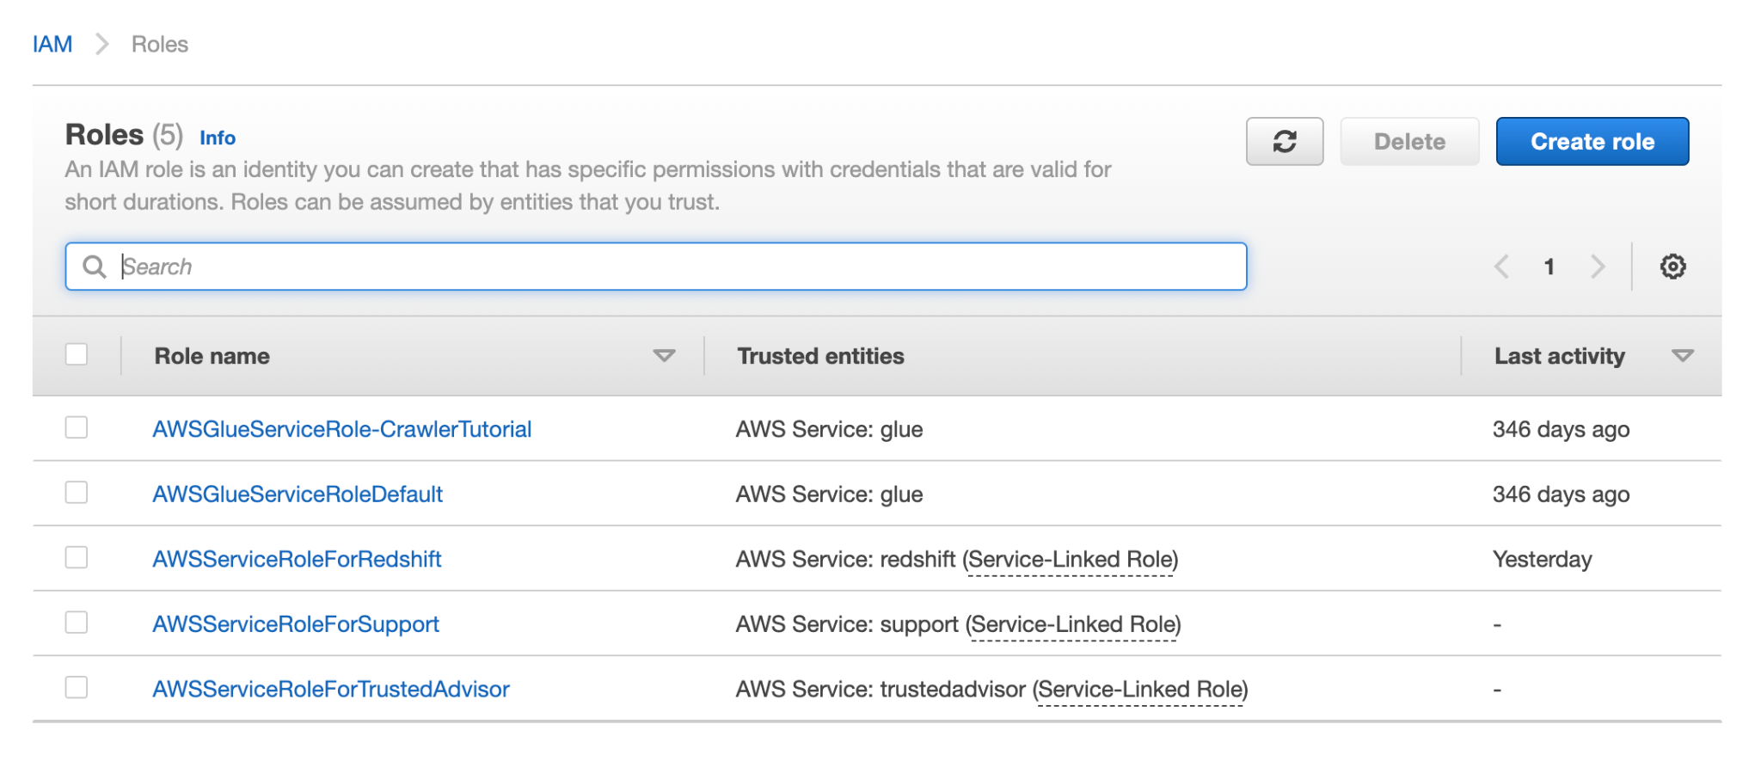

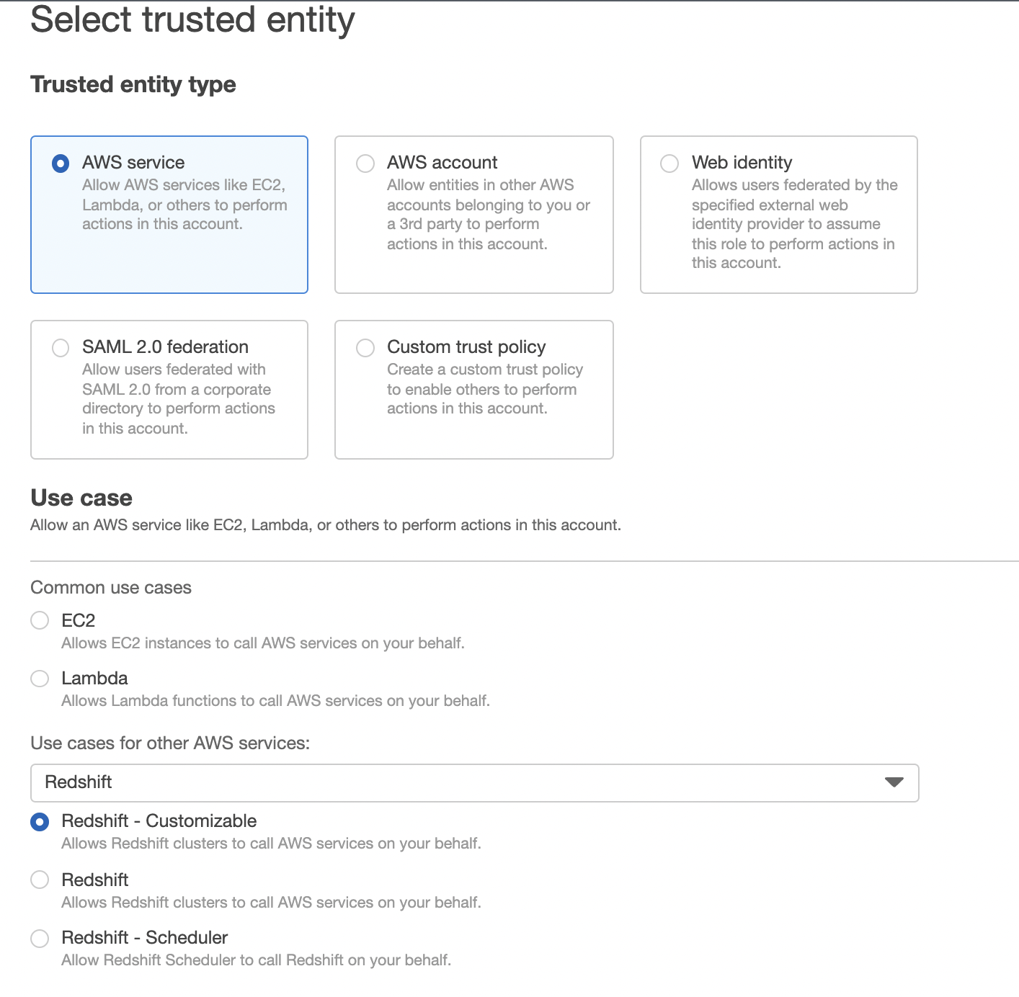

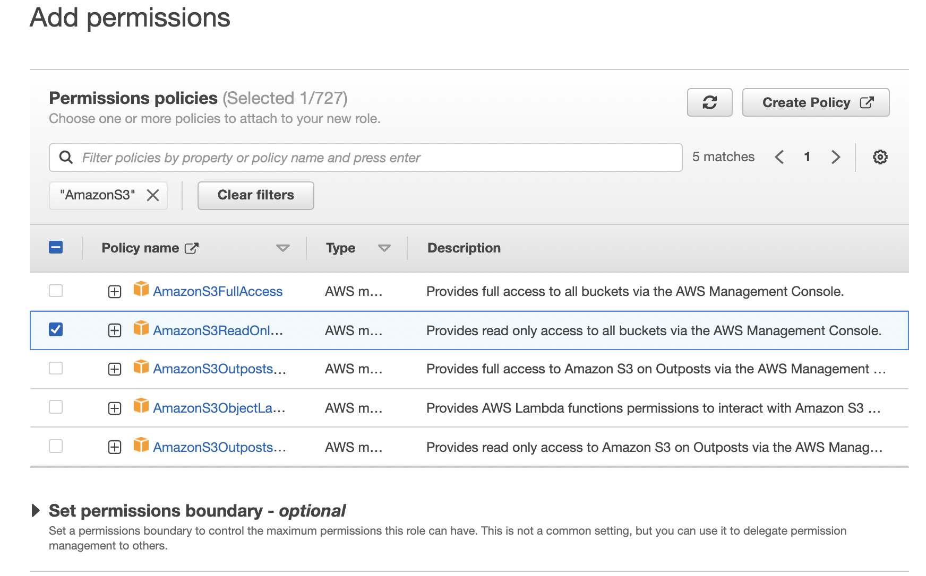

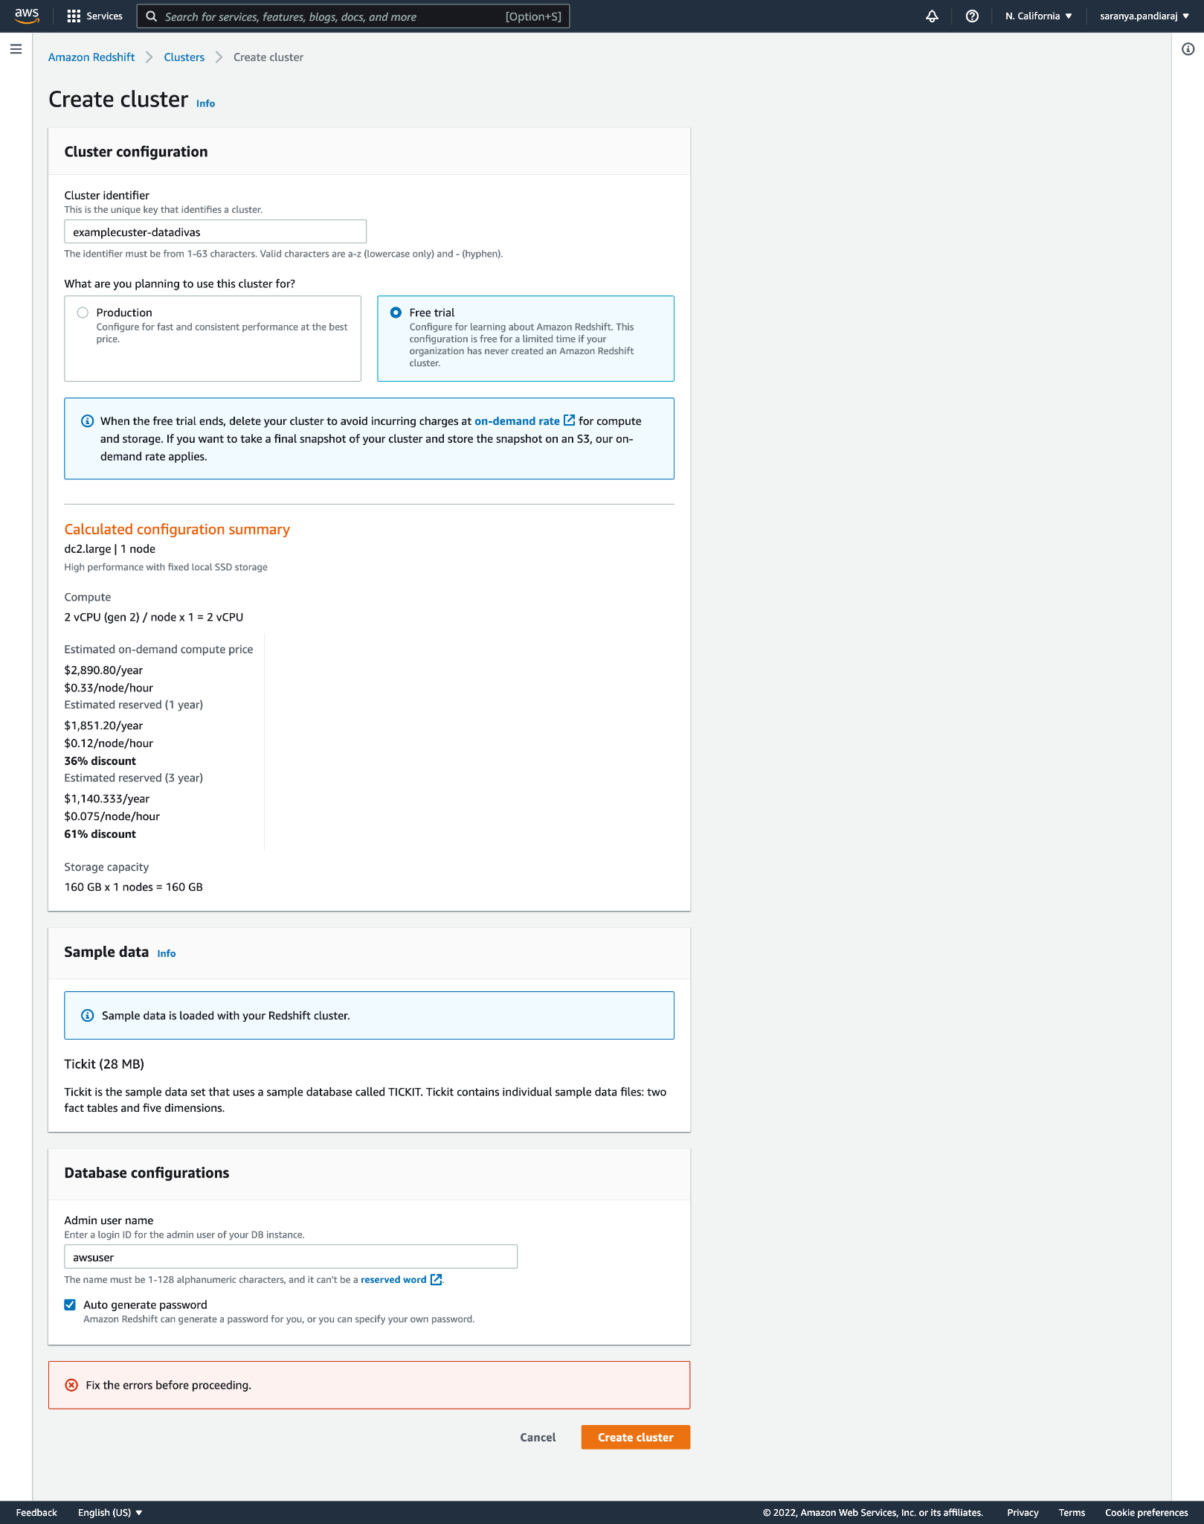

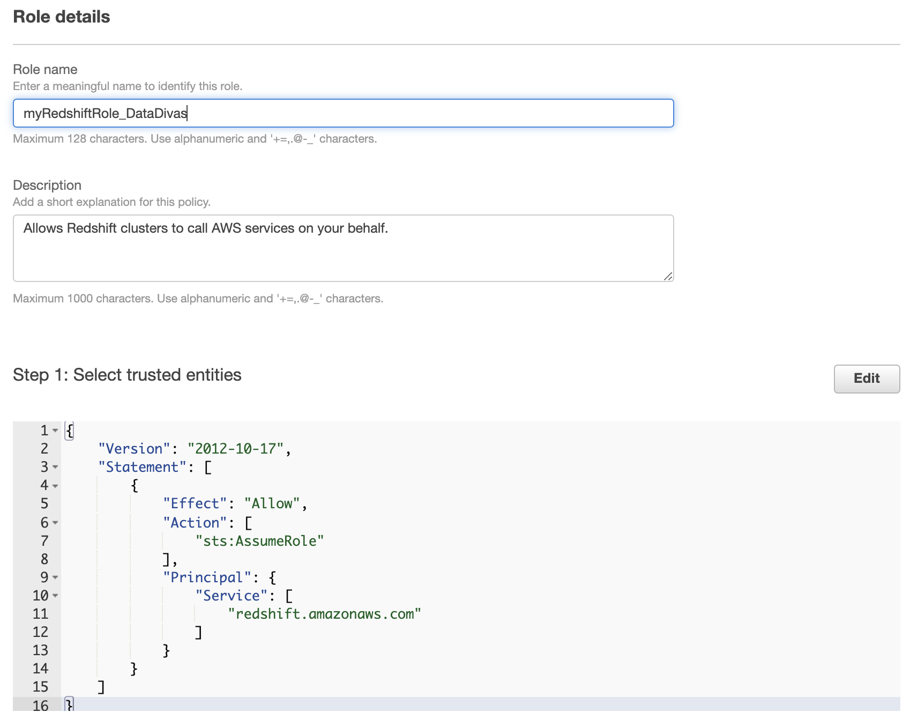

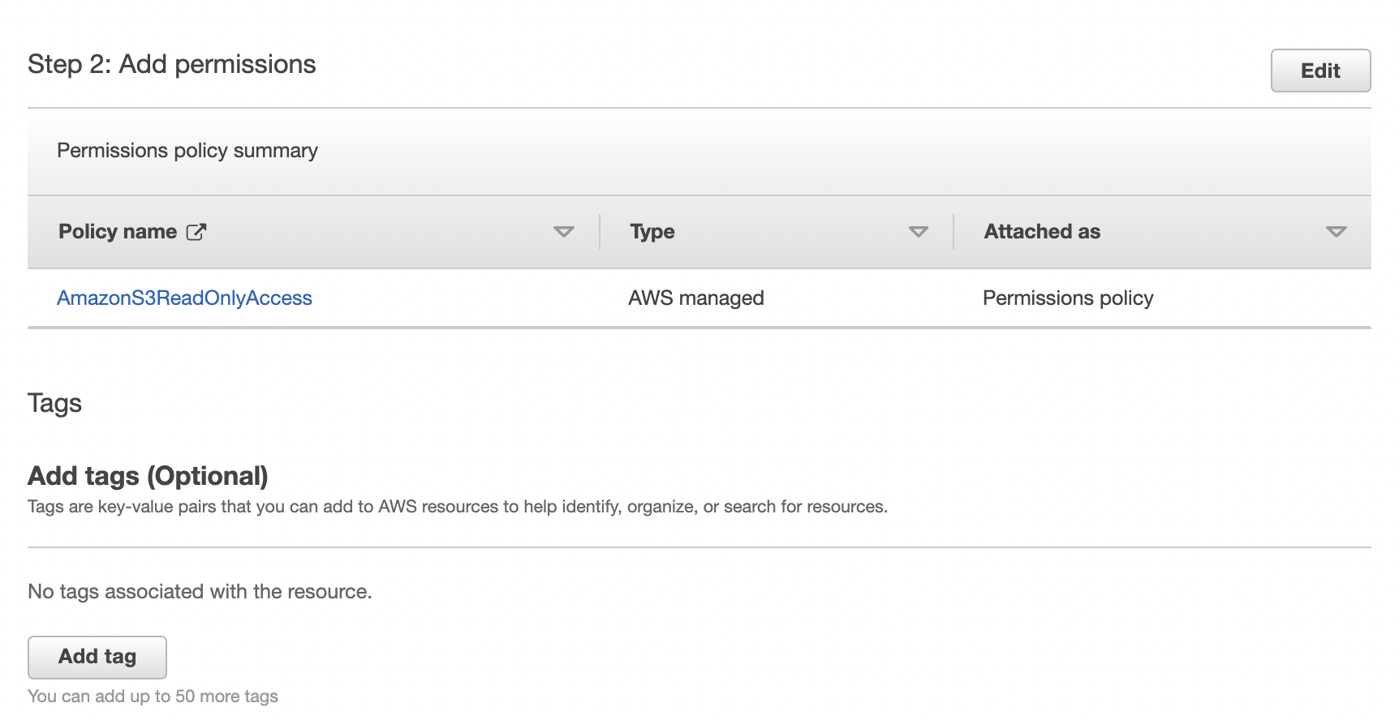

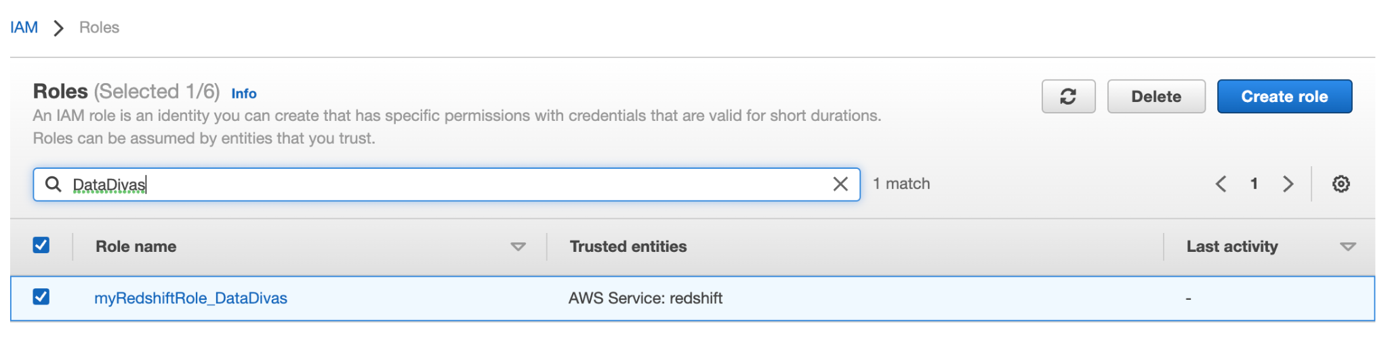

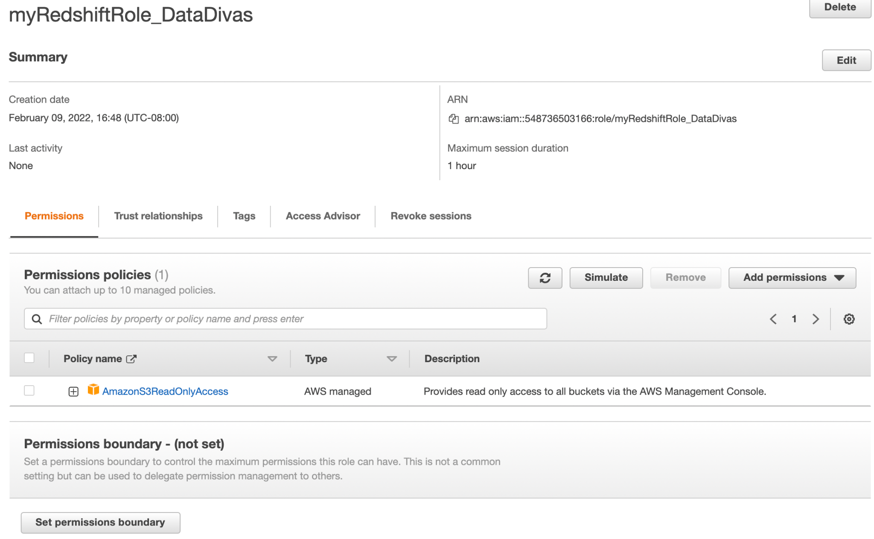

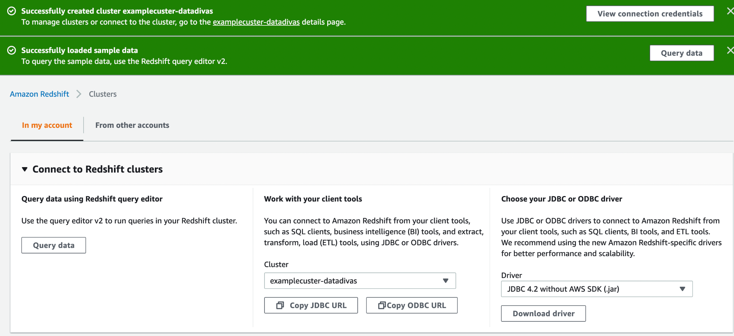

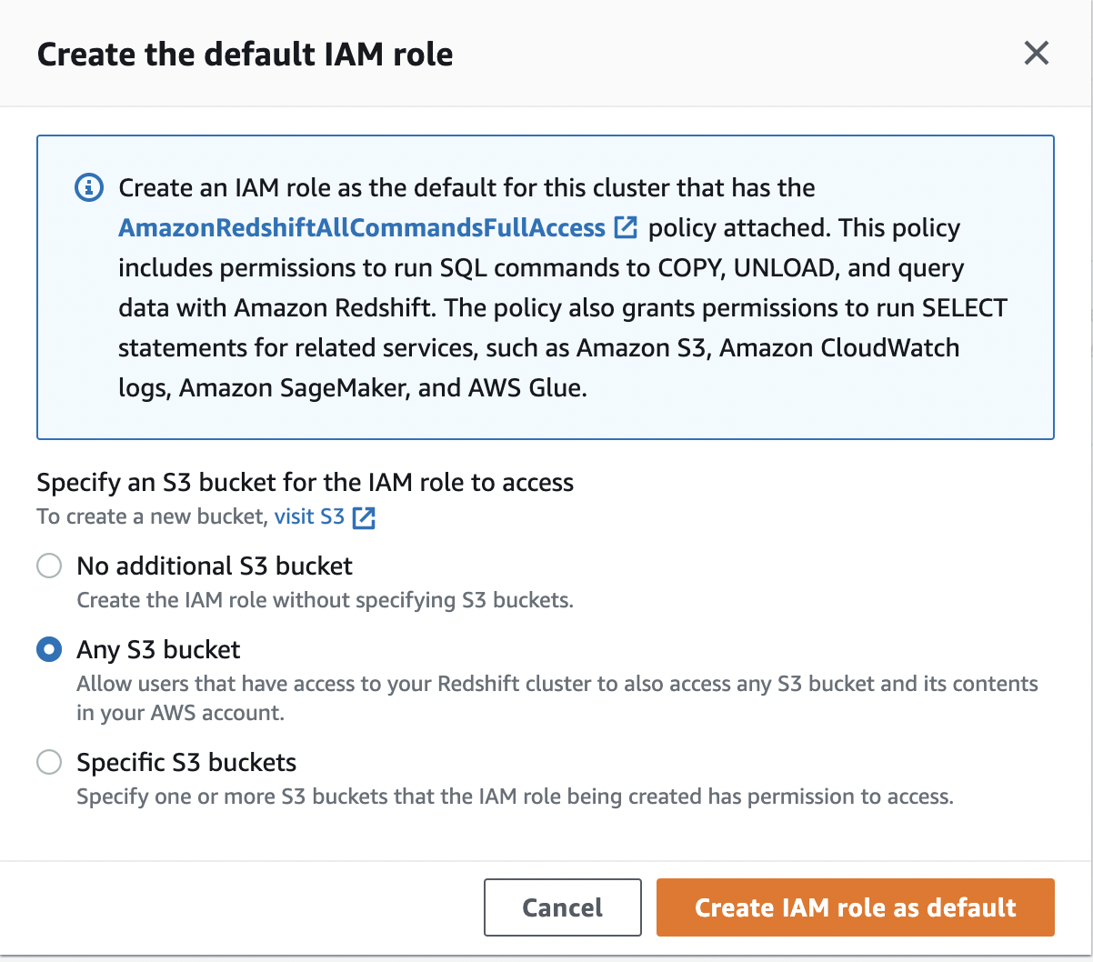

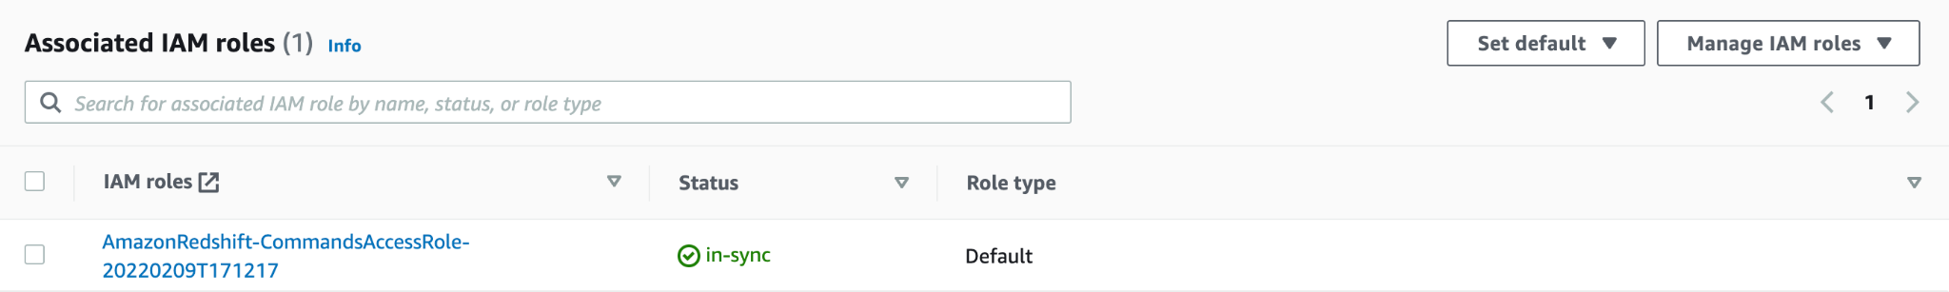

### Step 2: Configure inbound rules for SQL clients

Checking the firewall rules to see if the cluster needs to be accessed outside a firewall

### Step 3: Grant access to one of the query editors and run queries

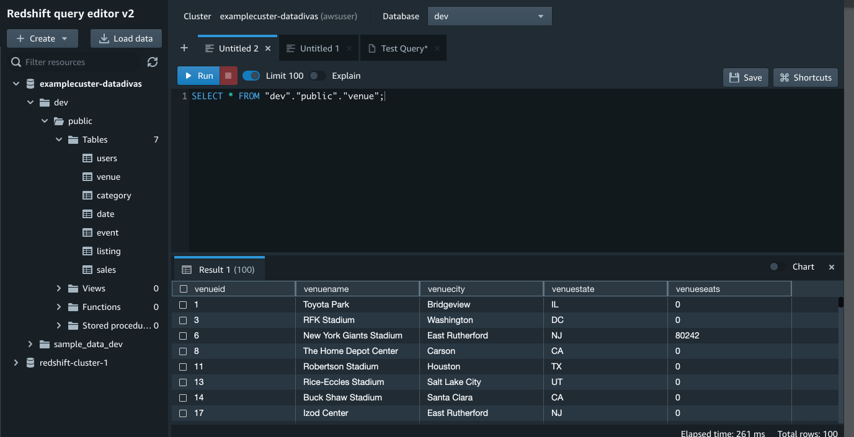

### Step 4: Load data from Amazon S3 to Amazon Redshift

Used the sample data which came from the free tier

### Step 5: Trying example queries using the query editor

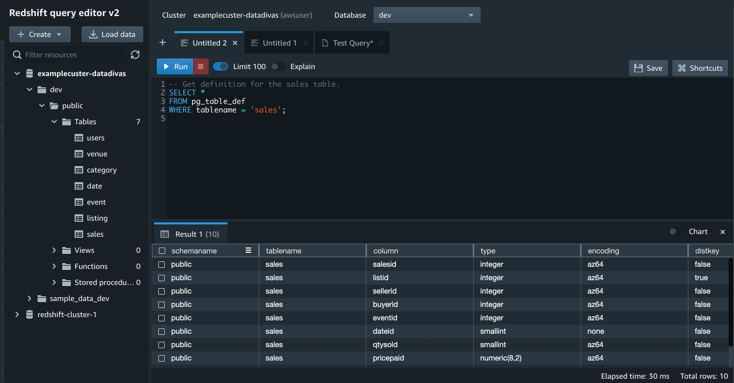

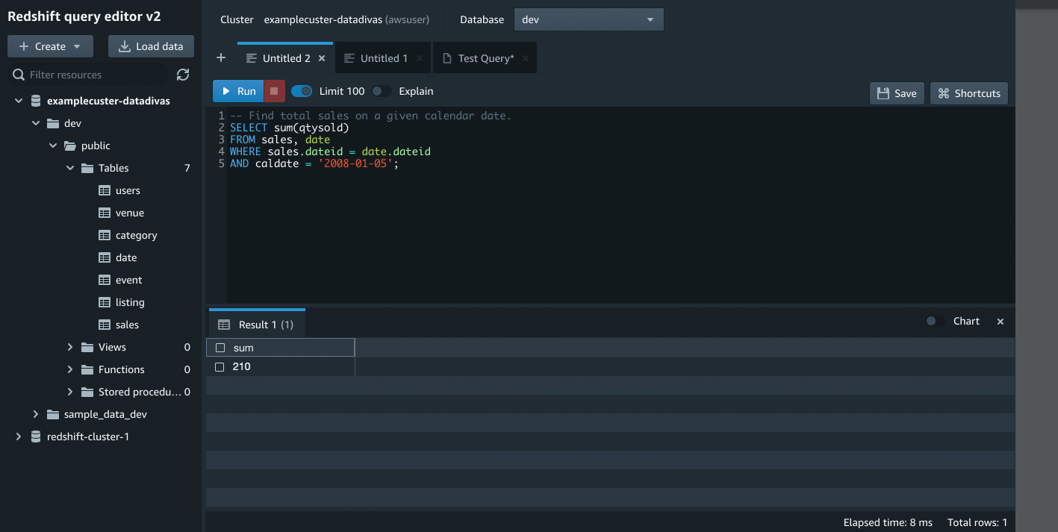

### Step 6: Reset your environment

Select Cluster and click Delete.

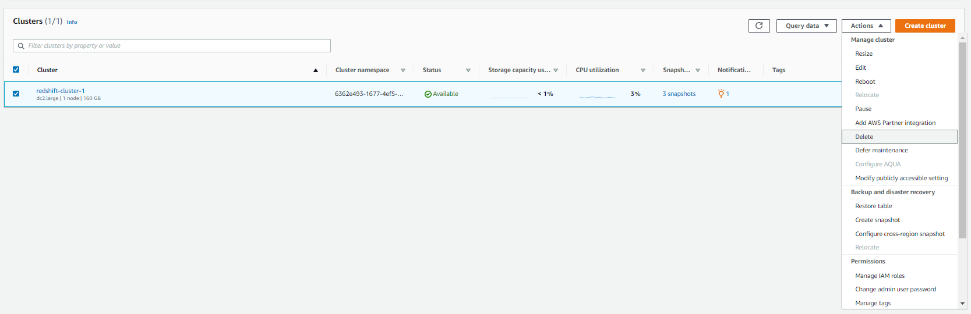

Type Delete in the Input Confirmation field and press Enter.

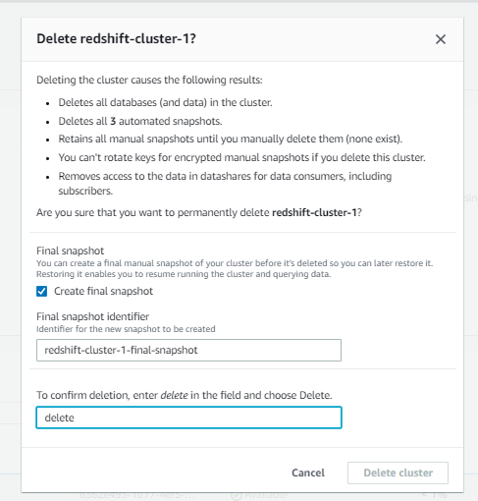

Click Delete.



## Getting started with common database tasks

### Task 1: Create a database

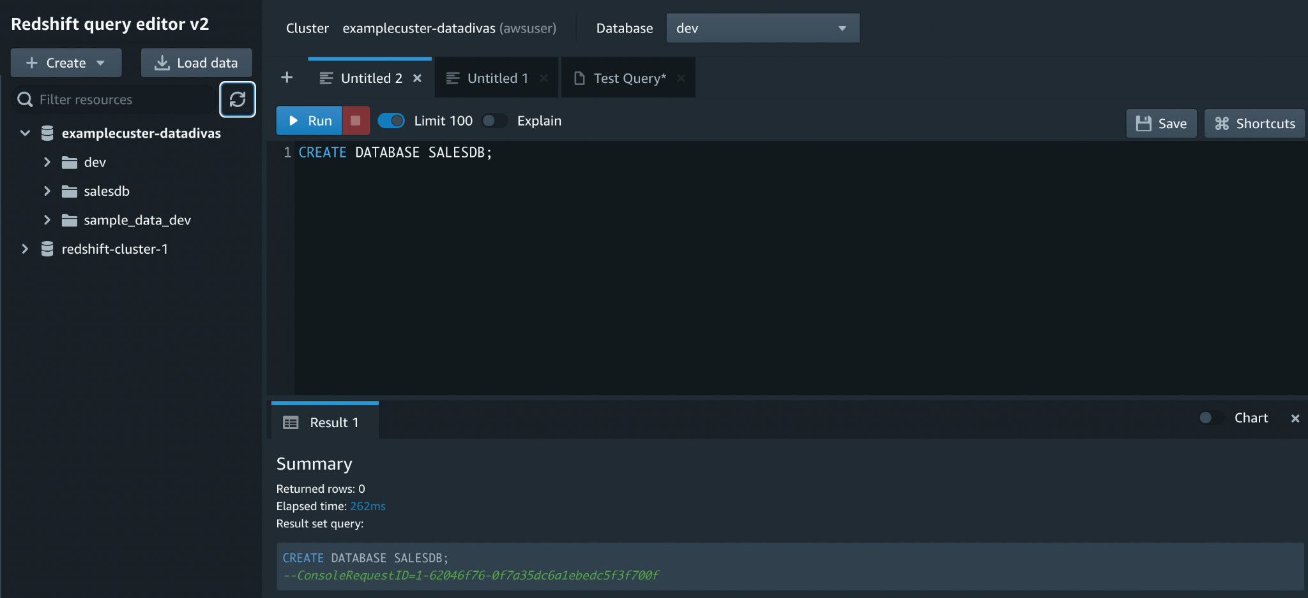

**Task 2: Create a user**

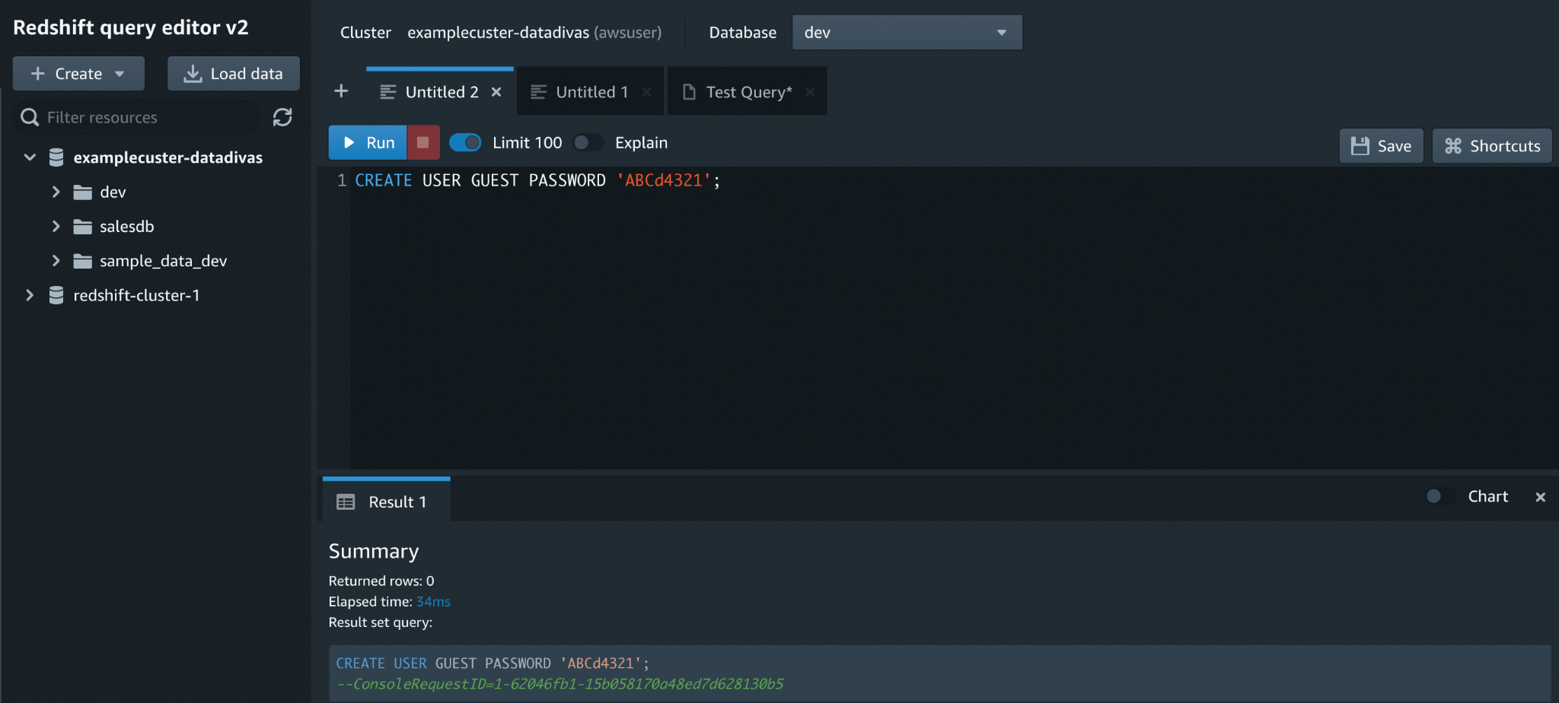

### Task 3: Create a schema

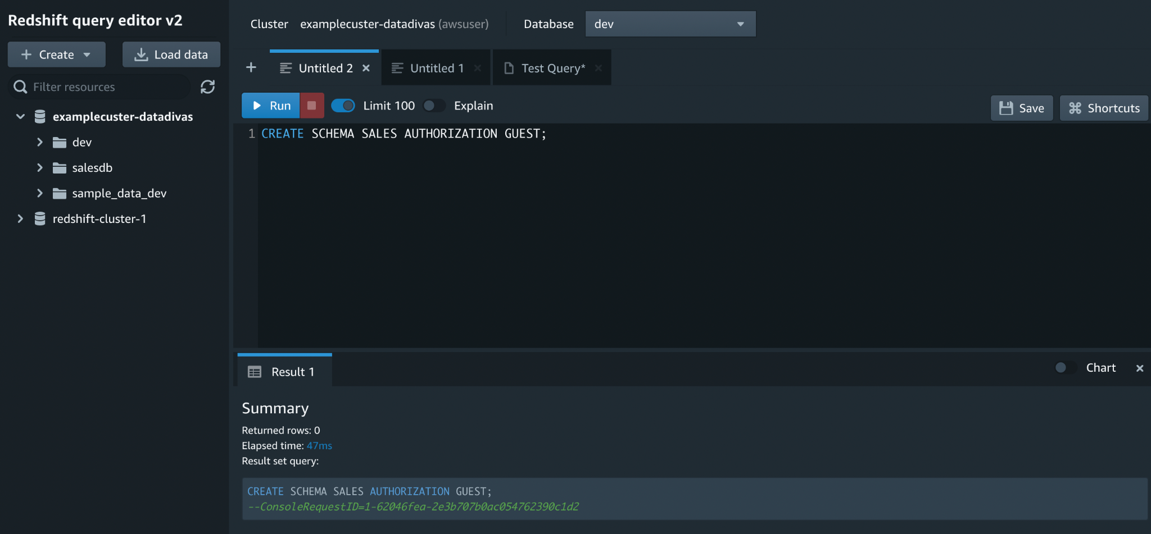

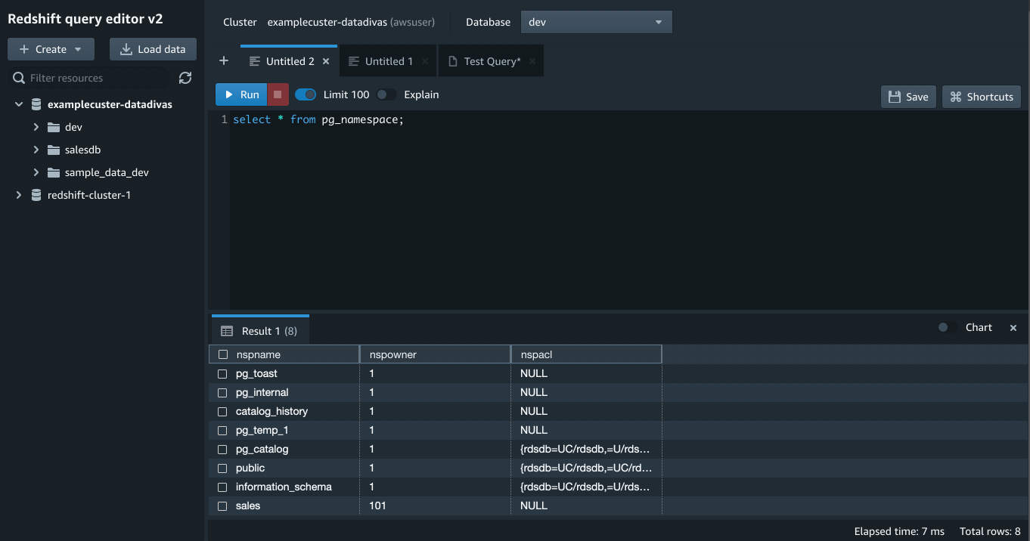

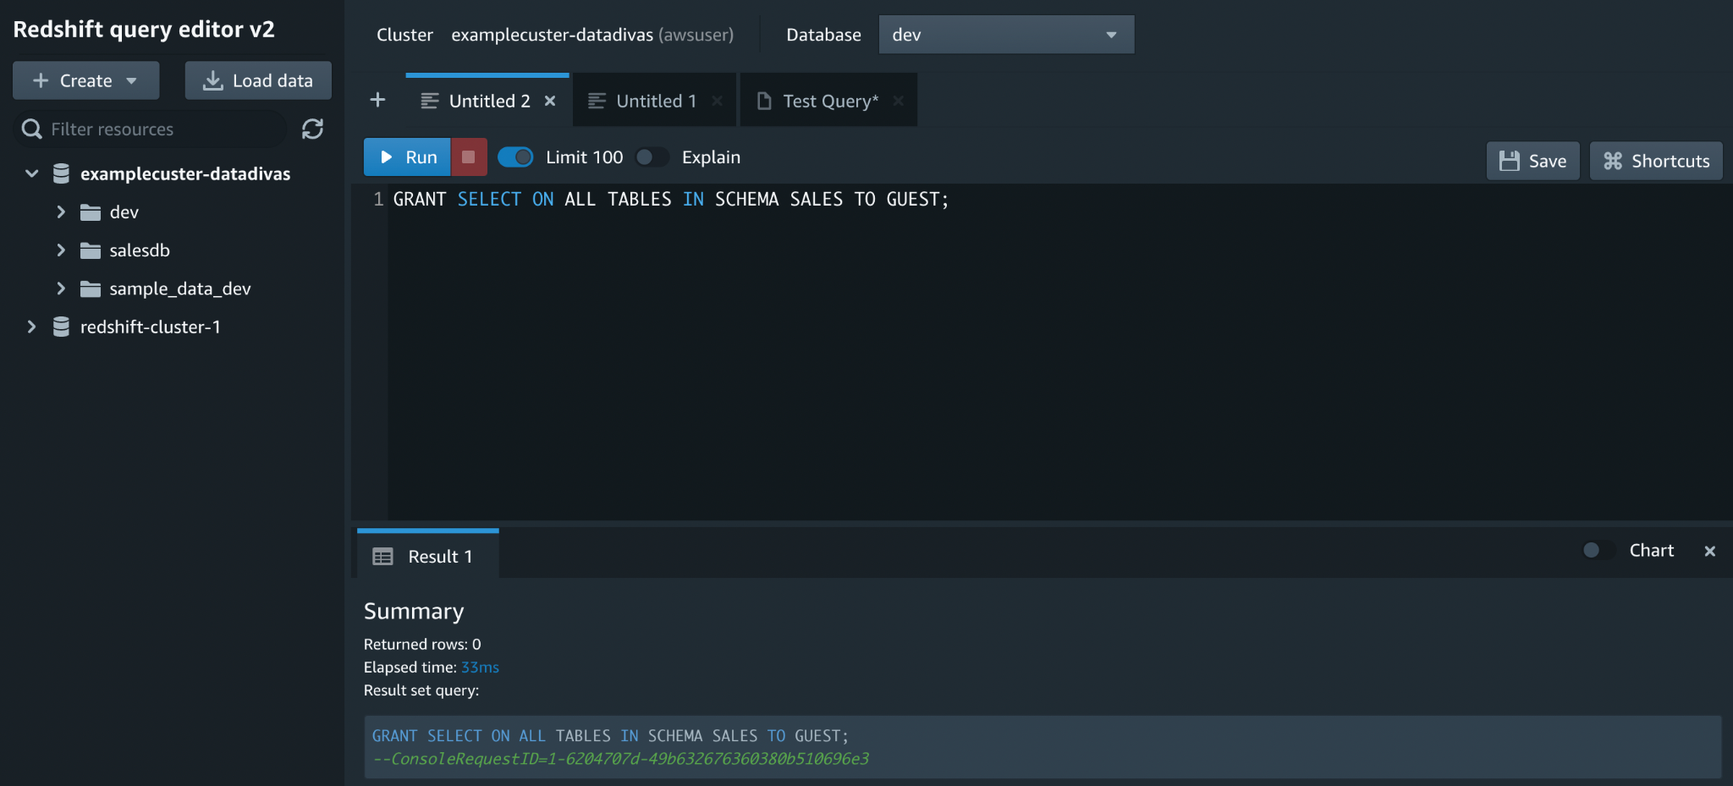

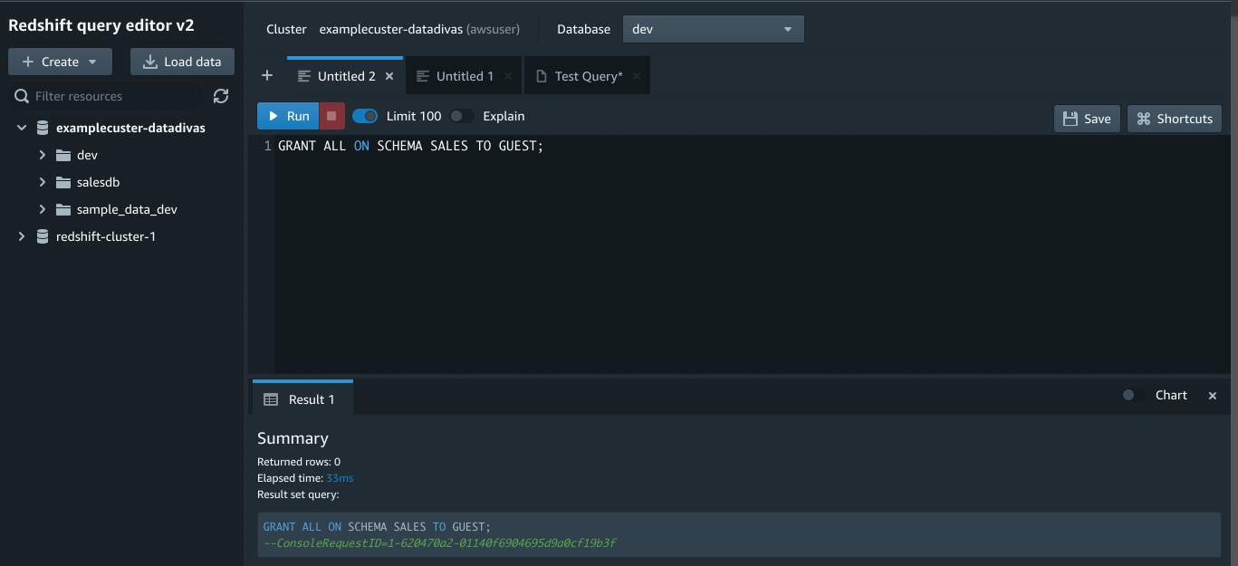

### Task 4: Create a table

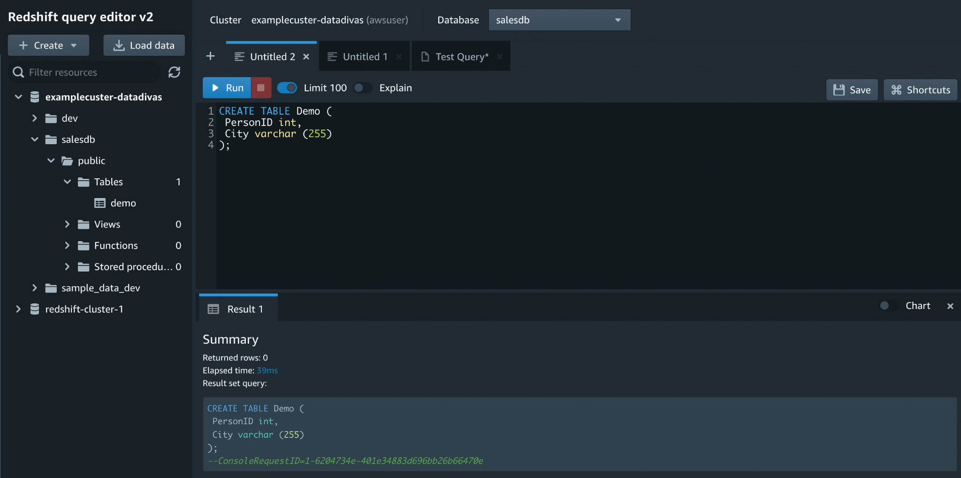

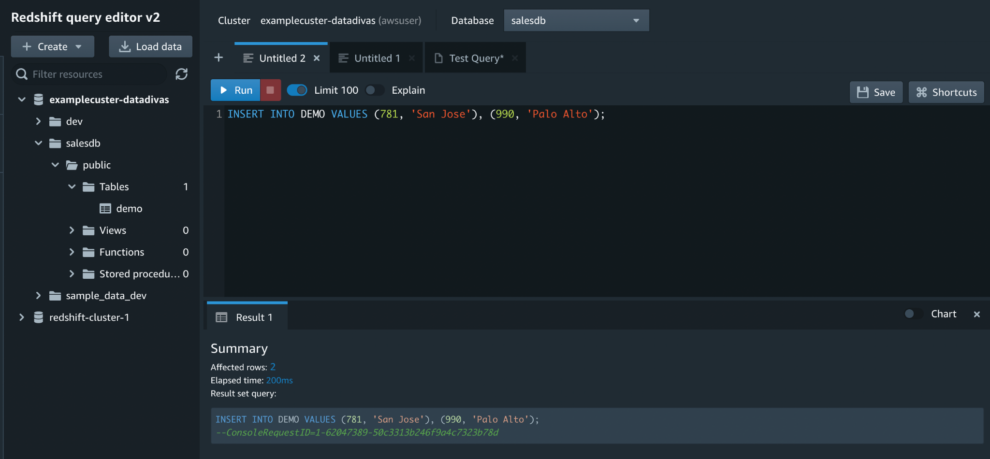

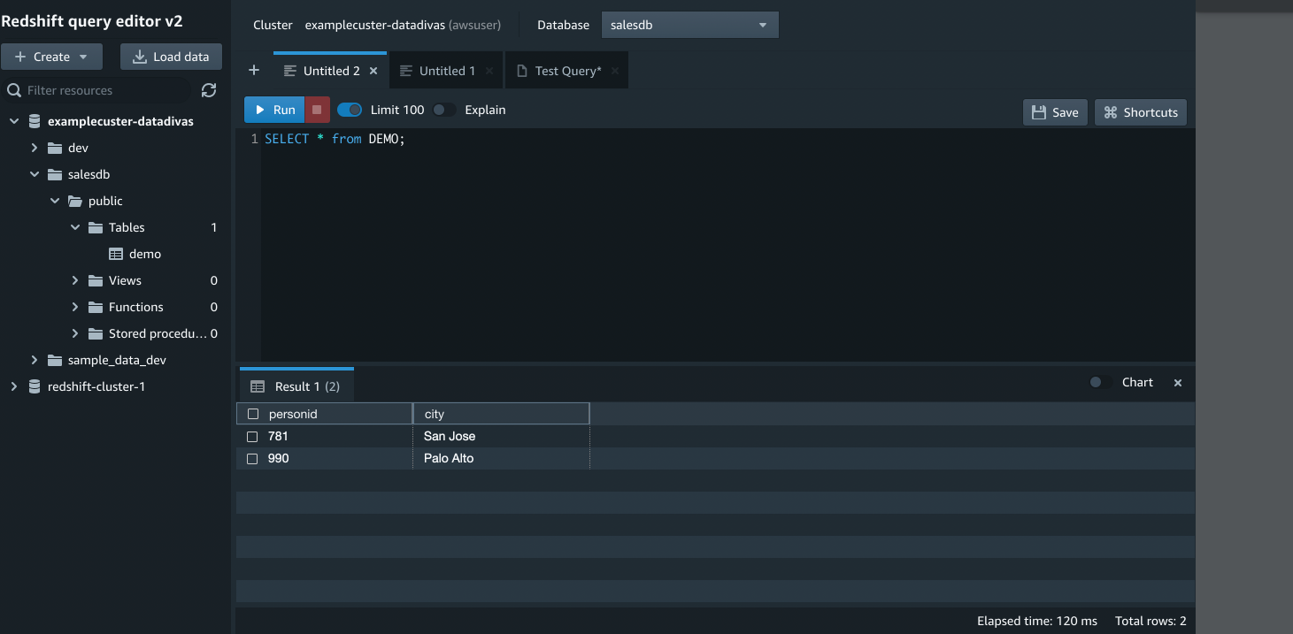

### Task 5: Load sample data

#### Creating Bucket

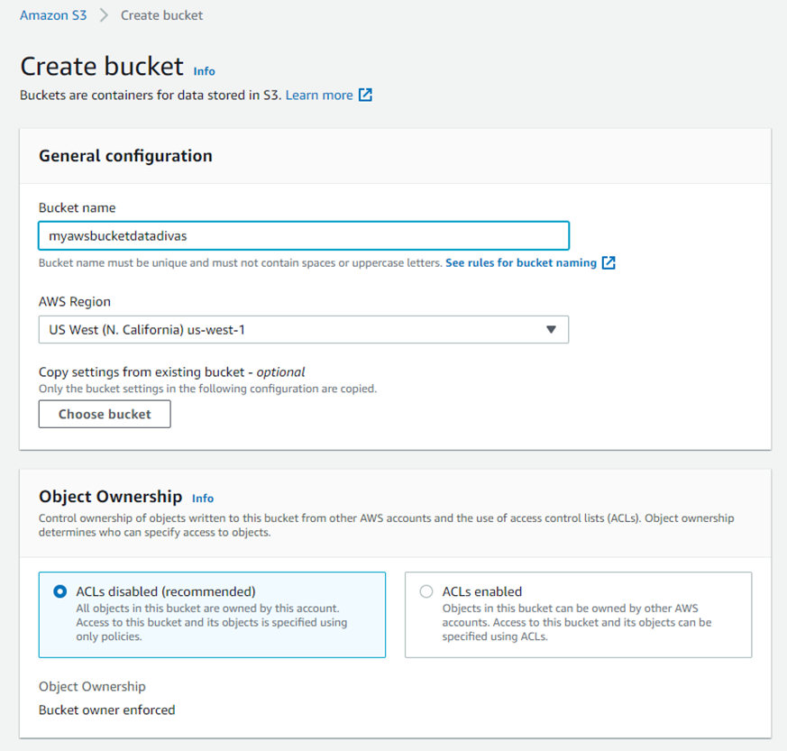

#### Upload your data to your Bucket

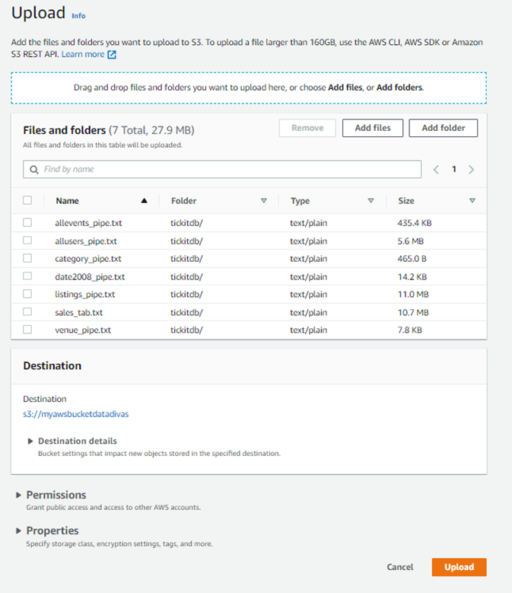

#### Uploading in Progress

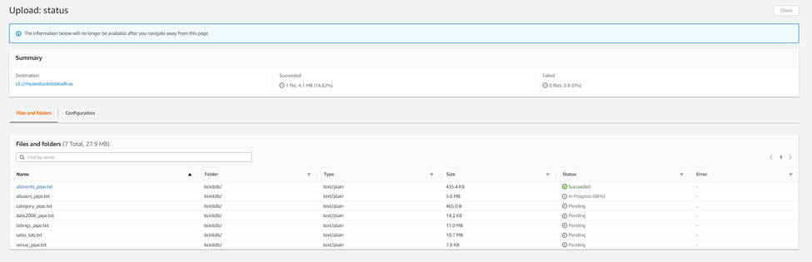

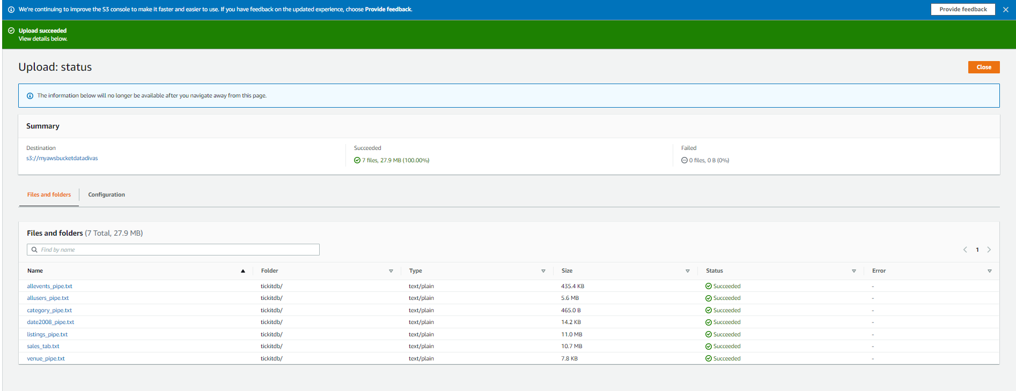

#### Associate IAM Role to cluster

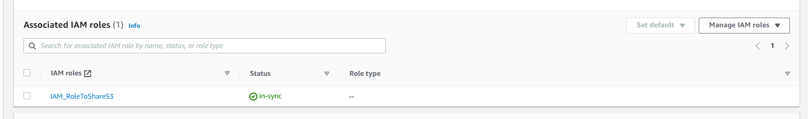

#### Create a table by clicking on



1. Load from CSV
2. Browse
3. Select File
4. Select Schema
5. Enter your Table Name.

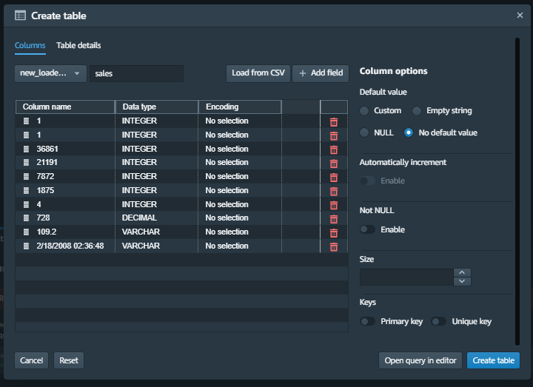

#### Click Load Data

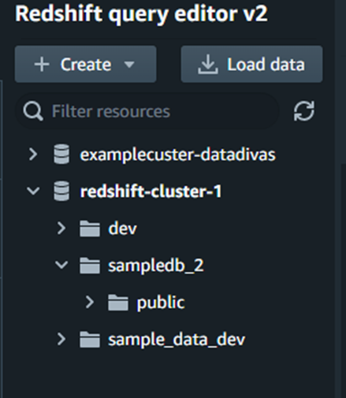

#### Browse S3

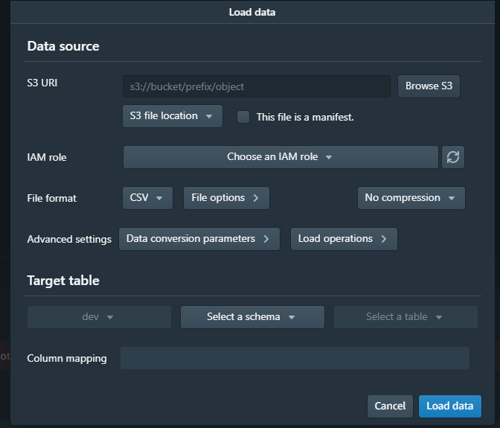

#### Select your data file

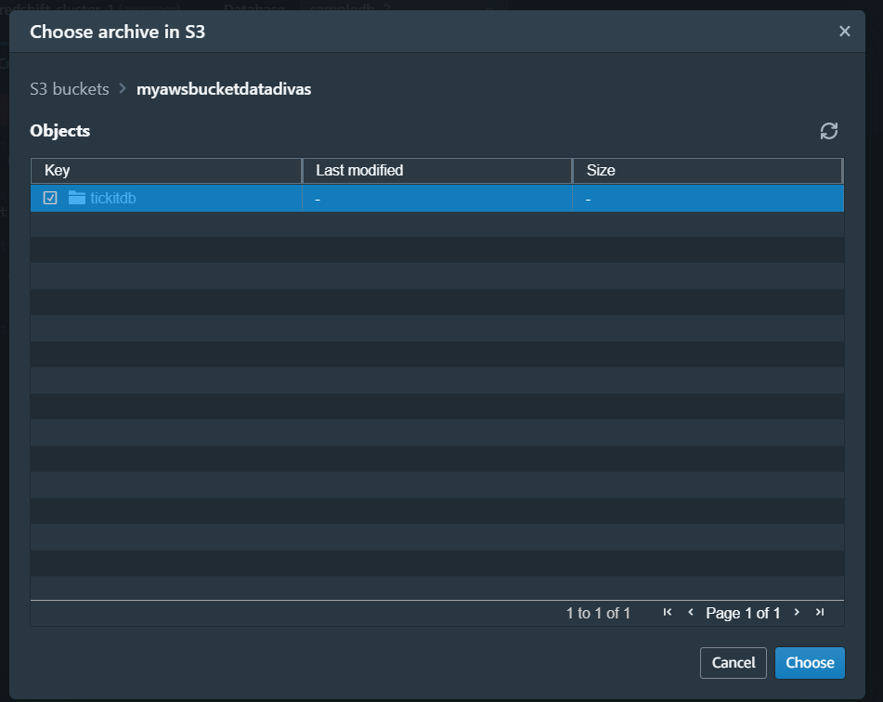

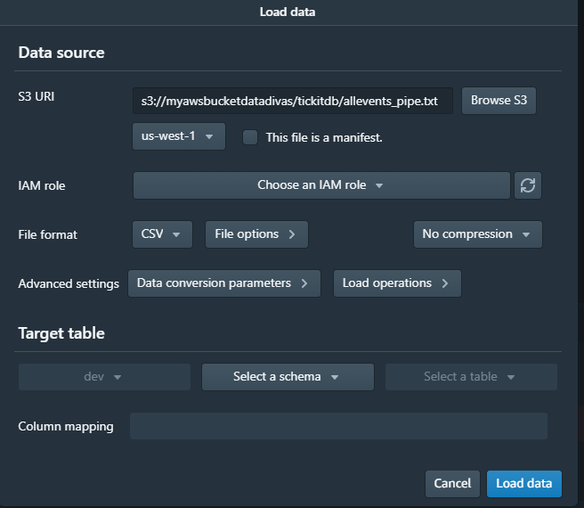

#### Choose IAM Role

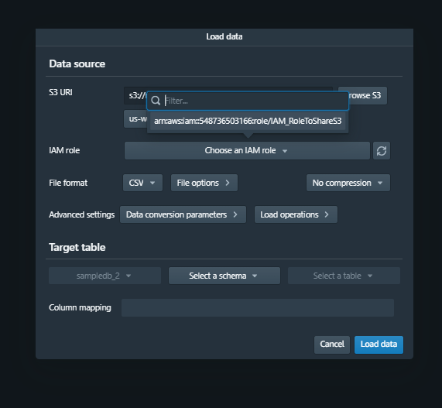

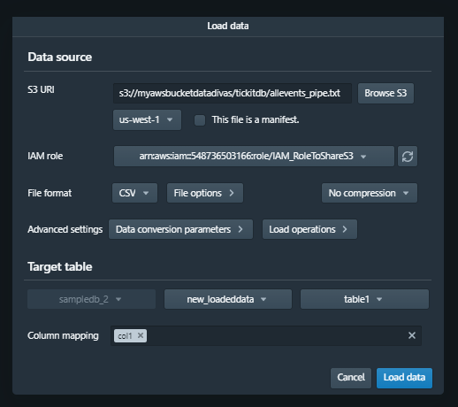

1. Select Schema
2. Select Table to which you want to copy data from S3 Bucket
3. Then click Load Data.

#### Successfully loaded from S3 Bucket to Database

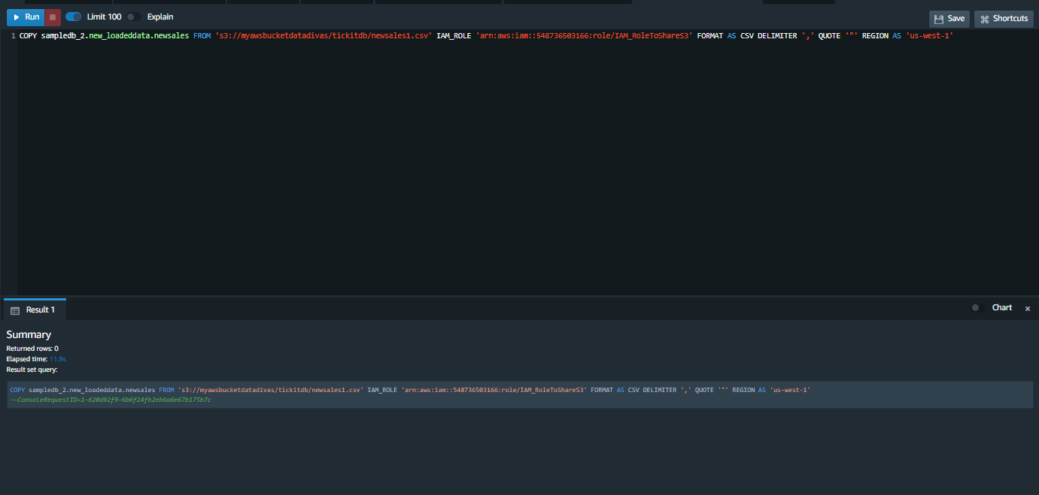

#### After Loading Data to Table

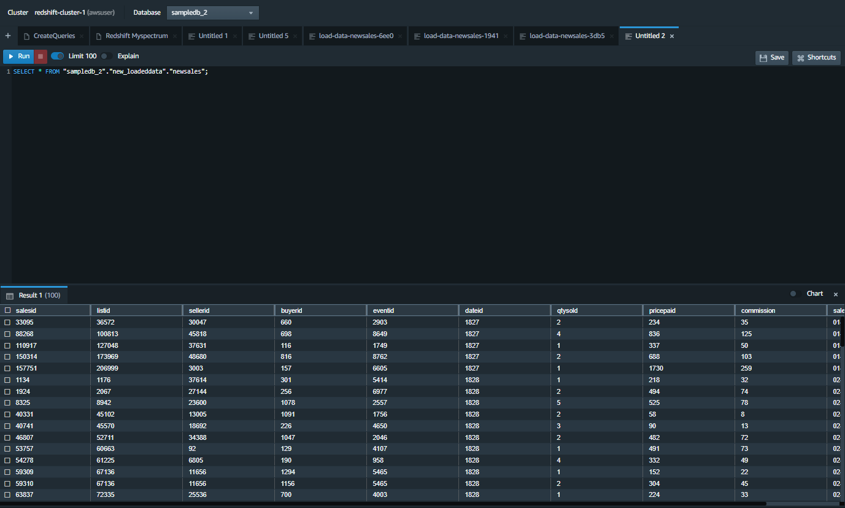

### Task 6: Query the system tables

To view a list of all tables in schema

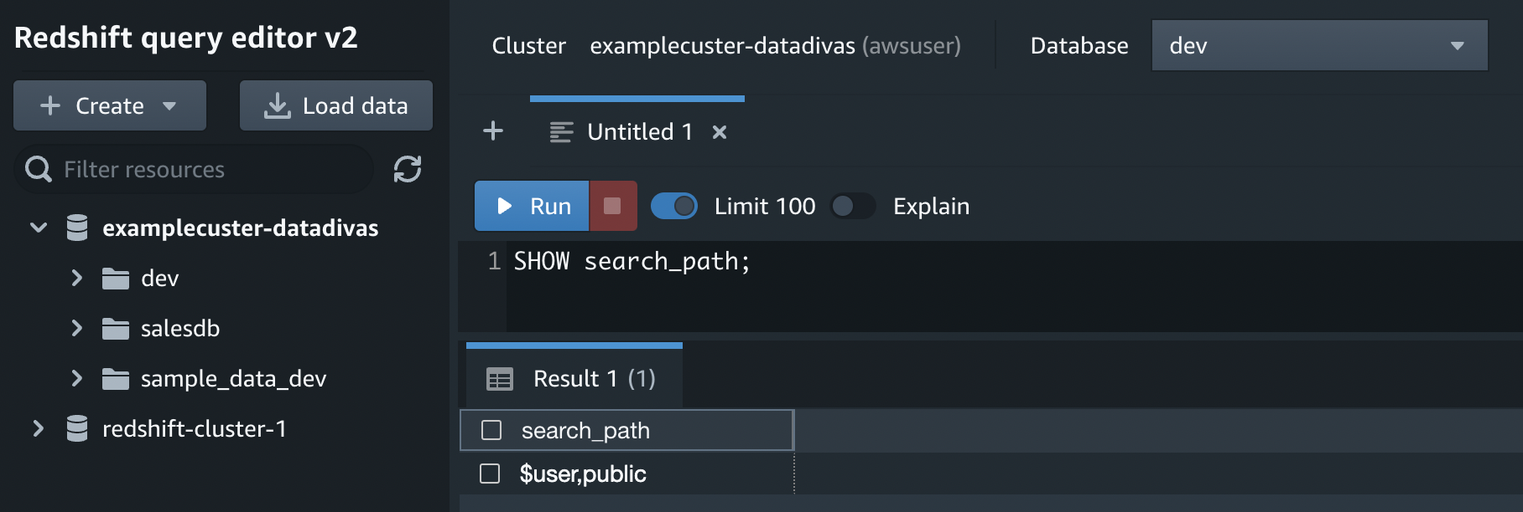

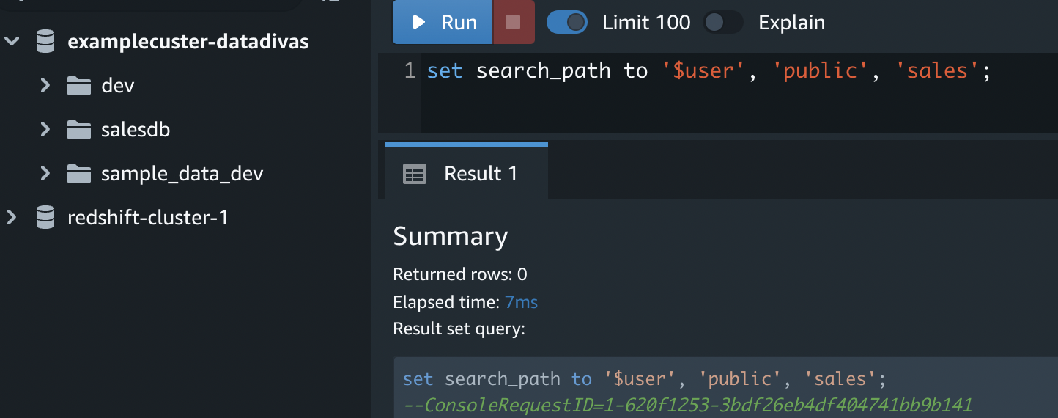

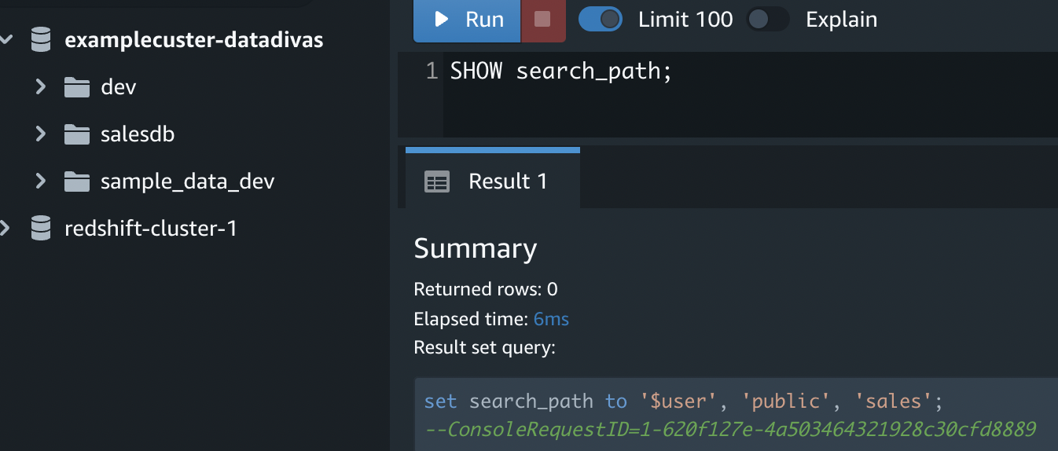

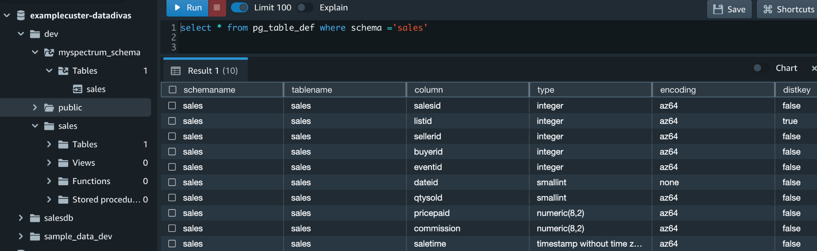

**View users**

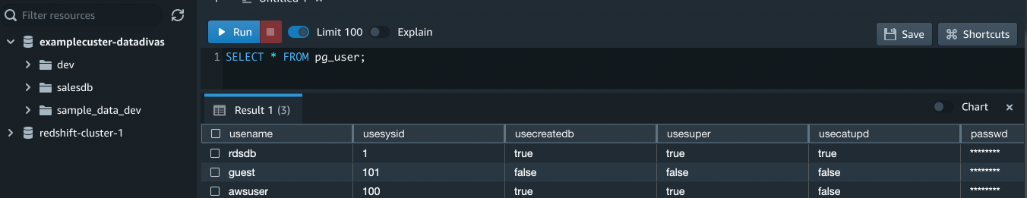

**View recent queries**

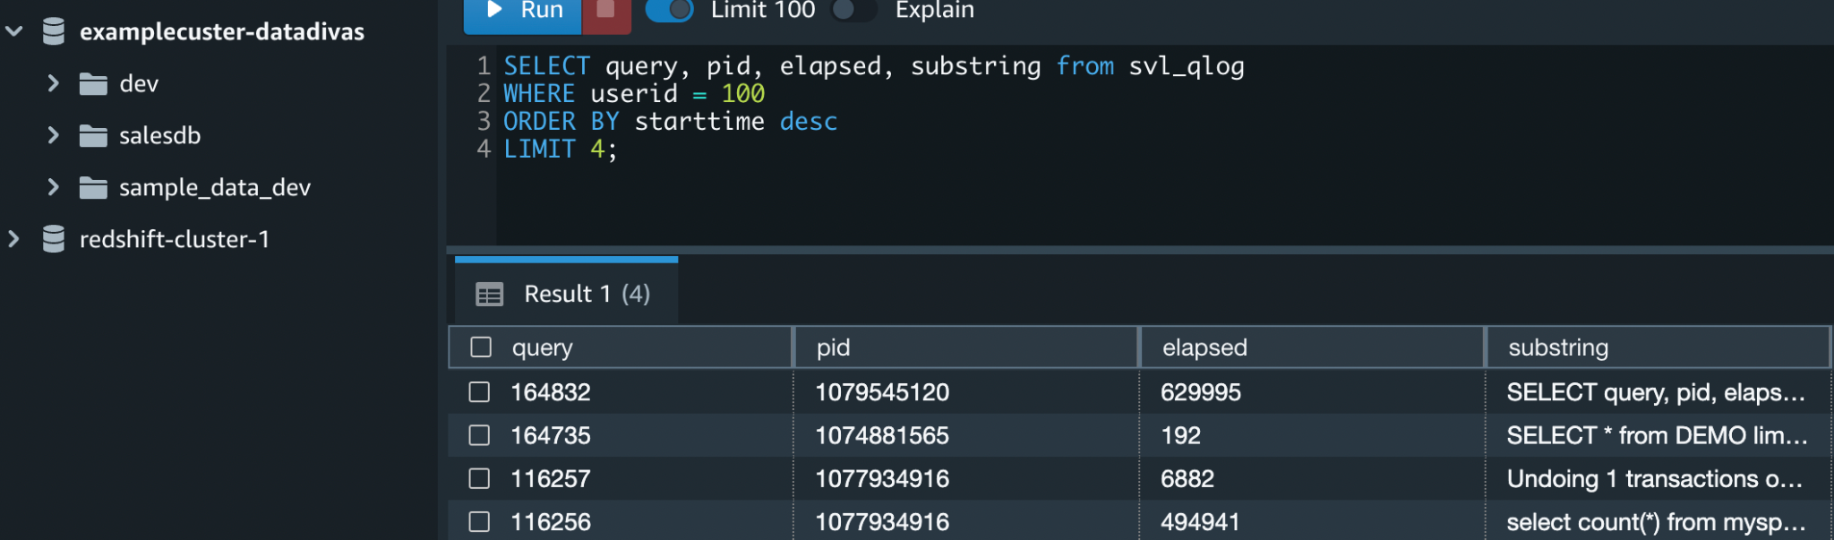

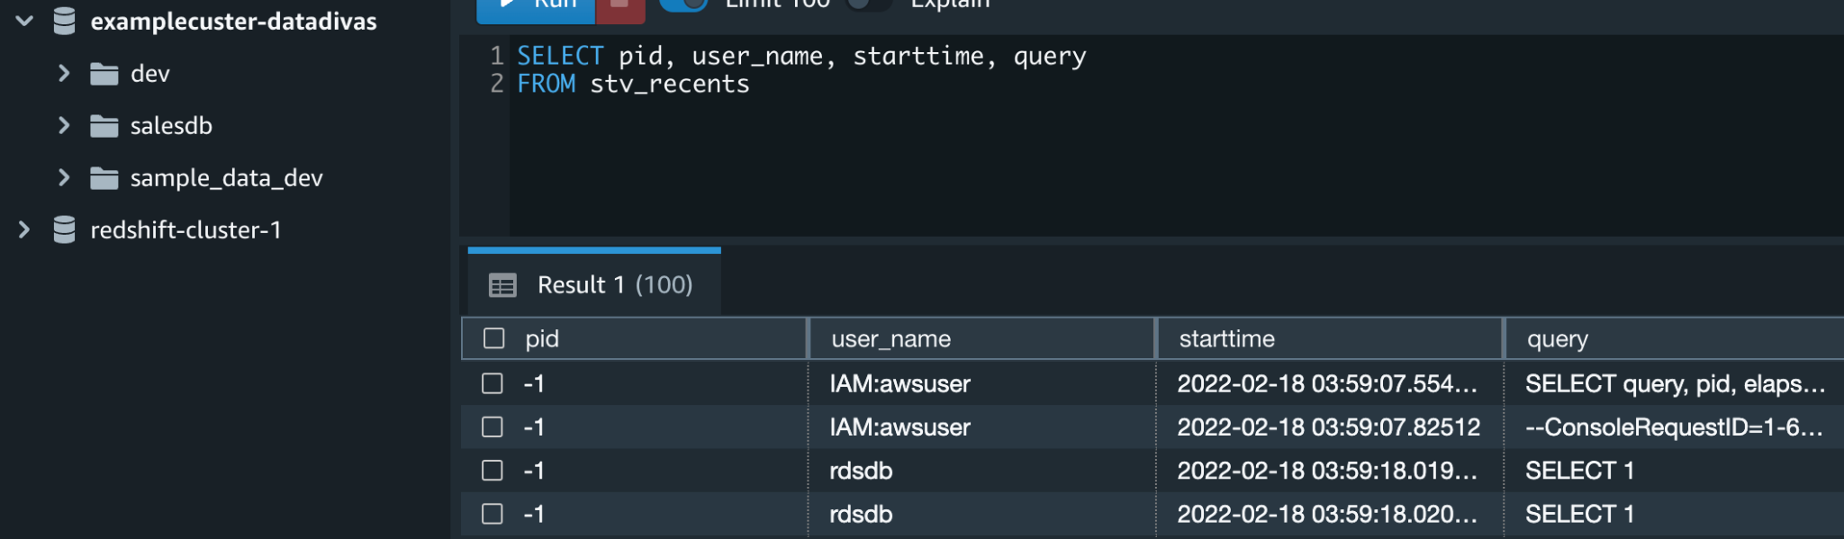

### Task 7: Cancel a query

Checking the elapsed time ( using where condition):

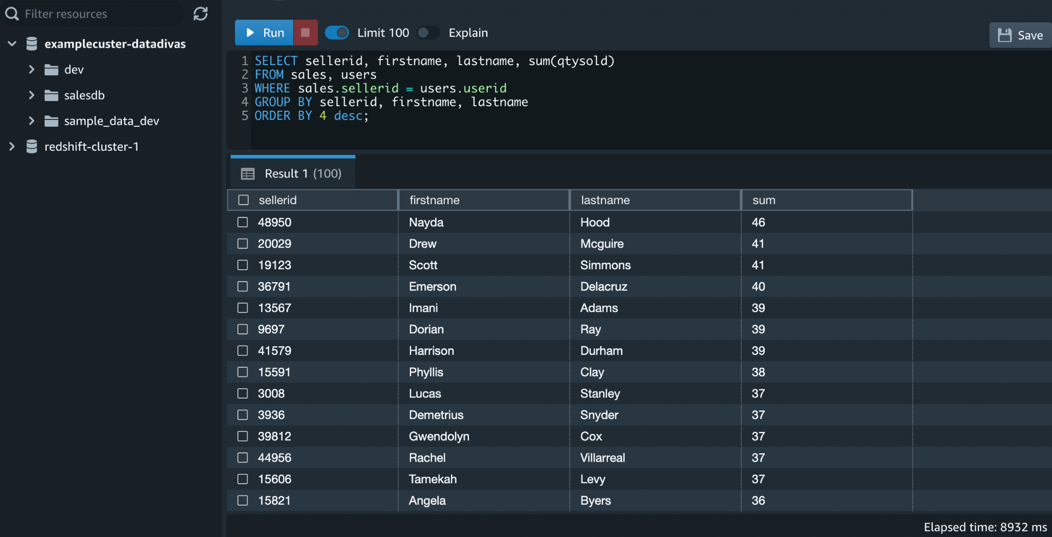

Checking the elapsed time ( without condition):

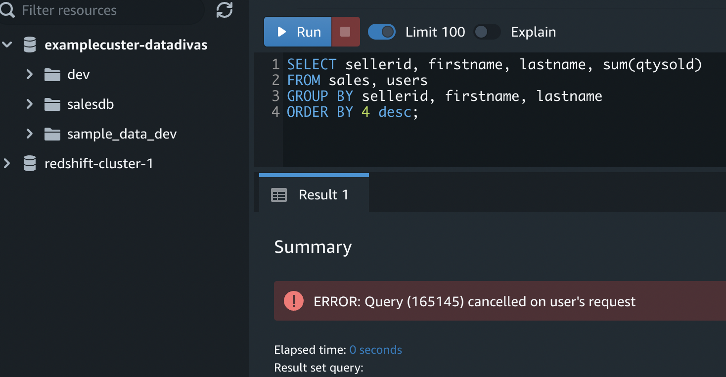

Without the where condition, the query takes a longer time since it creates a cartesian join; hence the q.

### Task 8: Clean up your resources

#### Before dropping salesdb Database

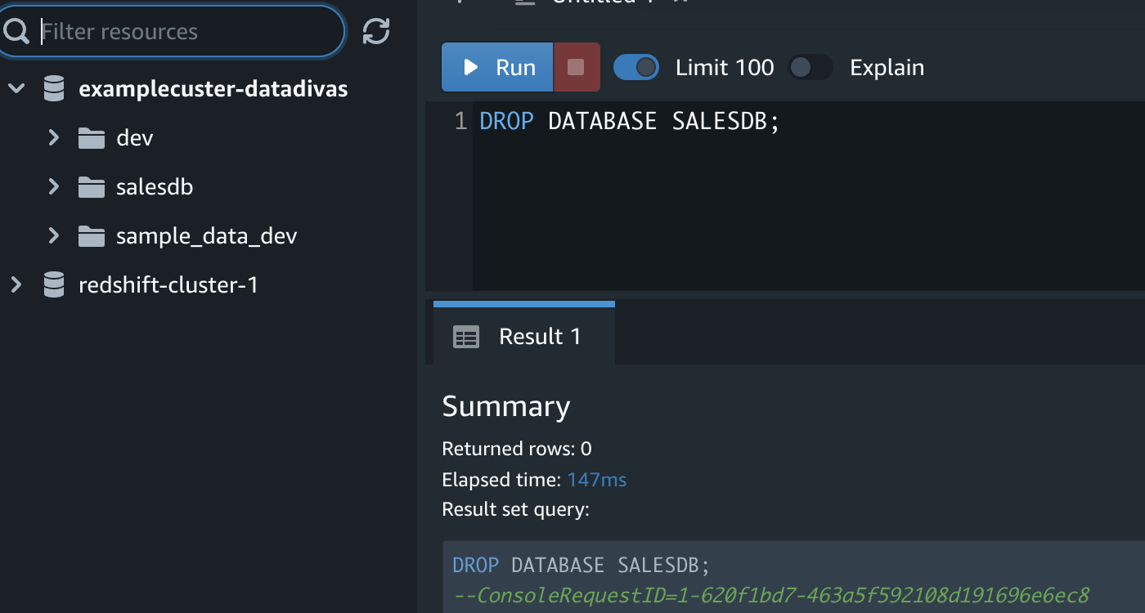

#### After Dropping Salesdb Database

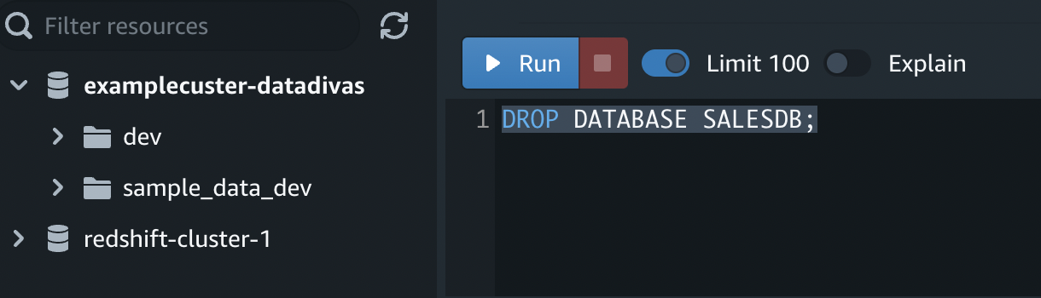

## Getting started querying your data lake

Amazon Redshift Spectrum is used in Amazon S3 files to query data without having to load it into Amazon Redshift tables, and it can query data in the following formats.

### Query Data Formats

Parquet, ORC, RCFile, TextFile, SequenceFile, RegexSerde, OpenCSV, and AVRO

## Getting started with Amazon Redshift Spectrum

### Step 1. Create an IAM role for Amazon Redshift

#### Creating Role

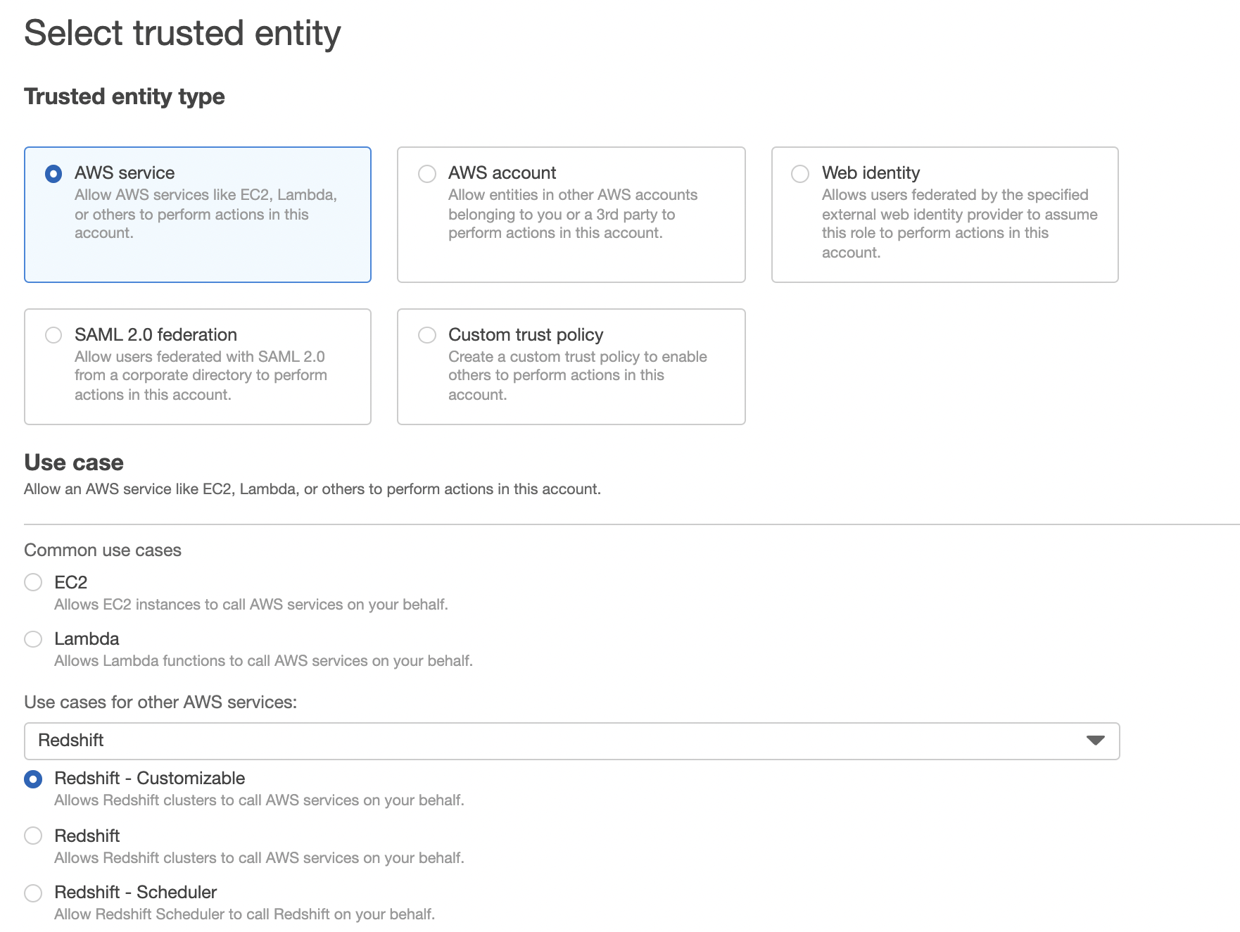

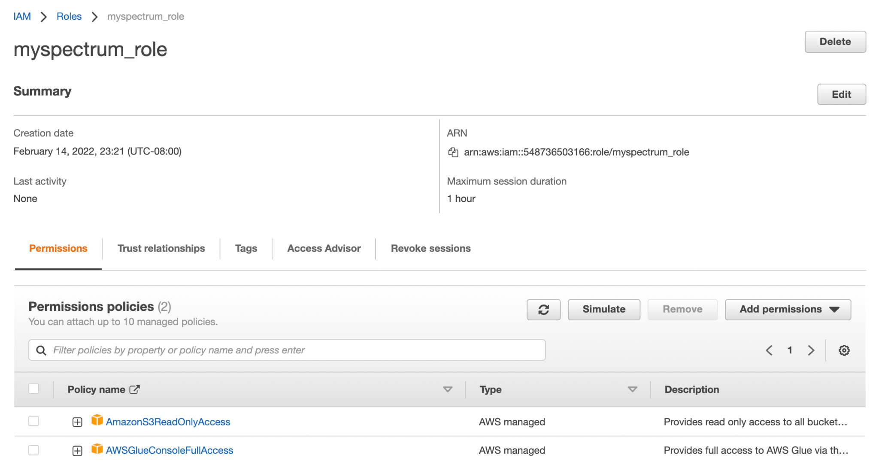

#### Creating Policy

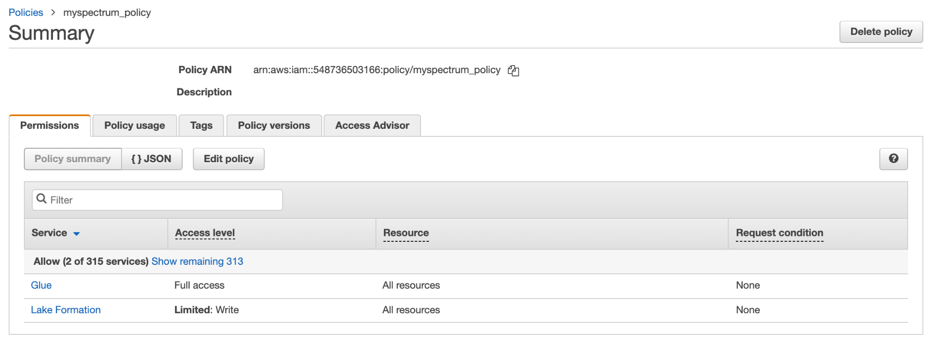

#### Creating role using [myspectrum_policy](https://console.aws.amazon.com/iam/home#/policies/arn:aws:iam::548736503166:policy/myspectrum_policy)

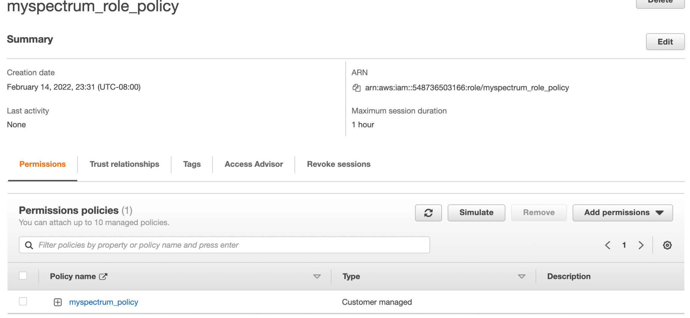

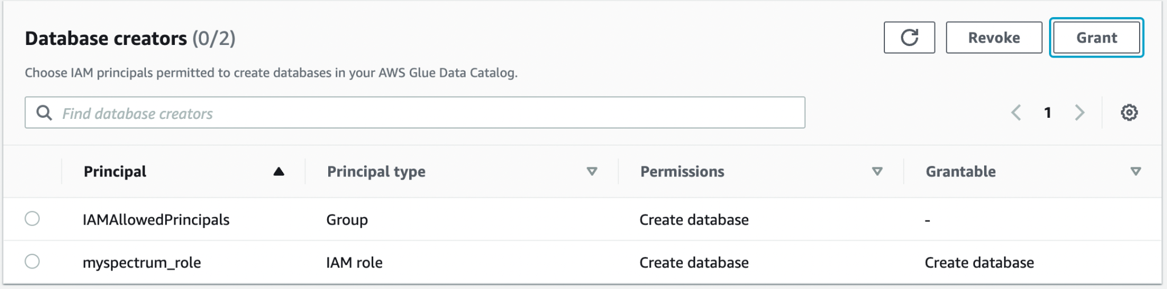

### Step 2: Associate the IAM role with your cluster

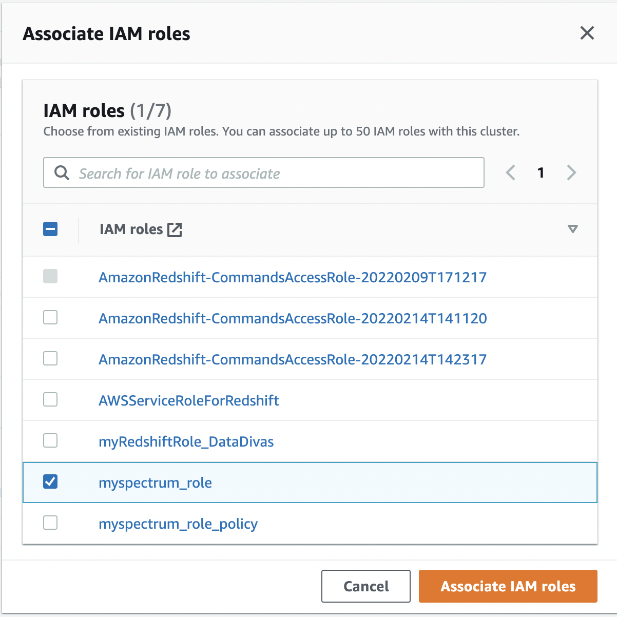

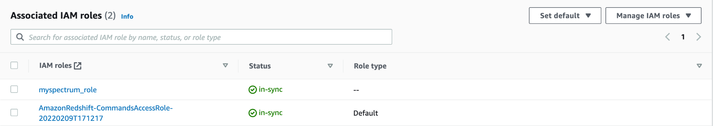

### Step 3: Create an external schema and an external table

#### Creating an external schema

**ARN : arn:aws:iam::548736503166:role/myspectrum_role**

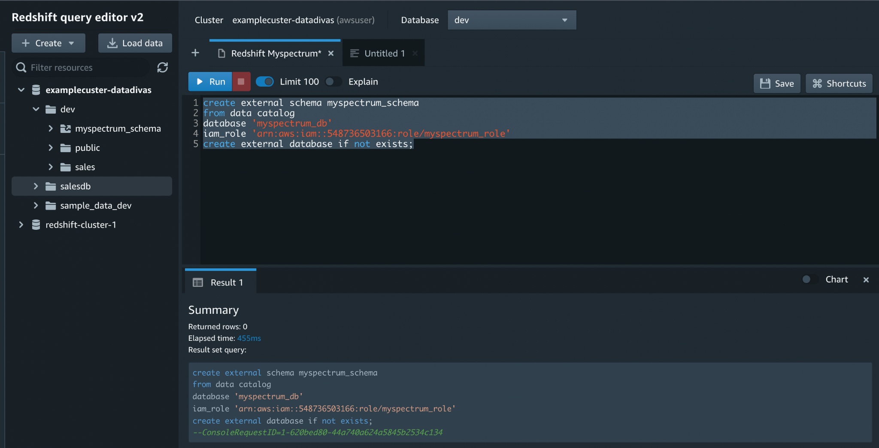

#### Creating an external table

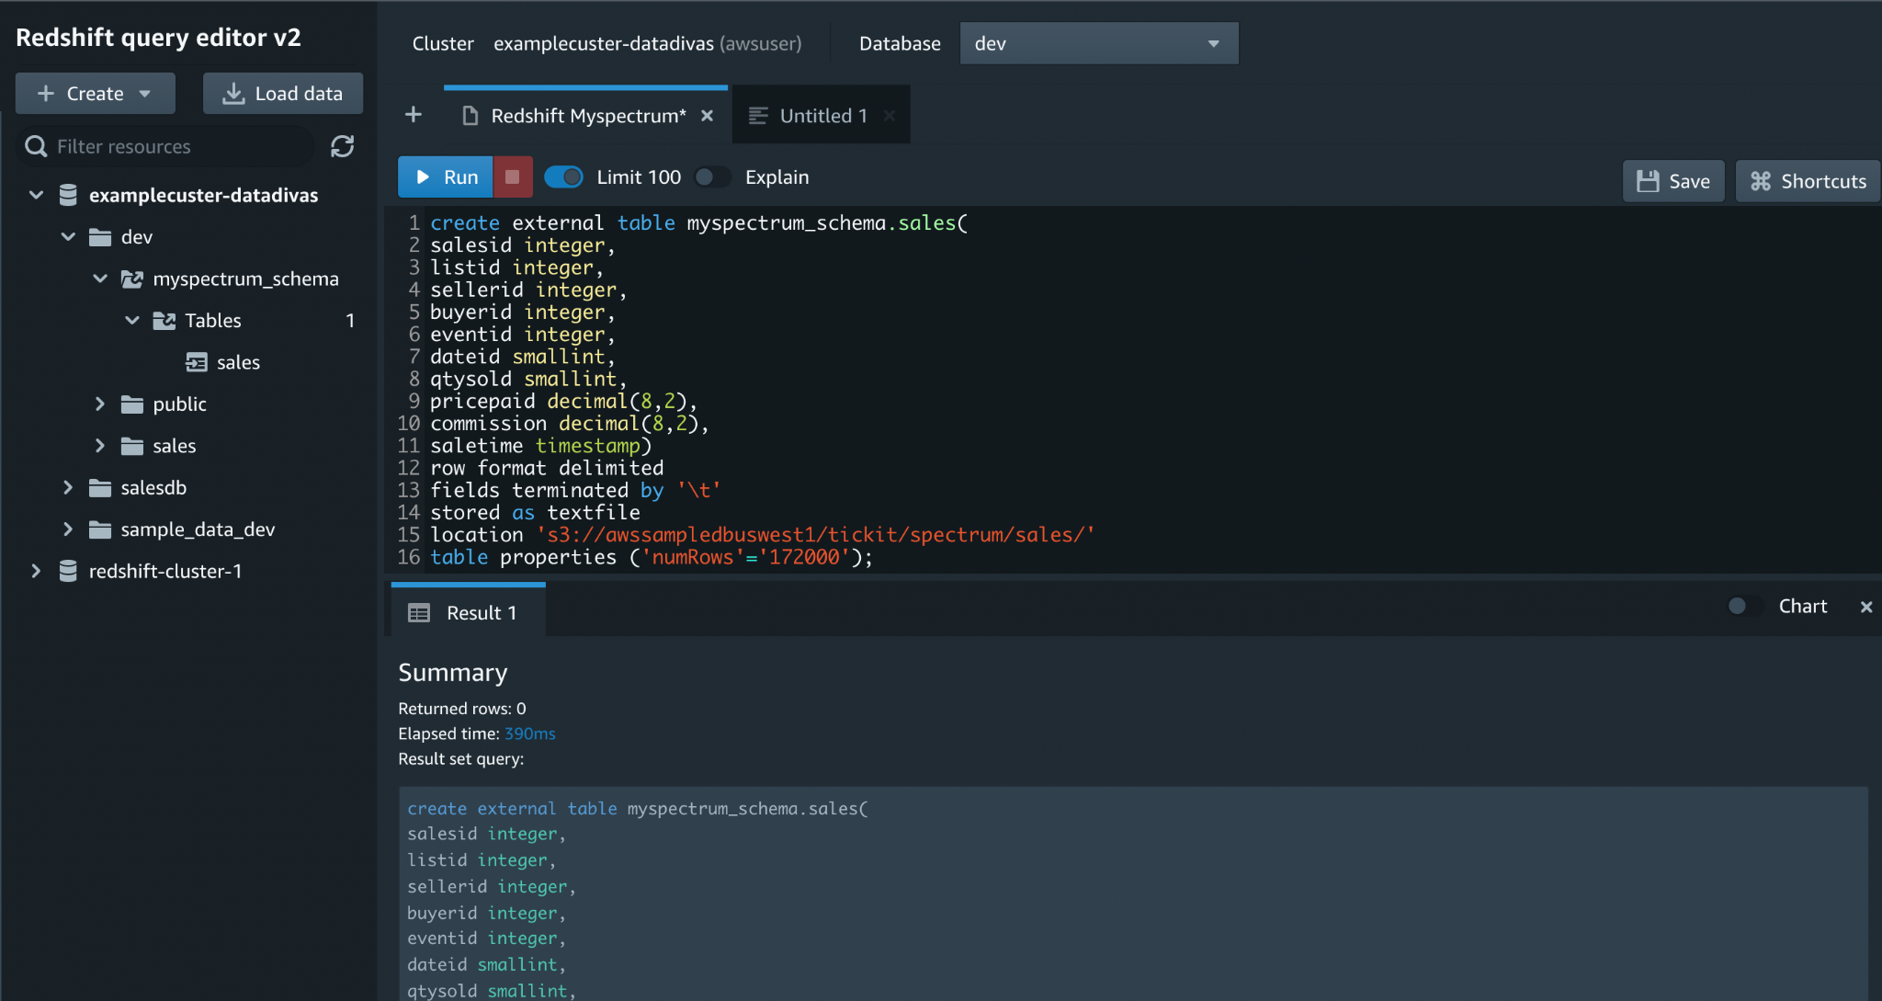

## Getting started querying data on remote data sources

Launching a CloudFormation stack for redshift federated queries

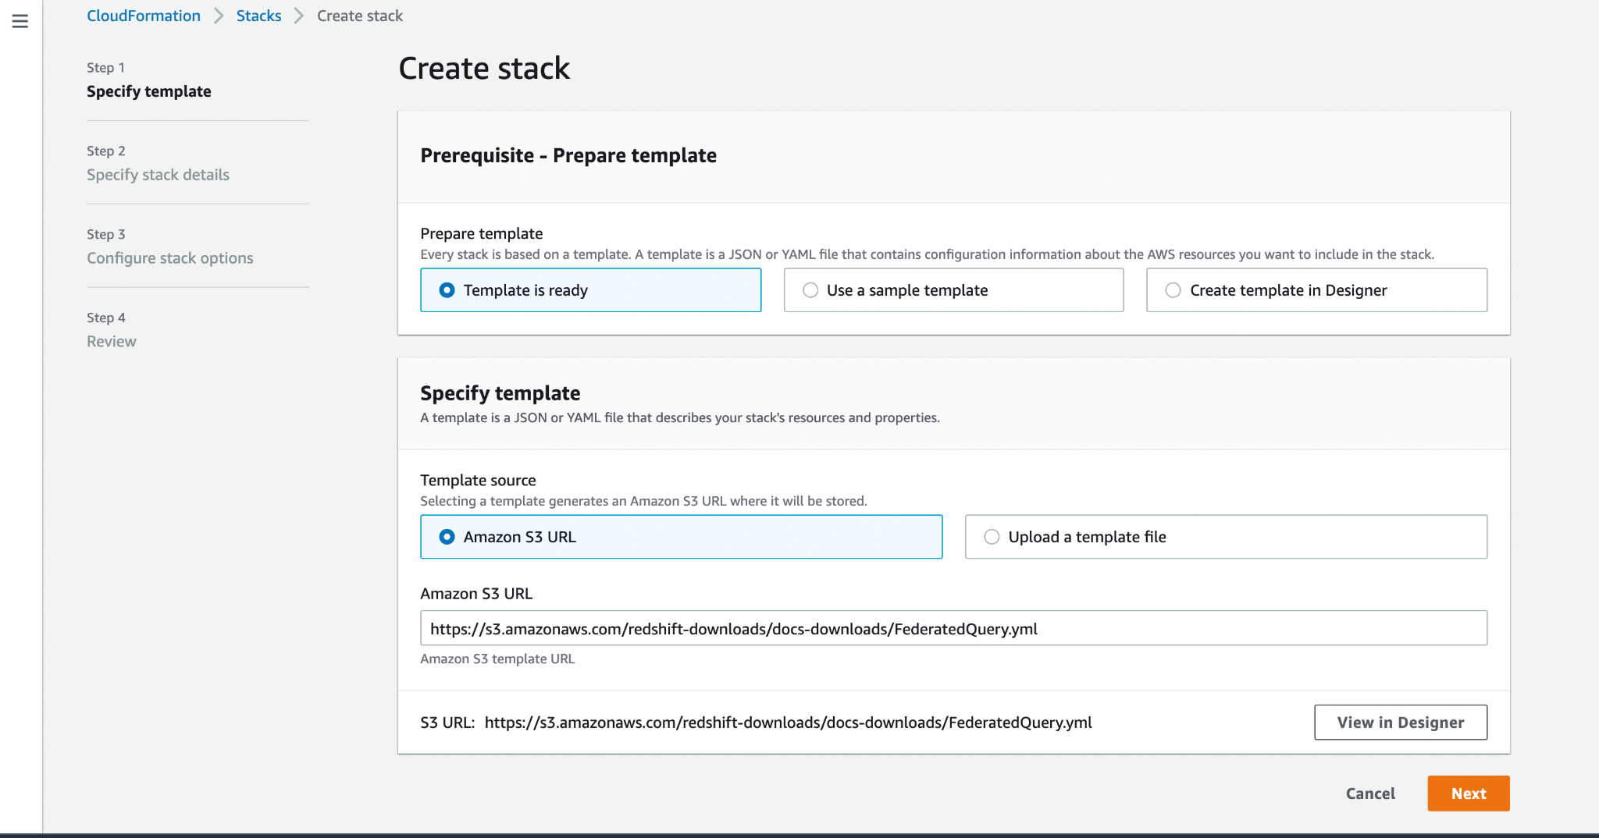

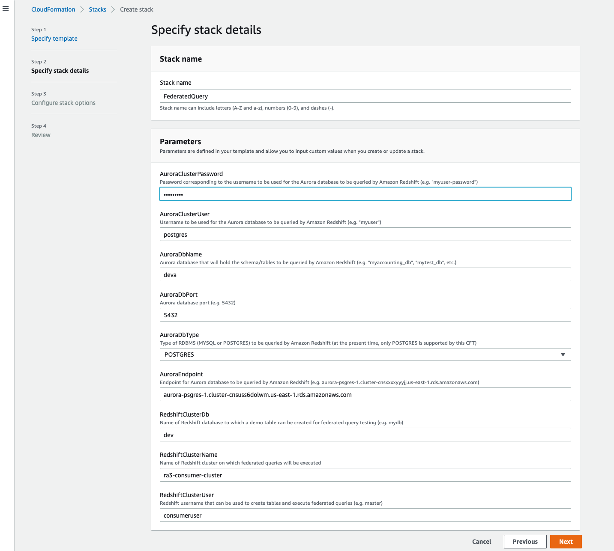

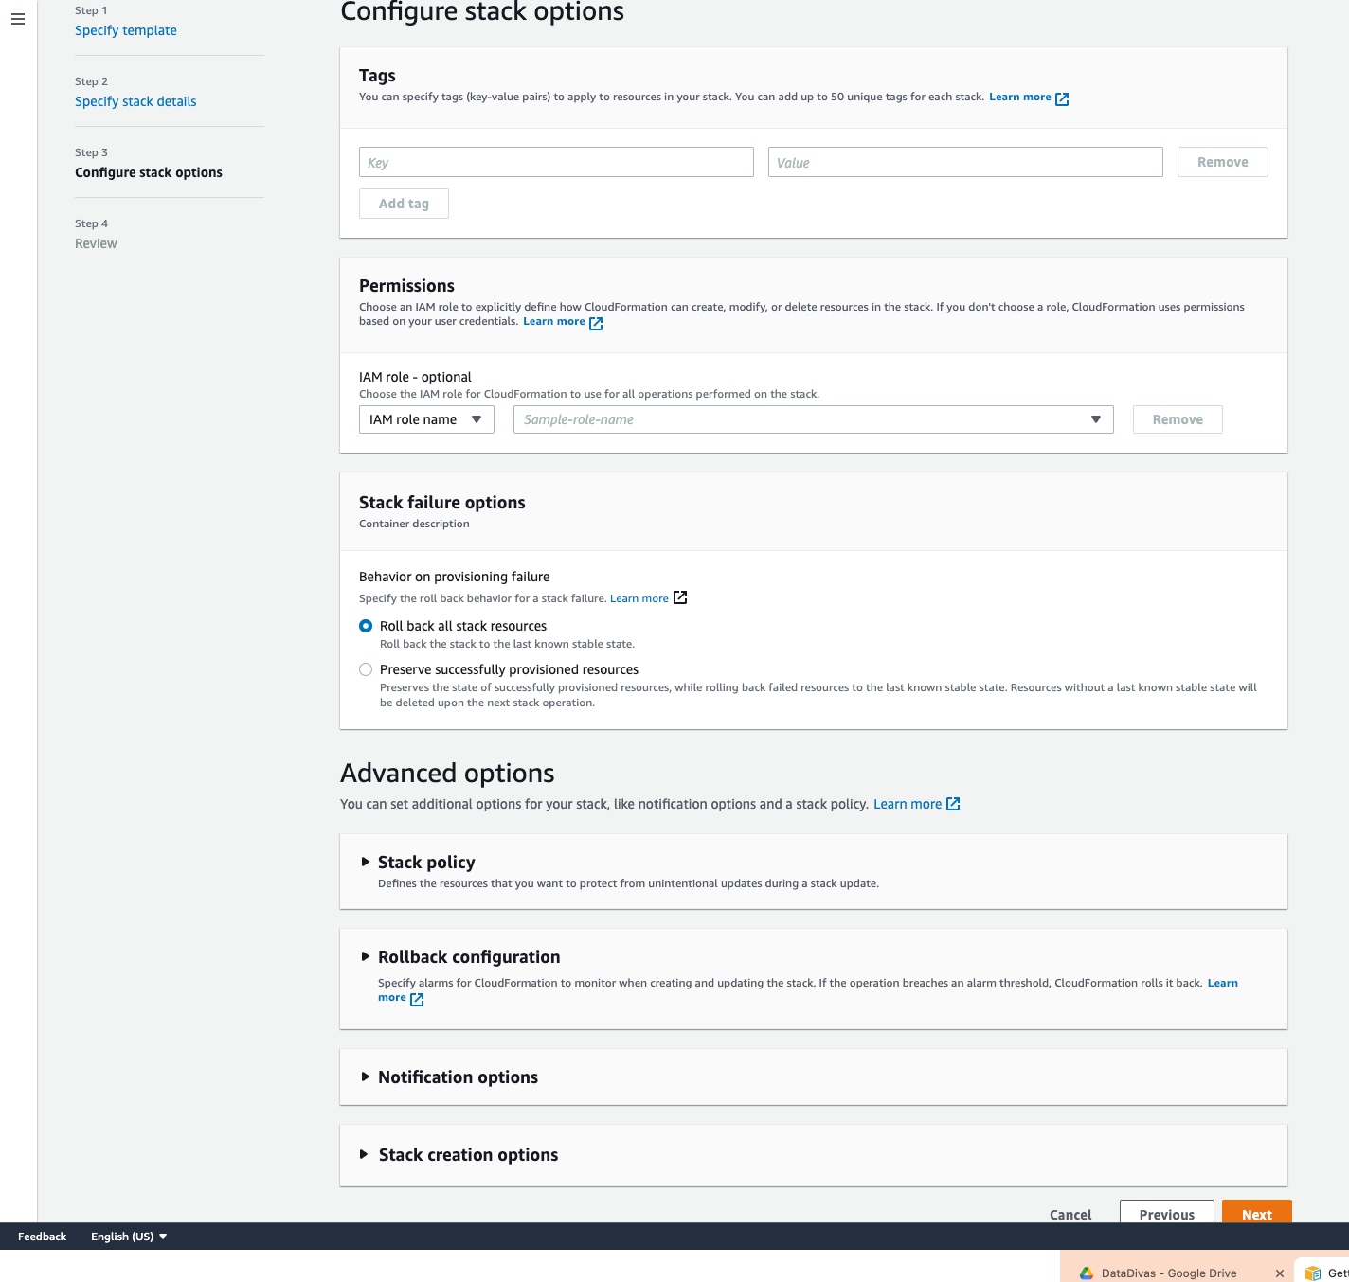

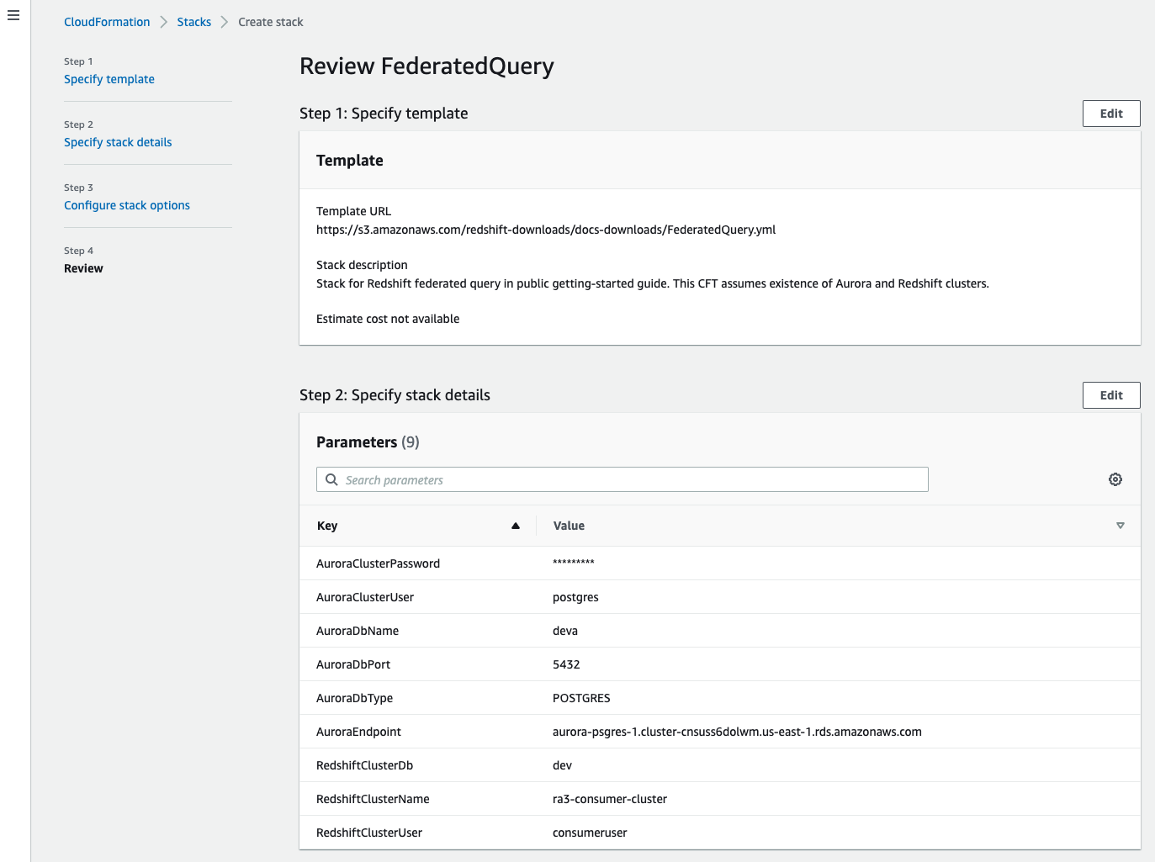

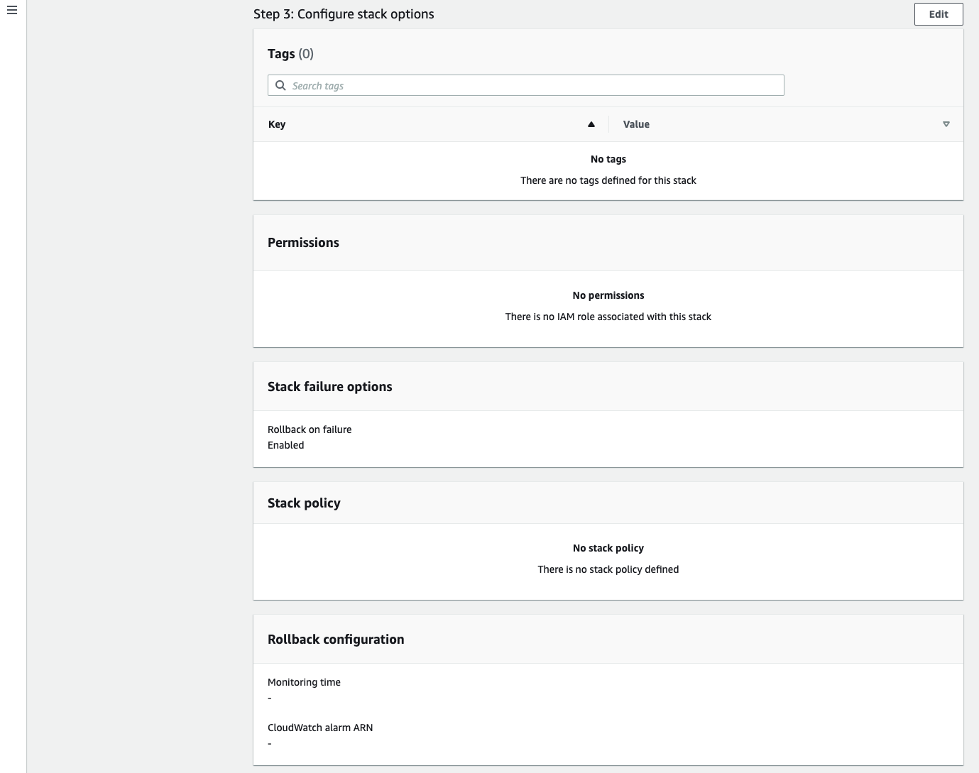

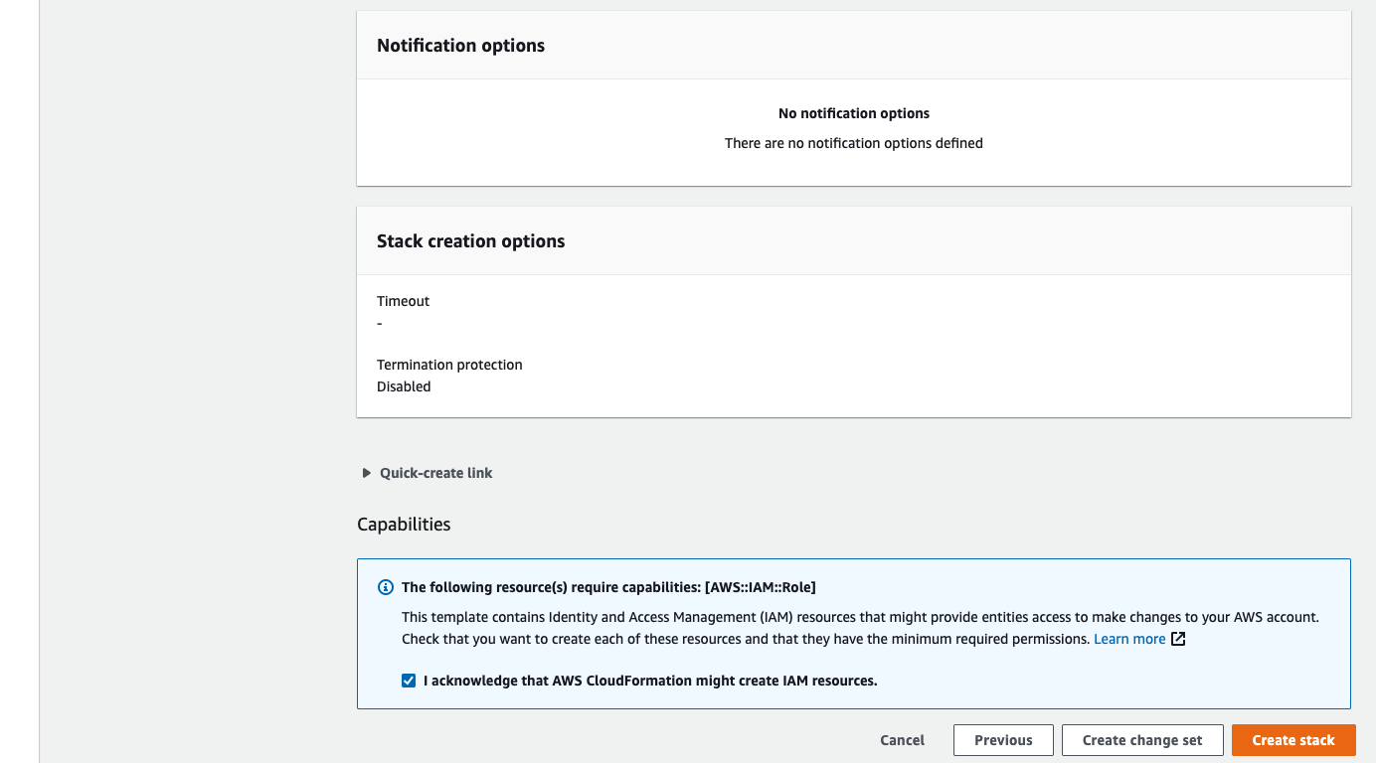

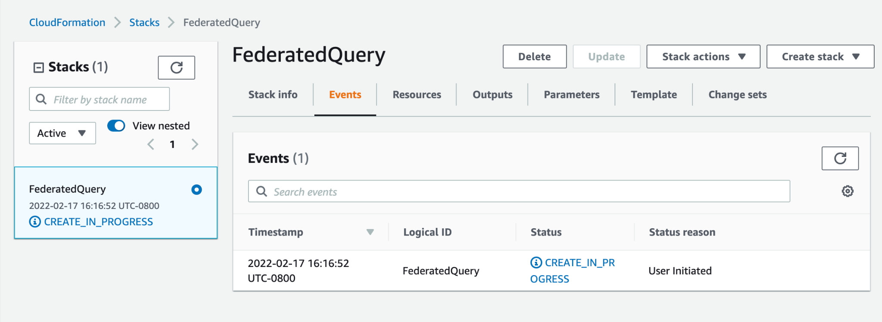

## Getting started accessing data in other Amazon Redshift clusters

The Data Sharing concept enables us to share the live data across AWS accounts or within AWS accounts with different clusters. Data sharing in Amazon redshift involves high security and ease in sharing data. We don’t need to manually copy or move the data anymore.

**Note: Amazon Redshift only supports data sharing on the ra3.16xlarge, ra3.4xlarge, and ra3.xlplus instance types for producer and consumer clusters.**

Data sharing is useful in the following cases:

* Data share among environments
* Centralizing business-critical workloads

### Getting Started data sharing

A producer cluster administrator or database owner will perform the following tasks:

**To create DATASHARE**:

**SQL Query**: CREATE DATASHARE Datashare_name;

**To grant or revoke permissions to awsuser on datashare_name:**

SQL Query: GRANT ALTER, SHARE ON DATASHARE datashare_name TO awsuser;

**To add/remove objects from datashare. For example: sales(Table):**

**SQL Query**: ALTER DATASHARE datashare_name ADD TABLE public.sales;

**To add views to a datashare:**

**SQL Query**: CREATE VIEW public.sales_view AS SELECT *FROM public.sales; ALTER DATASHARE datashare_name ADD TABLE public.sales_view;

**Grant or revoke consumers from datashares using namespace:**

**SQL Query**: GRANT USAGE ON DATASHARE datashare_name TO NAMESPACE ‘13b8833d-17c6-4f16-8fe4-1a018f5ed00d’;

**List and look into the datashare contents:**

**SQL Query**: DESC DATASHARE datashare_name;

**Drop datashare:**

**SQL Query**; DROP DATASHARE datashare_name;

**Remove or alter table from datashare:**

**SQL Query**: ALTER DATASHARE datashare_name TABLE public.sales;

Data Sharing can be done using:

* SQL interface
* Console
* AWS CloudFormation

The queries are similar for all these methods to work with this concept.

### Limitations of Data Sharing:

* Does not support stored procedures or user-defined functions of python [5]
* Does not support sharing tables with interleaved sort views and keys that refer to tables with interleaved sort keys [5]
* Consumer and producer clusters must be encrypted for cross-account data sharing [5]
* Does not support nested SQL user-defined functions on producer cluster [5]
* Demands the same collation of both producer and consumer databases [5]
* Does not support adding tables or schemas to data shares [5]

## Getting started training machine learning models with Amazon Redshift data

### Cluster and configure the setup for Amazon Redshift ML administration

#### Cluster setup for using Amazon Redshift ML

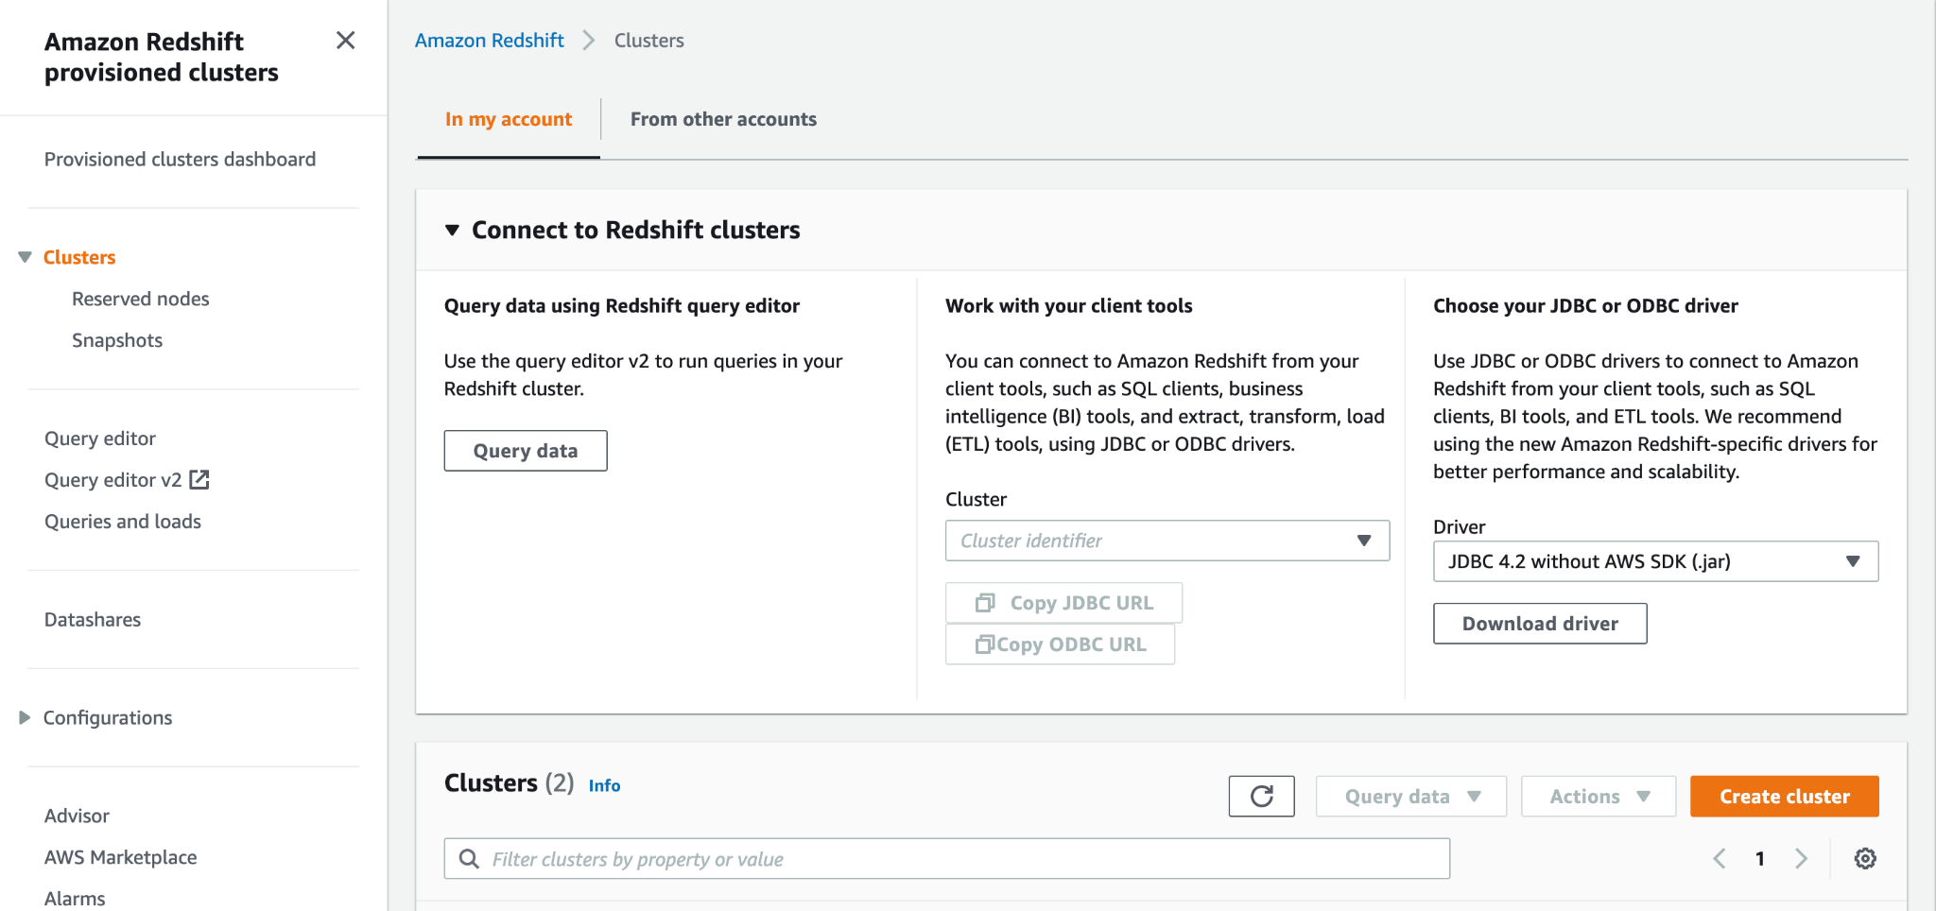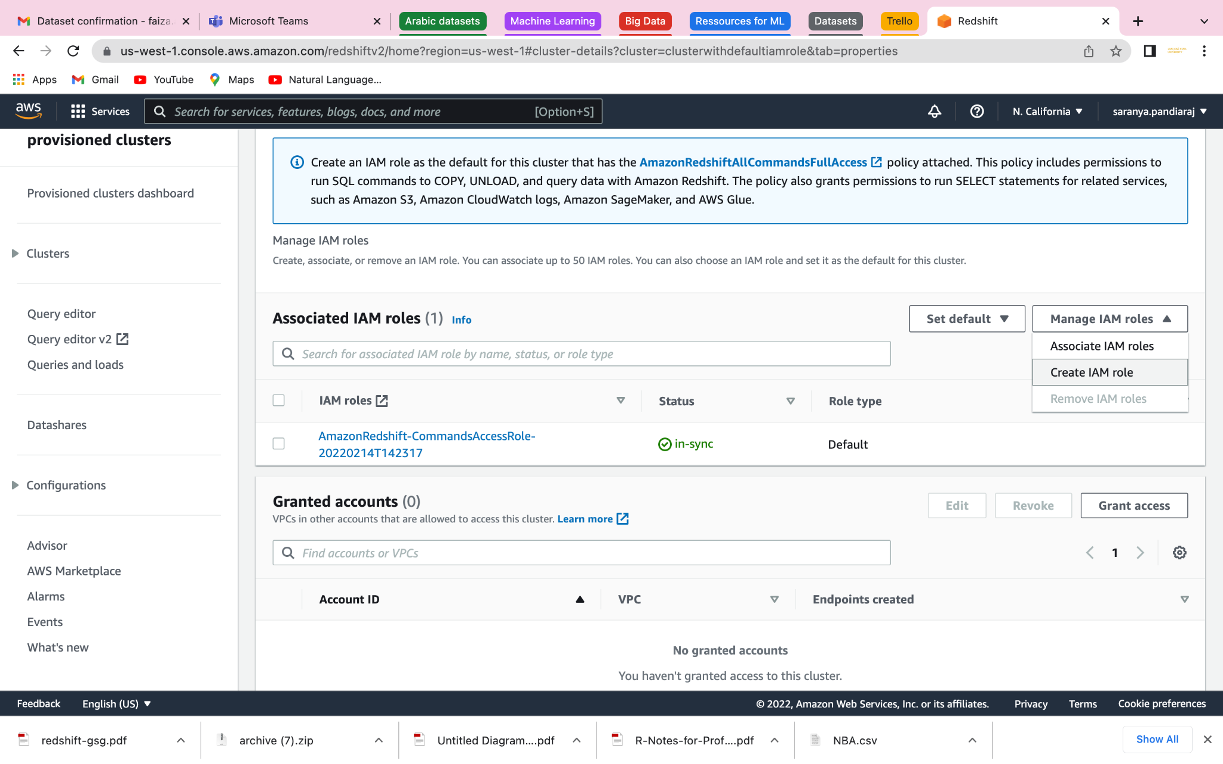

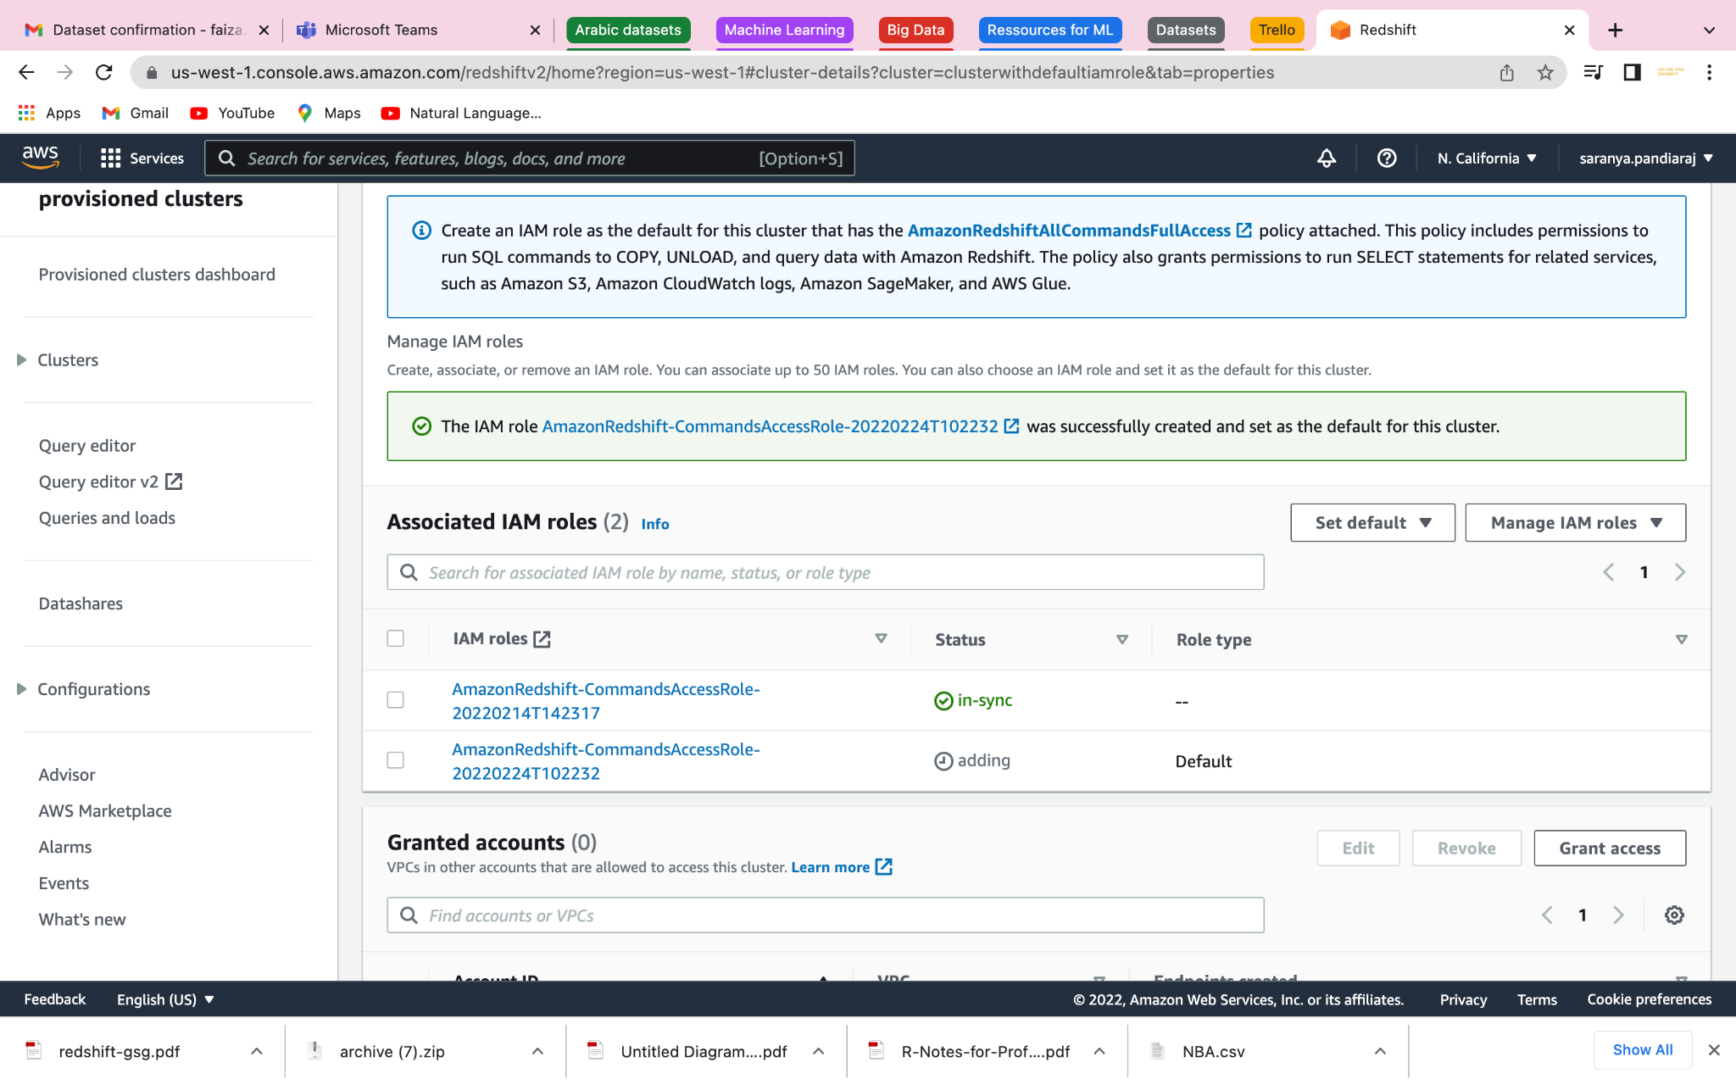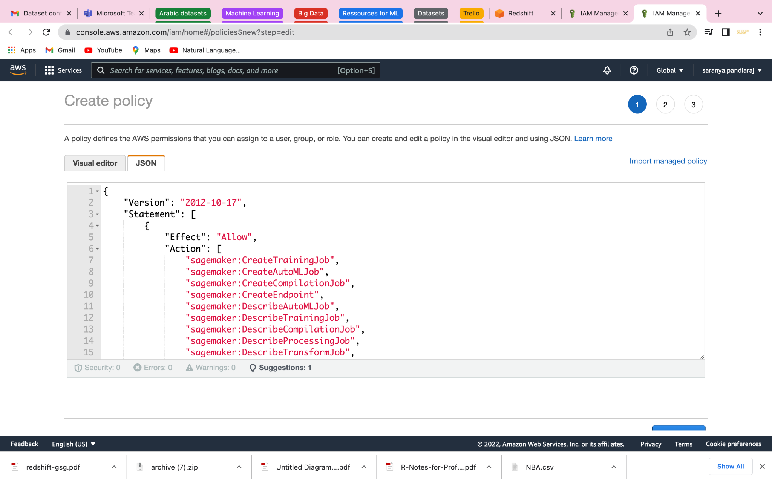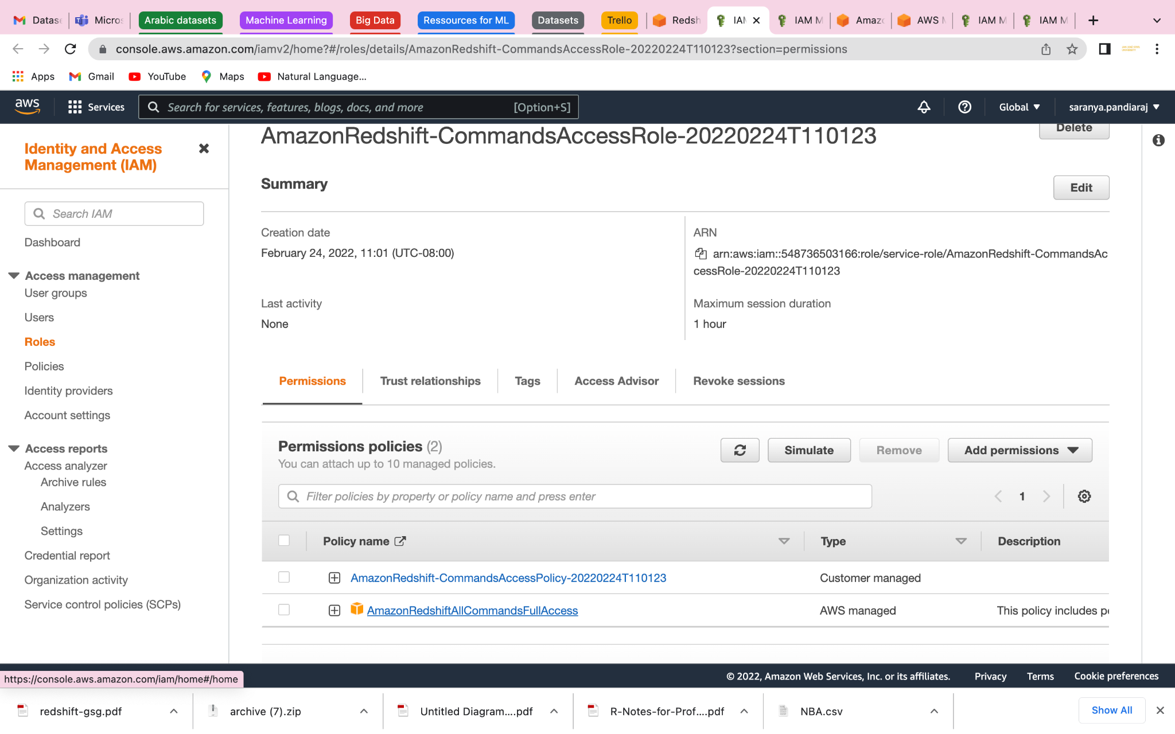

Managing permissions and ownership

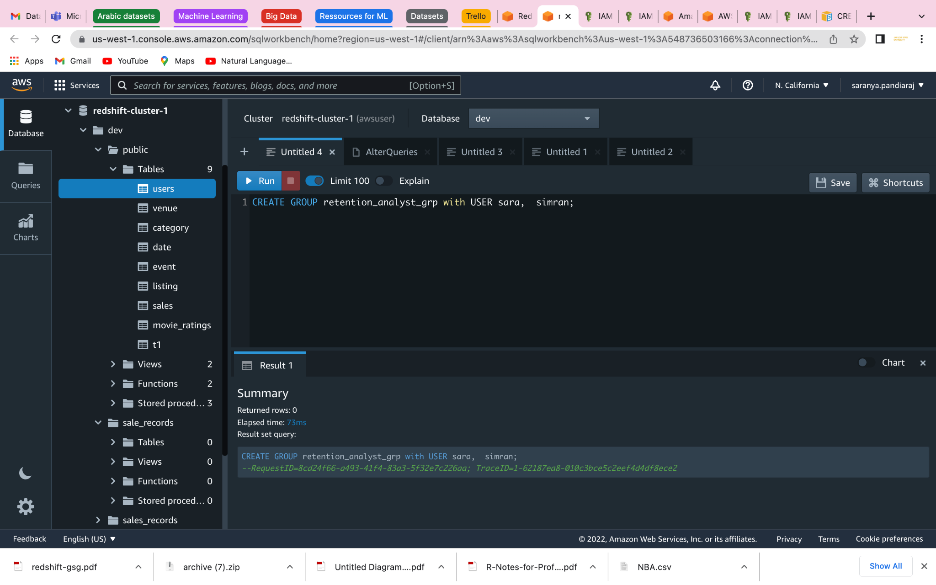

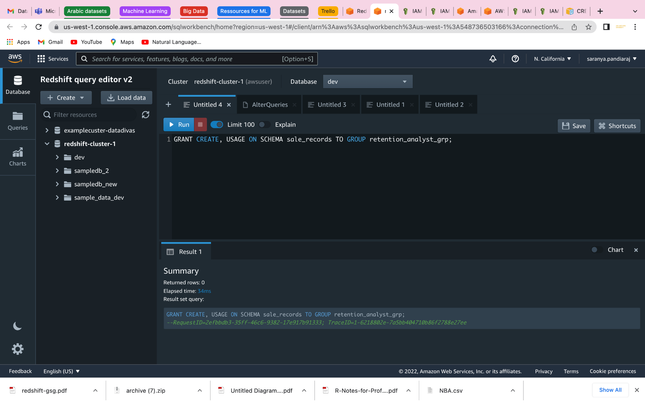

#### Using model with Amazon Redshift ML

#### Tutorial: Creating a customer churn model

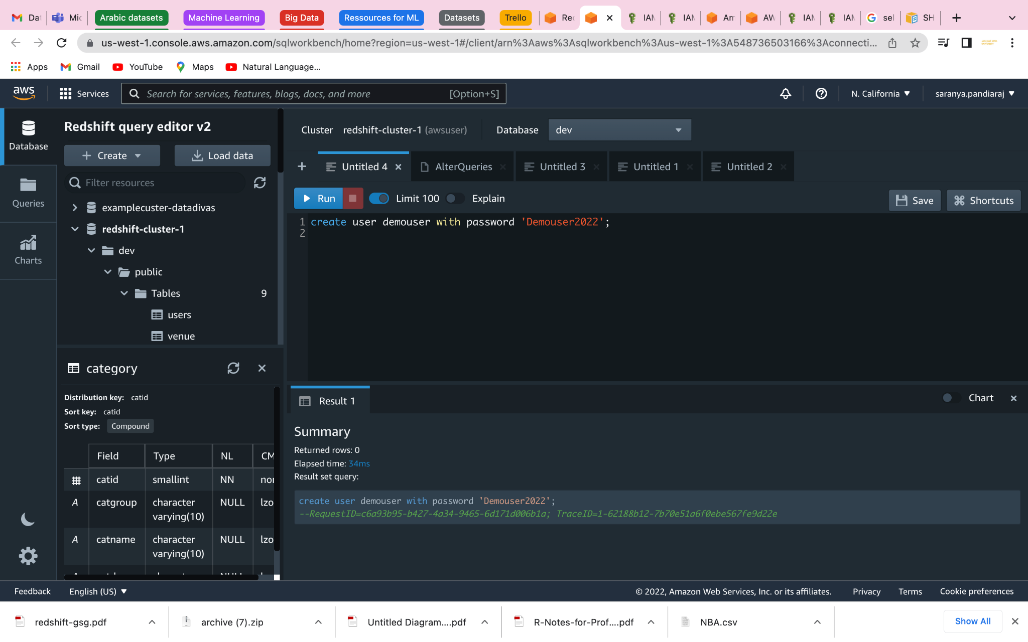

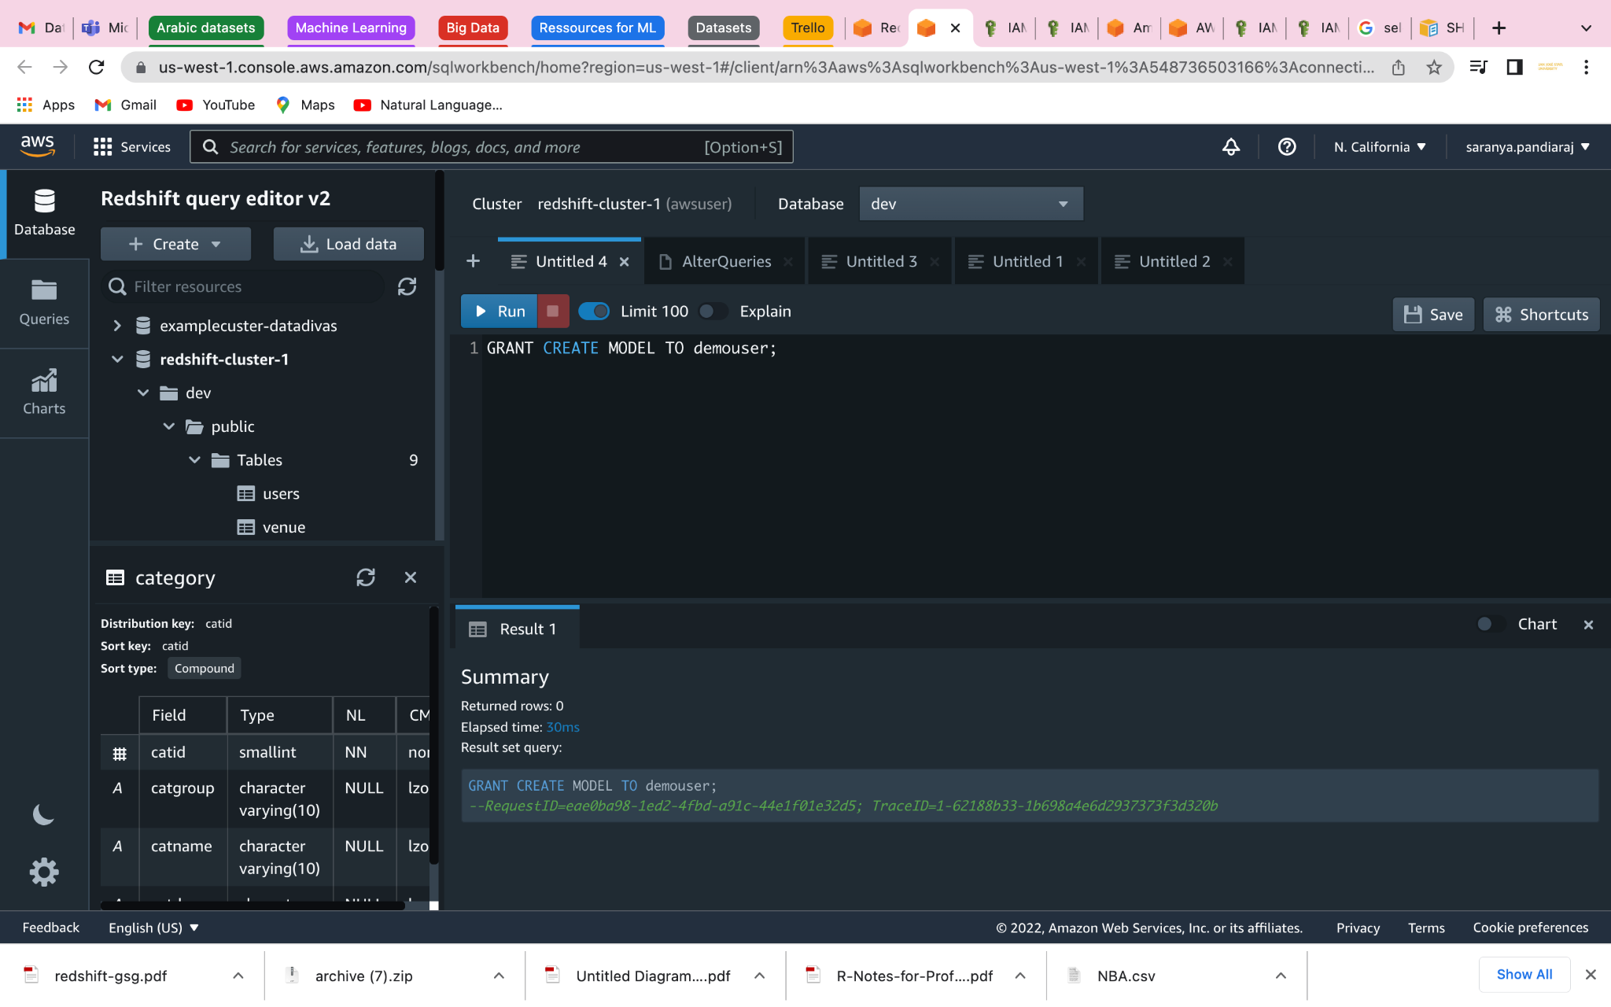

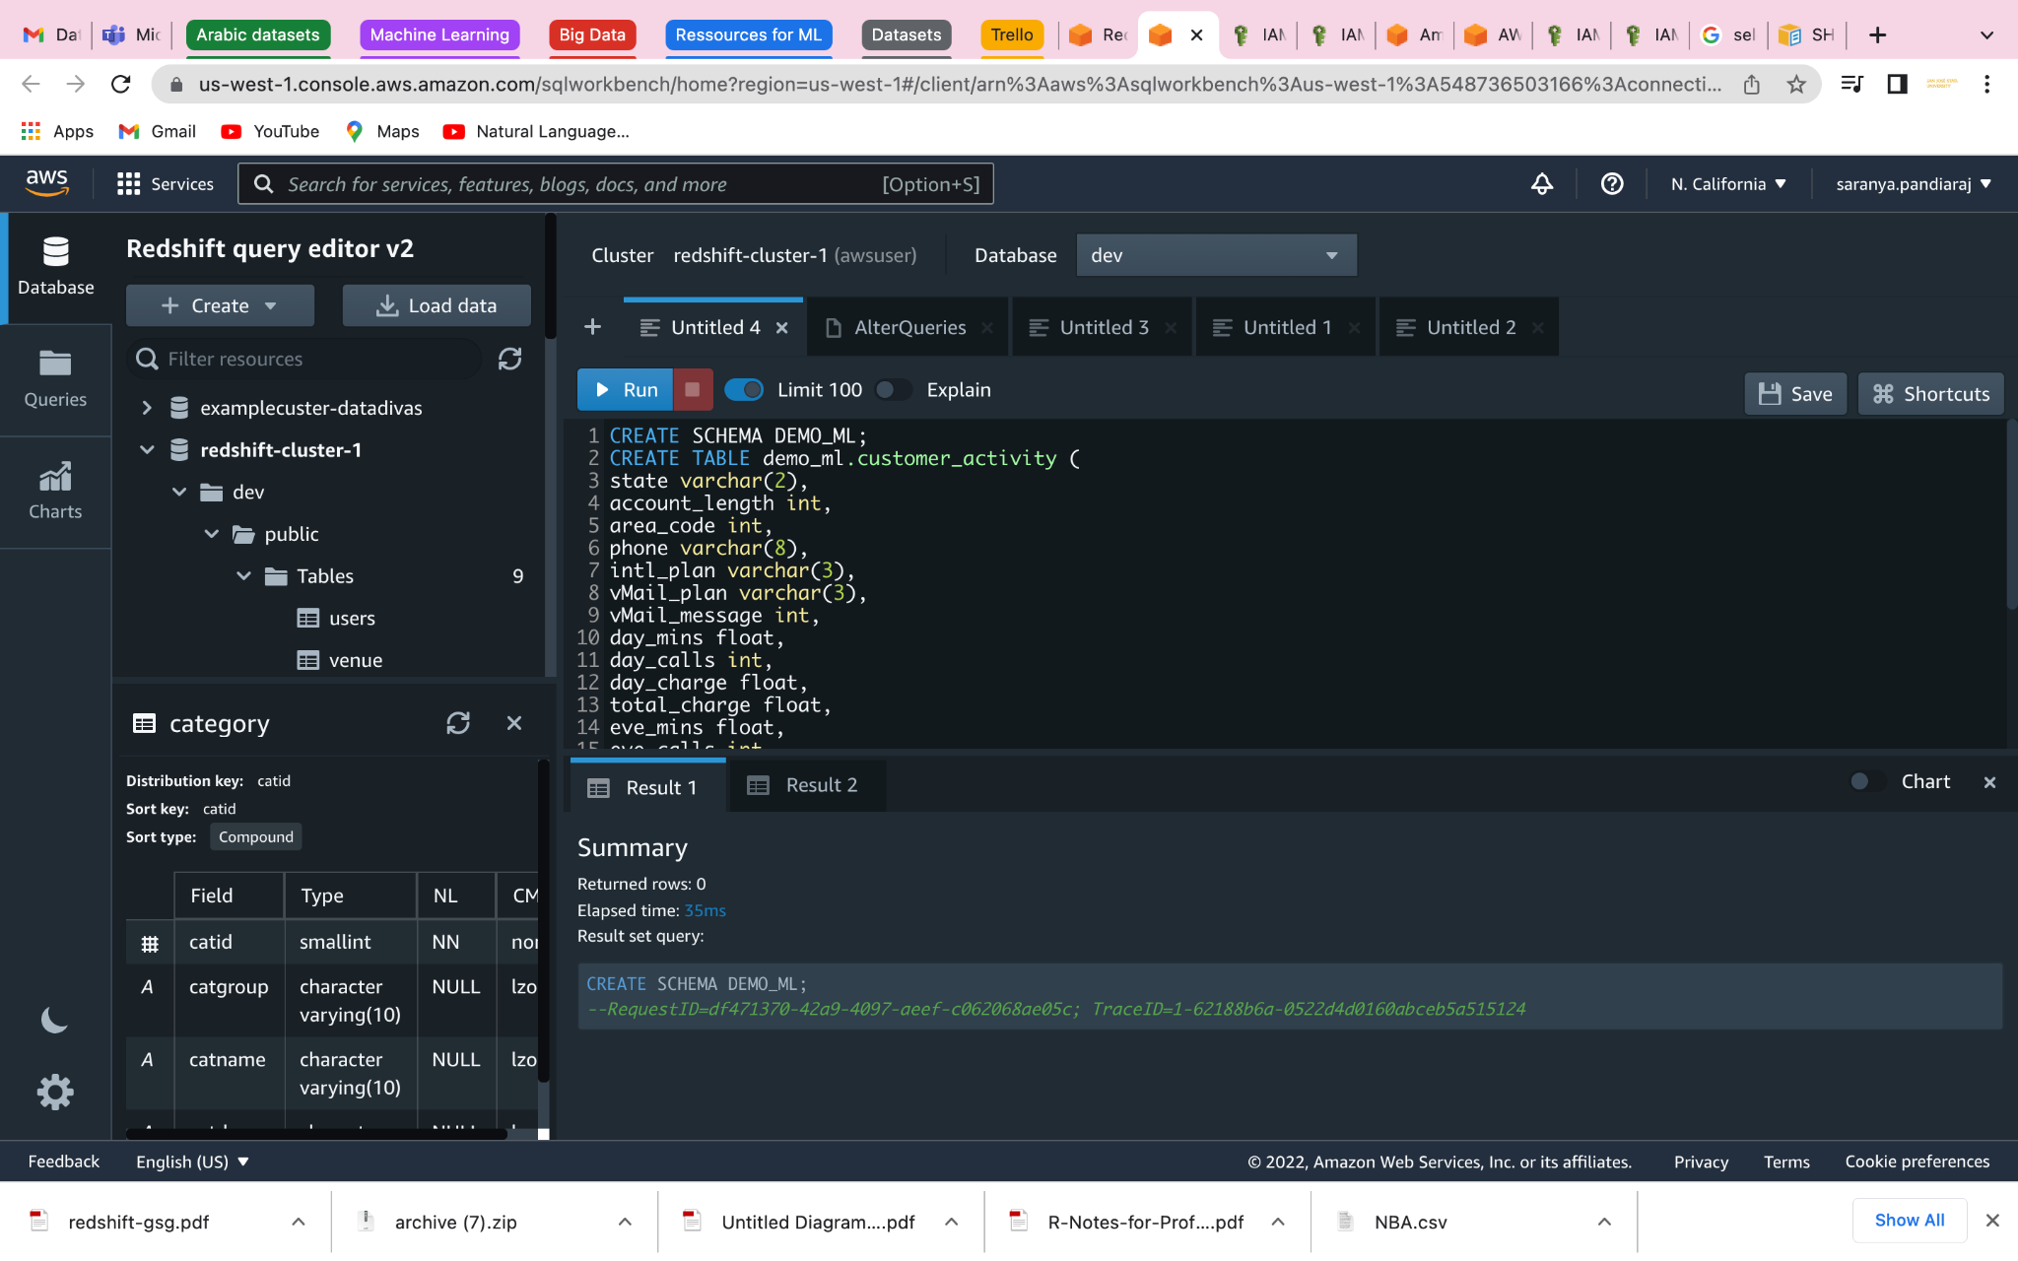

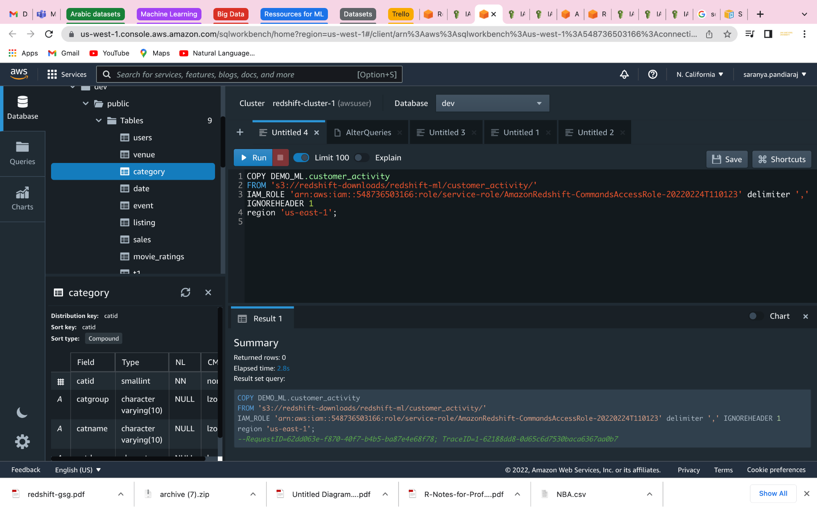

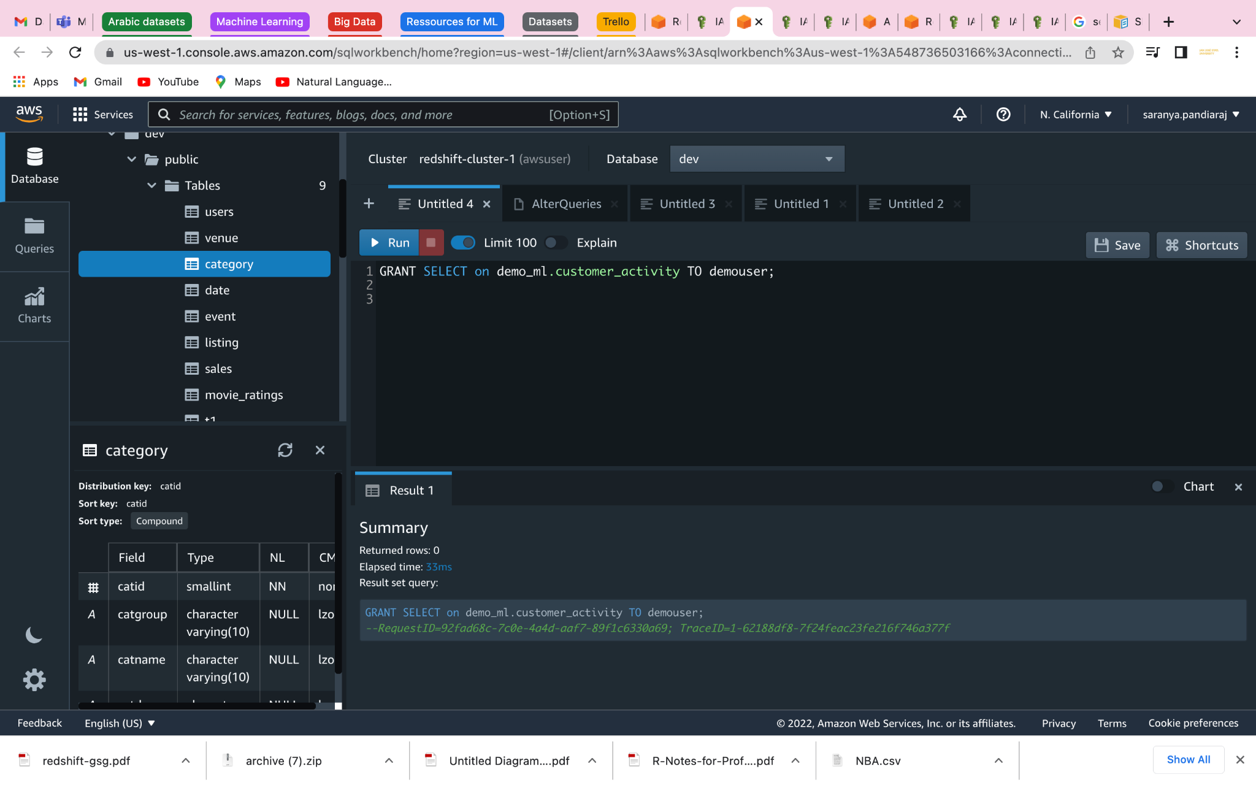

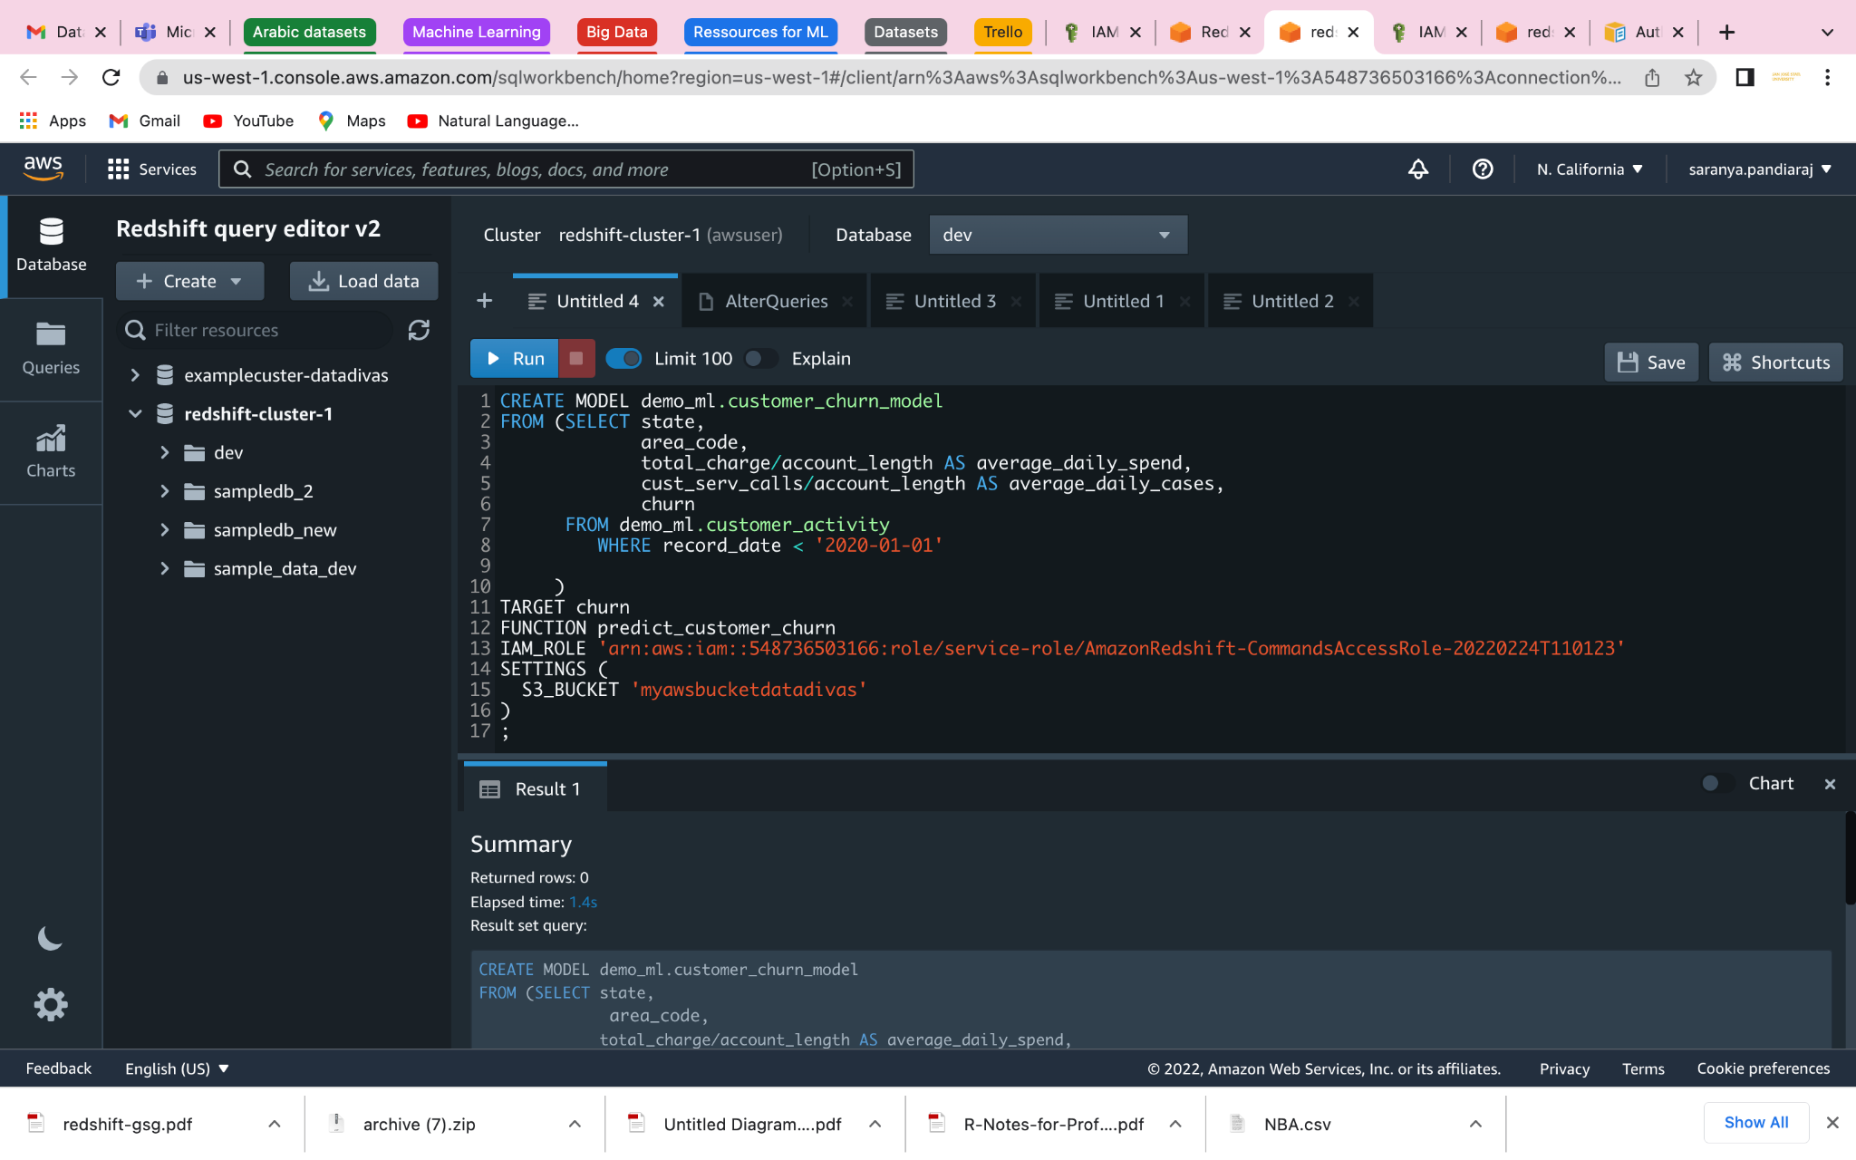

Check the status of your ML model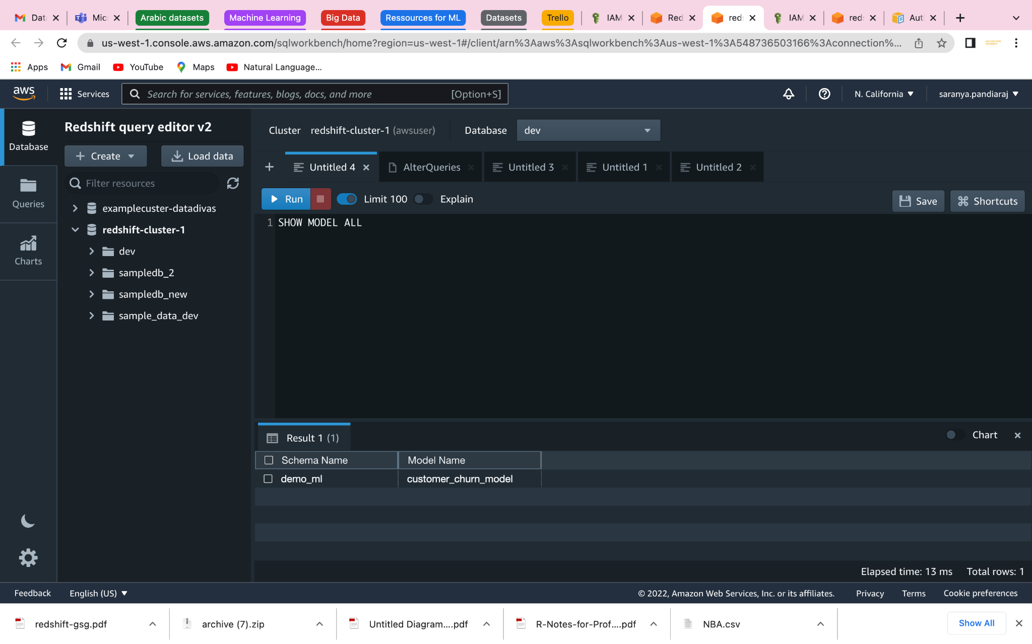

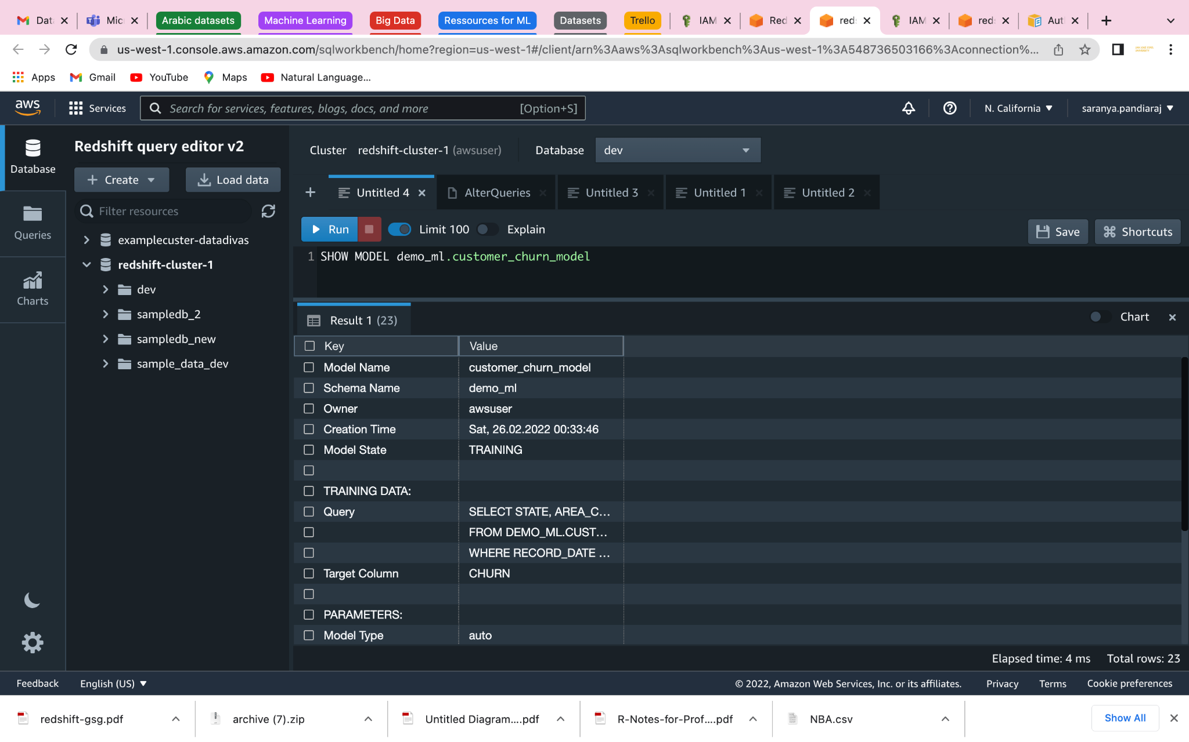

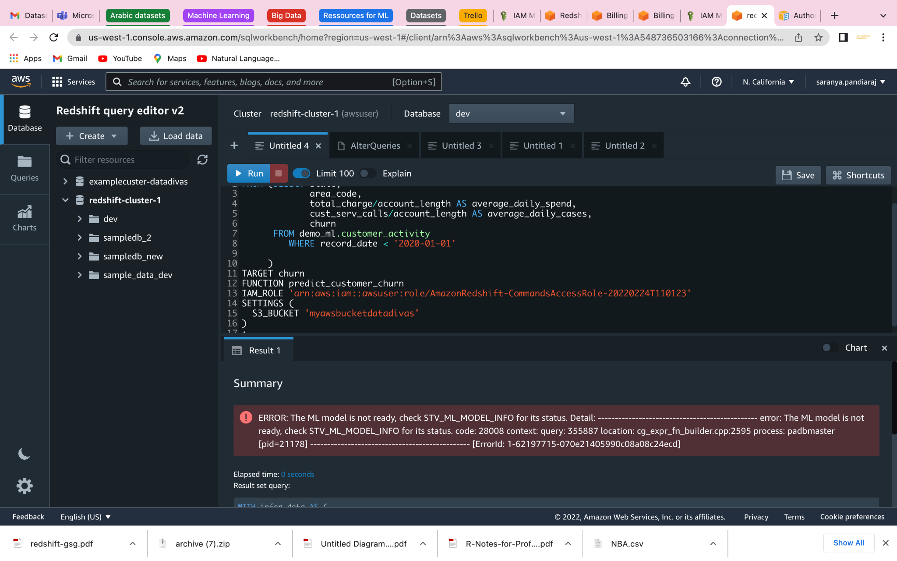

# SQL Reference

## SQL Commands

#### Abort Command

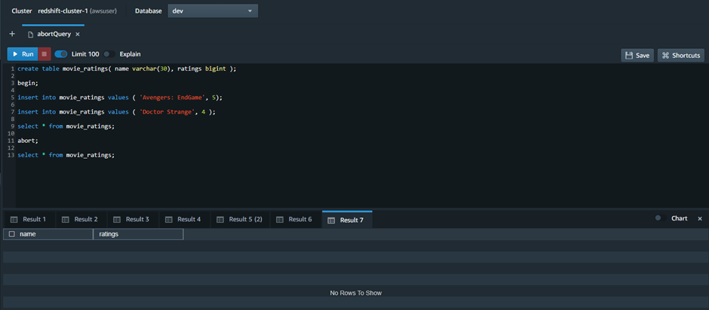

**Result 1:**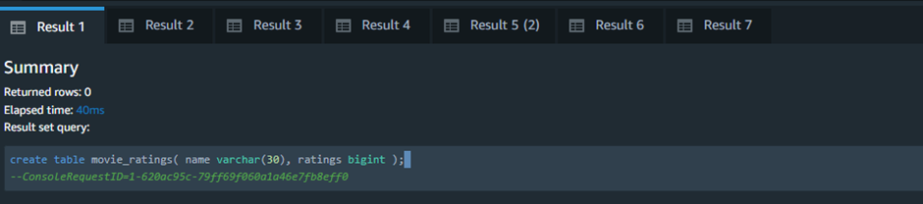

**Result 2:**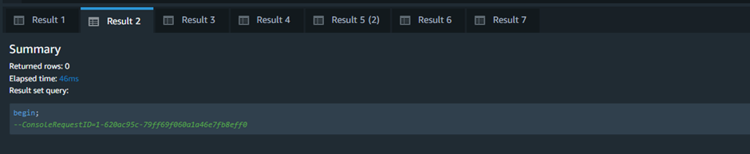

**Result 3:**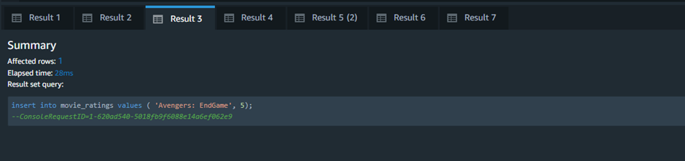

**Result 4:**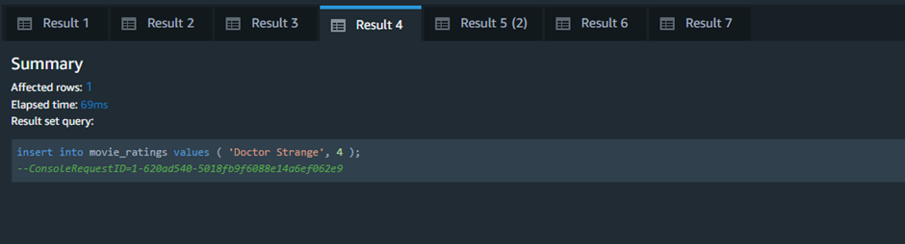

**Result 5:**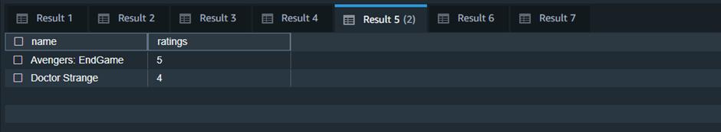

**Result 6:**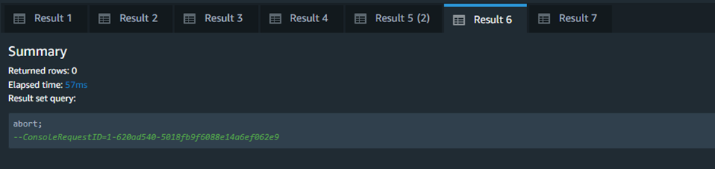

**Result 7:**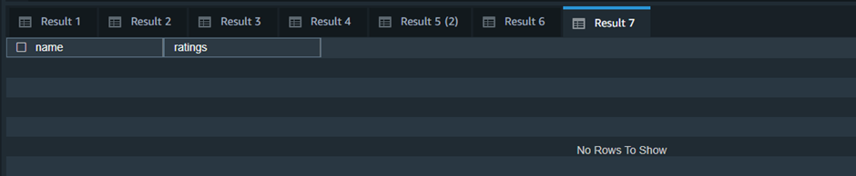

#### Alter Commands

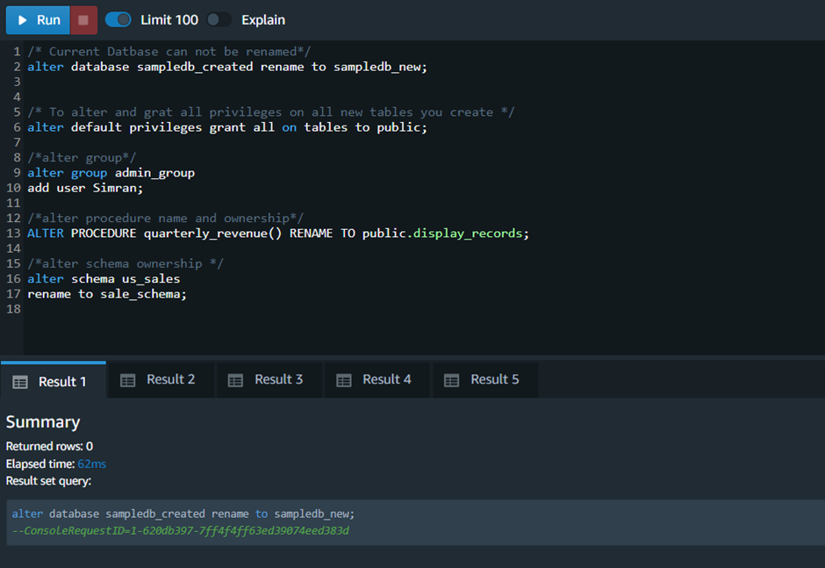

/* Current Database cannot be renamed*/

alter database sampledb_created rename to sampledb_new;

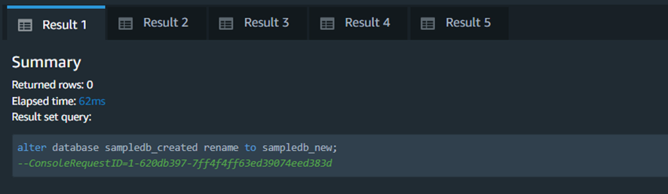

**/* To alter and grant all privileges on all new tables you create */**

alter default privileges grant all on tables to the public.

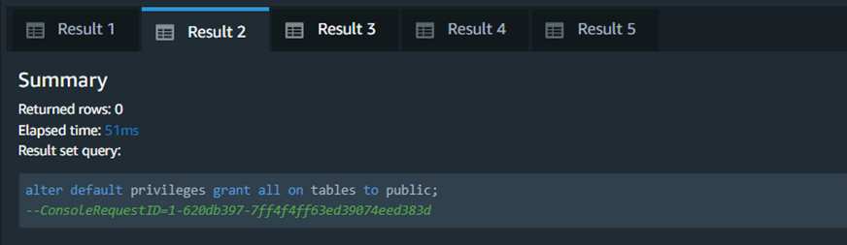

**/*alter group*/**

alter group admin_group

add user Simran;

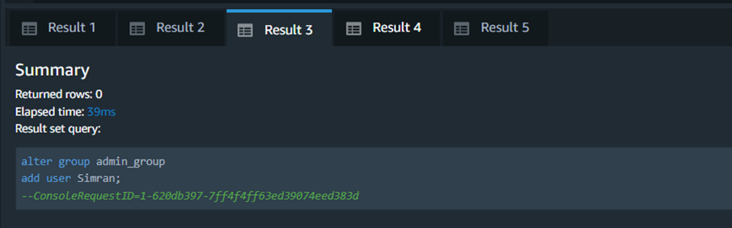

**/*alter procedure name*/**

ALTER PROCEDURE quarterly_revenue() RENAME TO display_records;

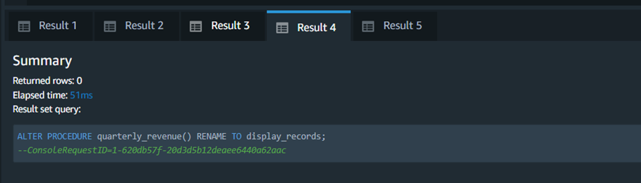

**/*alter schema name */**

alter schema sale_schema

rename to sale_records;

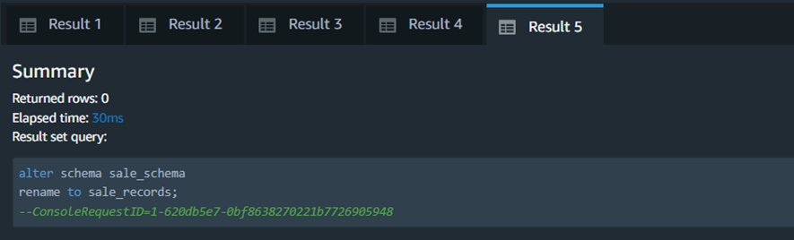

#### Create Commands

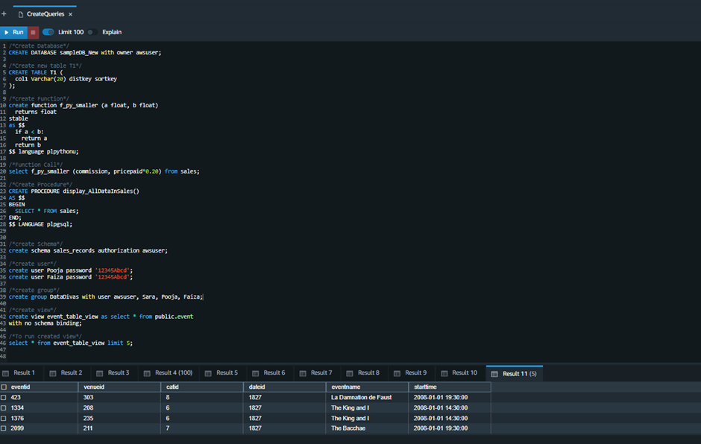

**/*Create Database*/**

CREATE DATABASE sampleDB_New with owner awsuser;

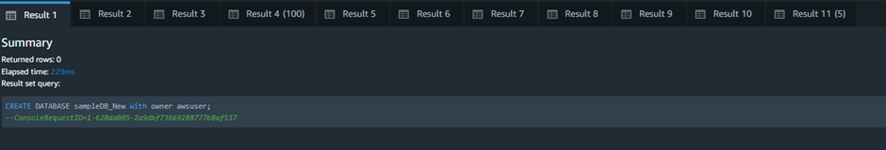

**/*Create new table T1*/**

CREATE TABLE T1 (

col1 Varchar(20) distkey sortkey);

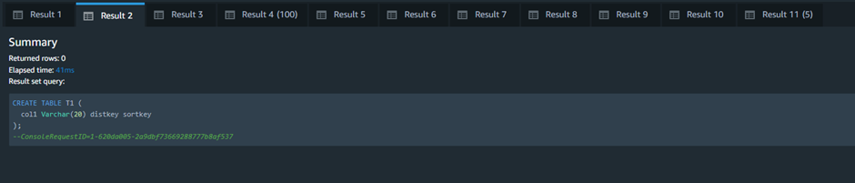

**/*create Function*/**

create function f_py_smaller (a float, b float) returns float

stable

as $$

if a < b:

return a

return b

$$ language plpythonu;

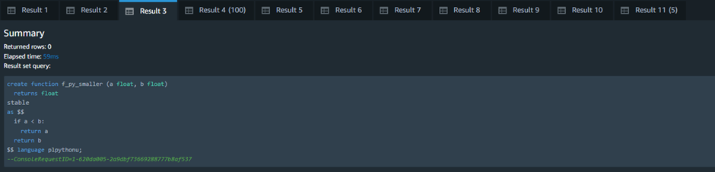

**/*Function Call*/**

select f_py_smaller (commission, pricepaid*0.20) from sales;

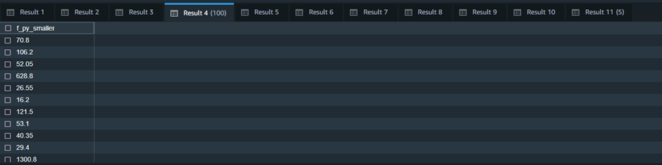

**/*Create Procedure*/**

CREATE PROCEDURE display_AllDataInSales()

AS $$

BEGIN

SELECT * FROM sales;

END;

$$ LANGUAGE plpgsql;

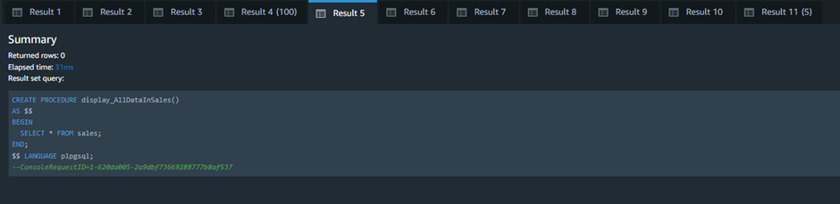

**/*create Schema*/**

create schema sales_records authorization awsuser;

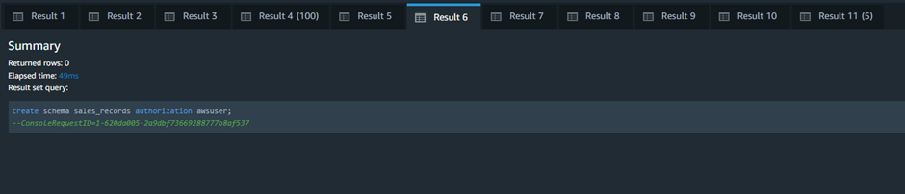

**/*create user*/**

create user Pooja password '12345Abcd';

create user Faiza password '12345Abcd';

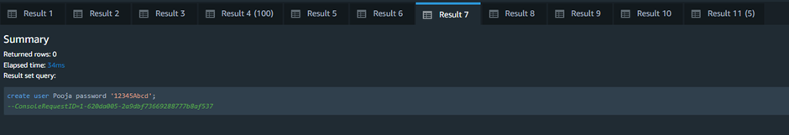

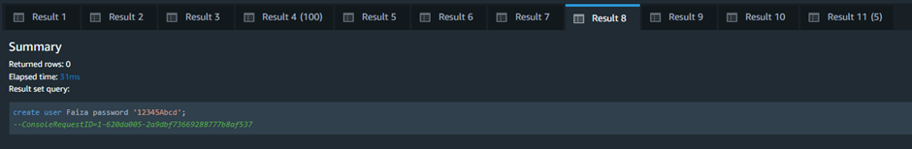

**/*create group*/**

create group DataDivas with user awsuser, Sara, Pooja, Faiza;

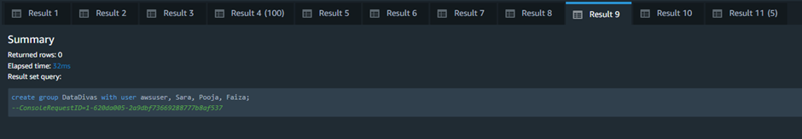

**/*create view*/**

create view event_table_view as select * from public.event

with no schema binding;

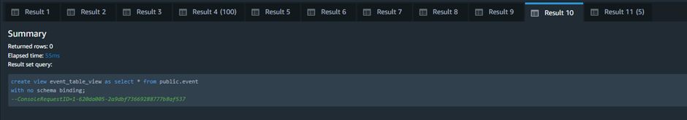

**/*To run created view*/**

select * from event_table_view limit 5;

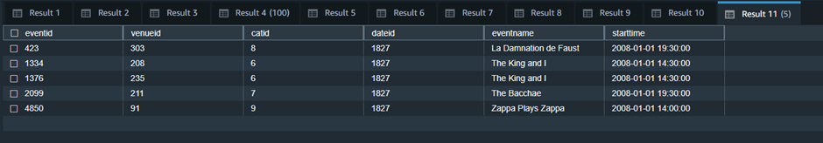

# References

* [1] 2022. [Online]. Available: https://docs.aws.amazon.com/redshift/latest/gsg/redshift-gsg.pdf#getting-started. [Accessed: 22- Feb- 2022].
* [2] *Youtube.com*, 2022. [Online]. Available: https://www.youtube.com/watch?v=fr-sAHyKjE0&t=1s. [Accessed: 22- Feb- 2022].
* [3] *Youtube.com*, 2022. [Online]. Available: https://www.youtube.com/watch?v=1KxdBIklLuc&t=0s. [Accessed: 22- Feb- 2022].
* [4] 2022. [Online]. Available: https://docs.aws.amazon.com/redshift/latest/dg/redshift-dg.pdf#getting-started-machine-learning. [Accessed: 22- Feb- 2022].
* [5] 2022. [Online]. Available: https://docs.aws.amazon.com/redshift/latest/dg/limitations-datashare.html. [Accessed: 23- Feb- 2022].
* [6] 2022. [Online]. Available: https://docs.aws.amazon.com/redshift/latest/gsg/redshift-gsg.pdf#page=32&zoom=100,96,293. [Accessed: 23- Feb- 2022].
* [7] 2022. [Online]. Available: https://docs.aws.amazon.com/redshift/latest/dg/considerations.html. [Accessed: 24- Feb- 2022].